

**DALL-E generated image**

May 12, 2025

Michele Maestrini

I.D. 13135521

Supervisor: George Magoulas

Plant Disease Detection   
Using Few-Shot Learning  
 with Siamese Networks, Triplet Loss,   
and Optimized Transfer Learning

**Abstract:**Does climate change have an effect on agricultural plant pathogens? This question has been contested with insufficient data that has led to varying degrees of unsubstantiated predictions. Long-term studies addressing the fundamental questions of how climate change is affecting our society will require a concrete baseline from which evidence can be collected and investigated. Many scientists are currently tackling this problem, however, initiating a viable means of data collection is one of the key components to being better informed. The problem lies with many farmers being in remote regions around the world that do not have access to algorithms that can operate on hand-held devices such as mobile phones, which could allow them to assess whether their crops are failing due to a variety of plant pathogens.

This research is an attempt to bridge the gap between large deep neural networks that need excessive amounts of data operating with enormous computational resources to make accurate classifications, with a model that can operate on small devices (IoT platforms) with comparable levels of accuracy.

This research investigated a system to create a binary plant disease classification using a lightweight transfer learning model (4.6 MB). It comprised several complex ‘*state-of-the-art*’ concepts. The MobileNetV2 backbone (with a width multiplier: $α=0.5$, learning rate: $η=0.0001$, dropout: $P=0.3$) is able to be considered as a viable option to operate on IoT platforms, while providing high-level predictive capabilities, comparable to larger deep neural networks, within the agricultural setting.

The PlantVillage database was converted into binary categories with stratified splitting applied to the training, validation and test sets using the distributed ratio of 7:2:1. The Few-Shot Learning Model (FSLM) leveraged the Siamese Network setup with the metric learning loss function, triplet loss on a low-dimensional embedding space in order to discriminate between healthy and unhealthy plant leave images.

Empirical evidence explicitly shows strong convergence of the loss function with further evidence of distinctive clustering formations from the t-SNE and separation of the mean Euclidean distances between the two pairwise distance distributions.

Building on the well structured embedding space that was created by the Siamese Network, a Few-Shot Learning (FSL) paradigm was introduced with a 2-way 5-shot environment, that incorporated a Softmax classifier embedded within a binary cross-entropy loss function with a Shannon regularizer. The validation and test sets were executed using an episodic support/query setup. The tuning of pertinent hyperparameters, namely, the Shannon regularizer coefficient $\left(λ_{ Shan}\right)$ and two scaling parameters $\left(ξ, ξ_{EI}\right)$ was conducted using the Bayesian optimization search algorithm.

The numerous hyperparameter permutations achieved in excess of 95% validation accuracy with the highest being near-optimal, as illustrated by a hyperparameter response surface which depicts a non-closed form array. This indicates that the model has acquired the necessary innate knowledge to distinguish vital abstract features from the binary classes. The configurations of the permuted hyperparameters were wide ranging, underlining the sensitivity of the tuning phase and precision of hyperparameter selection process.

With an optimized performance observed during training, this was maintained through the validation and testing phases, exhibiting good alignment among the three. The accuracy and loss curves displayed minimal divergence, indicating good generalization capabilities with no sign of overfitting. The test produced 98.75% predictive accuracy, with the Recall metric having 97.5%, which is a key metric in the disease detection environment.

This compact model showed sufficient resilience towards a highly imbalanced dataset which is often the norm when dealing with disease detection. It addressed the limitations placed on insufficient data, with remarkable near-perfect classification accuracy by embodying ‘*state-of-the-art*’ techniques. To this end, it is a good first step in the right direction on the investigative path to creating a model that will service the needs of the farmers.

Contents

1. Introduction 2

2. Aim & Objectives 4

3. Literature Review 8

3.1 Transfer Learning 8

3.2 Few-Shot Learning 14

3.3 Bayesian Optimization 16

3.4 Summary 17

4. Methodology 18

4.1 Overview 18

4.1.1 Machine Learning Pipeline 18

4.2 Few-Shot Learning (FSL) 19

4.2.1 Training Phase 20

4.2.2 Softmax Function & Classifier 21

4.3 Hyperparameter Optimization 22

4.3.1 Bayesian Optimization 24

4.3.2 Gaussian Process 25

4.3.3 Acquisition Function 27

4.3.4 Expected Improvement 27

5. Implementation 29

5.1 Data 29

5.2 Data Preprocessing & Analytics 30

5.3 Statistical Metrics 32

5.4 Transfer Learning Architecture 33

5.5 Code Implementation 33

5.5.1 Stage 1 - BLM 33

5.5.2 Stage 2 - FSLM 35

6. Execution & Results. Stage 1 - BLM 40

6.1 Data Investigation & Preprocessing 40

6.2 Developing the BLM 43

6.3 Generated Results 44

7. Analysis. Stage 1 47

7.1 Global Metrics 47

7.2 Loss Curves 47

7.3 Summary 48

8. Execution & Results. Stage 2 - FSLM 50

8.1 Siamese Network. Training the FSLM 50

8.2 Generated Results 51

8.3 Few-Shot Learning. Hyperparameter-Tuning & Testing the FSLM 56

8.4 Generated Results 57

9. Analysis. Stage 2 61

9.1 Siamese Network with Triplet Loss 61

9.1.1 Model Summary 61

9.1.2 Triplet Loss Curve 61

9.1.3 t-SNE of Siamese Embeddings 61

9.1.4 Density Plot of Pairwise Distances 62

9.1.5 Hyperparameters 62

9.2 Few-Shot Learning with Bayesian Optimization 62

9.2.1 Setup of 2-Way 5-Shot Framework 62

9.2.2 Hyperparameter-Tuning the FSLM 62

9.2.3 Analysis Across Trials 63

9.2.3.1 Loss & Accuracy Plots 64

9.2.4 Final Validation & Test Performance 68

10. Concluding Remarks 69

References 73

Appendix I. Brief Overview of t-SNE 75

Appendix II. Brief Overview of Density Plots 77

Appendix III. Loss & Accuracy Plot for All Trials 79

Appendix IV. Decision Rule & Threshold Formulation 80

# 1. Introduction

Climate change is a hotly contested topic, and irrespective of which side of the fence your opinion lies, it does have a bearing on our environment. The carbon dioxide emissions have increased significantly since the dawn of the industrial revolution. When a closed system such as Earth, which was experiencing a stable period is perturbed even by a fraction, the effect could be detrimental to the long-term trajectory of our planet.

Currently, there is insufficient evidence or research that states climate change has a direct effect on plant diseases. In order to facilitate the on-going monitoring on how climate change is potentially impactful on plant pathogens, more information is required in order to establish a strong baseline to work from [1].

However, there are other more short-term issues to consider. With the exponential growth of the human race, more pressures are placed on farmers to meet the ever-increasing supply and demand requirements. The ability to actively impart a timely response to any plant disease without being reliant on the cumbersome domain knowledge system that is currently being employed, lends itself to having a more automated platform [2] especially in light of the expanding mobile networks, thus enabling the availability of IoT devices which are ubiquitous in our society allowing for an exact identification of the pathogen, known as “precision agriculture” [3].

To facilitate the much needed research on plant pathogens in relation to climate change and to ensure that the demands are met to continue supplying the plant-based agricultural food sources; further studies to develop learning algorithms investigating plant diseases are required. To this end, the research goal of this project is to develop a learning algorithm that will consist of several key components, including transfer learning integrated with few-shot learning paradigms that utilize a triplet loss function. Given the limited computational resources available for IoT devices and the scarcity of field data (e.g. images of plant diseases captured in real-world conditions), the plant disease detection model must be optimized for efficiency. This will encapsulate a combination of methodologies from existing research, using an off-the-shelf pre-trained convolutional neural network to bolster the few-shot learning approach.

Optimizing an array of hyperparameters will play a critical role in achieving the most efficient model within the above mentioned constraints, with Bayesian optimization being the principle technique. Bayesian optimization is ideal for this regime, as it effectively handles the complexity and computational expense of optimizing hyperparameters, ensuring that the model has a good degree of accuracy and at the same time is resource efficient. In short we are dealing fundamentally with an optimization problem, which is underlined by enabling the model’s many components to meet the specific challenges imposed by the restraints.

A high-level explanation of the two major components involved are as follows:

1. Transfer learning:

In 1959, the 1st director of NASA’s manned spacecraft, Bob Gilruth only selected military test pilots to fly on Project Mercury, saying, “It made it quite simple and logical to delegate flight control and command functions to pilots” for the space rockets – in essence highlighting transferable skillsets.

Within the realms of machine learning and computing, the first known instance of transfer learning was mentioned in 1997 in the book “Learning to Learn” [4]. This work outlined the fundamental concepts that remain relevant today, emphasizing that knowledge acquired from previously learned tasks can be leveraged to enhance performance on new tasks. This early illustration laid the groundwork for what is now a widely used approach in numerous machine learning applications.

1. Few-Shot Learning (FSL):

It is a method that can be akin to humans. We, as a species do not need large amounts of information to gain a fundamental understanding of what an object is. If a new object is presented for the first time, only a few images are needed to appreciate the nuances to be able to identify the object. This paradigm enables a model to determine the likelihood of whether two objects are similar or not, thereby identifying with a degree of confidence what it is.

To emphasize this reasoning, if we analyse the left image in Figure 1.1[1] [5], there are three fictitious objects that are highlighted in red. By observing these, are we able to discern similar objects from the remaining depictions? The results are located in the image on the right. Invariably humans are very good at identifying objects that they have just learnt, from a very small dataset. This skillset may have been developed through evolutionary adaptation from our environmental past by recognizing harmful plants or animals after just seeing them a few times.

Figure 1.: “Given these alien objects and three examples (boxed in red) of ‘tufas’ (a word in the alien language), which other objects are tufas?” [5]

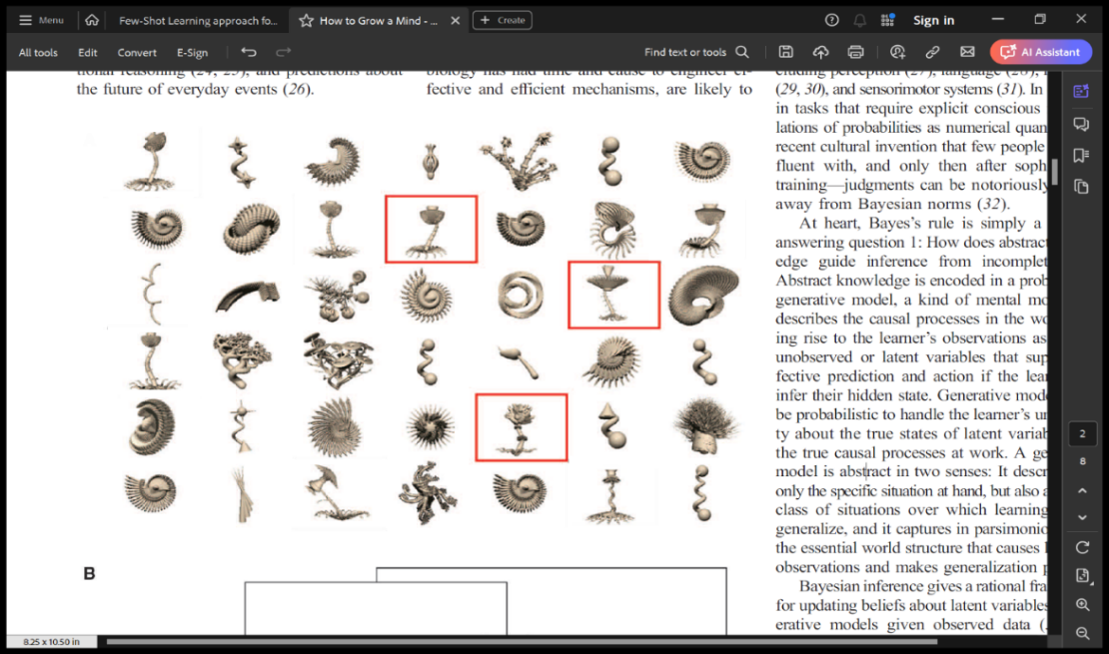

# 2. Aim & Objectives

* 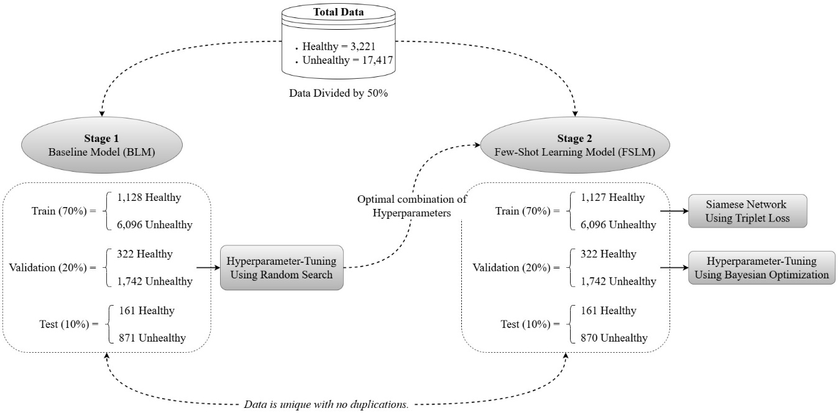**Aim:** The aim of this project is to develop a model that is efficient and capable of producing high-levels of accuracy in plant disease detection, despite being constrained by low computational resources and limited data. The dataset that will be used to investigate if it is possible to create such a model is PlantVillage, which contains 20,638 images that have been taken in a controlled environment, namely, plants photographed with good lighting possessing minimal noise/interference from unwanted intrusions [6]. Thus the goal is to obtain a reasonable level of predictive accuracy that suggests that the model can distinguish between whether a plant is healthy or not and have the possibility of not being restricted to the controlled conditions. This property will hypothetically allow it to be applicable to operate in real-world environments with other agricultural samples that lie outside of the original control group.

Figure .1: Stages of the investigation. The calculated numbers are only estimates and will be verified during the implementation of the data preprocessing phase

The project encompasses several objectives that are crucial to its success. To provide context and structure, Figure 2.1 is presented, offering a summary of the methodologies that will be detailed later in the report. This figure clarifies the rationale behind the various objectives by illustrating how they are integrated within the overall project framework, thereby enhancing the understanding of the project’s structure.

* **Data Preparation Objective:** The data will be divided equally between the stages and subsequently distributed into various constituent parts and operated on by specific phases of the analysis. A more in-depth discussion is offered in section ‘*5.2 Data Preprocessing & Analytics*’ and is itemized in Table 5.2 for further clarification. For completeness, a brief description is given here:
  + The data comprises two prominent classes which are contained in 15 different plant categories; healthy and unhealthy. When viewed as two distinct categories within a binary classification, it becomes apparent that the data is highly imbalanced with the healthy class being in the minority. Normally when dealing with disease detection, the minority class is usually the unhealthy category, which is not the case here.
  + Within each stage, each class will be distributed with the ratio 7:2:1 to the train, validation and test sets respectively.
* **Model Design & Implementation Objective:** The objective is to design and implement a plant disease detection model that is robust enough to handle insufficient data, while having a low computational cost, that will be suitable for deployment on IoT platforms. The final model, namely, Few-Shot Learning Model (FSLM) will be a lightweight transfer learning model, capable of predicting with a high degree of accuracy, whether a plant is healthy or not with only a few unseen images being analyzed instead of the usual requirement of accessing large databases.
  + Each stage will incorporate the following:
    - Training phase: During this phase, the models parameters are trained by learning patterns from the data that is presented. Through backpropagation, the weights and biases are manipulated in order to minimize the loss function.
    - Hyperparameter-Tuning phase: The performance of the models are evaluated on the validation dataset so as to tune the hyperparameters which cannot be learnt. Numerous hyperparameter permutations are investigated and the best-performing configuration which obtains a more flexible representation of the given data, while avoiding overfitting will become part of the models’ architecture. In principle the models can cycle between the training and hyperparameter-tuning phases until it is deemed that they cannot be improved. Then and only then will it be allowed to be tested against the naïve data. For the purpose of simplifying the problem the models will only be subjected once to the validation sets and their results will be assumed to be optimal.
    - Testing phase: The models are evaluated on their performance by viewing their generalization errors on an entirely separate and unseen dataset. They will be characterized by pertinent metrics where inferences are subsequently made. Once the models have been subjected to the test data, it can no longer be re-tested against the same data. If further testing is required then new data will need to be introduced.
  + Stage 1: This stage is in essence an exploration stage. Its primary objective is to investigate certain hyperparameters using a random search algorithm during the tuning process. The generated model will be the baseline model (BLM). The transfer learning model will have it’s layers frozen and trained using backpropagation while enlisting a logistic classifier encoded within a binary cross-entropy loss function. An $L_{2}$ regularizer will be bolted onto the loss function in order to bolster the reduction of overfitting issues that sometimes arises with limited data. Once BLM has been tuned on the validation data, it will undergo testing on the test data, which will give some indication on how well the encoded hyperparameters within its architecture have performed. Once the optimal hyperparameters have been established, they become an integral part within the architectural make-up of the model during the next stage.
  + Stage 2: This stage is the Few-Shot Learning (FSL) stage. Its primary objective is to train a transfer learning model using Siamese Networks with a Triplet Loss algorithm. The gradients of the triplet loss with respect to the model’s structural parameters are computed and subsequently propagated back through the Siamese Network. Hyperparameter-tuning will leverage the power of Bayesian optimization search by investigating three more hyperparameters. Once the optimal combination has been generated, they will become part of the FSLM and subjected to the test data.
* **Model Training & Evaluation Objective:** The goal is to train two models – the BLM and the FSLM.  
  + The BLM will be trained by employing backpropagation on a transfer learning model and evaluated by utilizing a random search in order to obtain the optimal combination of hyperparameters. The main metric of choice for evaluating the BLM’s performance is the Matthews Correlation Coefficient (MCC) due to the highly imbalanced data[2].  
    - Matthews Correlation Coefficient (MCC): Using MCC is a more appropriate metric than accuracy when dealing with imbalanced datasets within a binary classification environment, especially during the hyperparameter-tuning and testing phases. Due to the difficulty that inherently lies in classifying highly imbalanced data, the model should achieve 50% or higher.
  + The FSLM will be a newly created transfer learning model where it will inherit the optimal hyperparameters from the previous stage. It will then be trained using a Siamese Network with a triplet loss function. Once the model has been tuned using Bayesian optimization, it will be evaluated using the Few-Shot Learning (FSL) paradigm; 2-way 5-shot and it’s performance monitored by using the accuracy metric. Although the data is imbalanced, the structure of Siamese Networks and the FSL framework eliminates the need to cater for any imbalance, thus promoting the accuracy metric to be the measurement of choice.
    - Accuracy: The model should achieve an accuracy of 85% or higher on the training set, indicating that it has correctly classified the majority of the training samples.
  + Additional metrics will be used in conjunction with the above-mentioned metrics which are[3]:
    - Precision: It should reach 80% or higher on the training set, ensuring that the false positive rates are minimized. This level of precision will suggest that the models are not overfitting to noise, thereby avoiding an increase in false positives.
    - Recall (Sensitivity): The models should achieve a Recall of 80% or higher, which implies that the false negative rates are kept low. At this level it ensures that the models correctly identifies the majority of true cases of plant diseases, demonstrating its ability to recognize disease cases effectively and reducing the risk of underfitting. As this metric is a key barometer to how well the model is recognizing disease cases, it will need to be prioritized, because failing to detect unhealthy plants (false negatives) could render the whole crop worthless, if stringent monitoring is not administered. Thus, early detection of a pathogen could mitigate the spread.
    - F1-Score: The models should achieve a F1-Score of 80% or higher, reflecting a balanced approach to precision and recall. This would demonstrate the models competence in managing the trade-offs between false positives (healthy instead of unhealthy) and false negatives (unhealthy instead of healthy).
  + The training errors should demonstrate that both models are effectively learning to discriminate between the binary classes. A relatively low training error should translate into strong generalization performance when the models are tested on naïve data.
* **Model Optimization Objective:** The objective is to optimize the models by means of hyperparameter-tuning, utilizing random search for the BLM and Bayesian optimization for the FSLM, to enhance their performances, particularly in terms of generalization.
  + Hyperparameter Optimization: Identify the optimal set of hyperparameters that maximizes the models’ performance. This will be assessed using the various statistical metrics that have been previously discussed in the ‘*Model Training & Evaluation Objective*’.
  + Reduction in Overfitting: Ensure the models generalize well by minimizing overfitting. This will be monitored by evaluating the differences between the training and the hyperparameter-tuning’s accuracy/loss metrics. A smaller difference ($∆$) between these metrics indicates improved generalization – Equation (2.1).

|  |  |
| --- | --- |
|  | (2.1) |

* + Convergence Rate: The model should achieve the optimal performance more quickly through the use of optimized hyperparameters. This will be measured by the number of epochs required to reach the optimal performance. Fewer epochs indicate a greater learning efficiency.

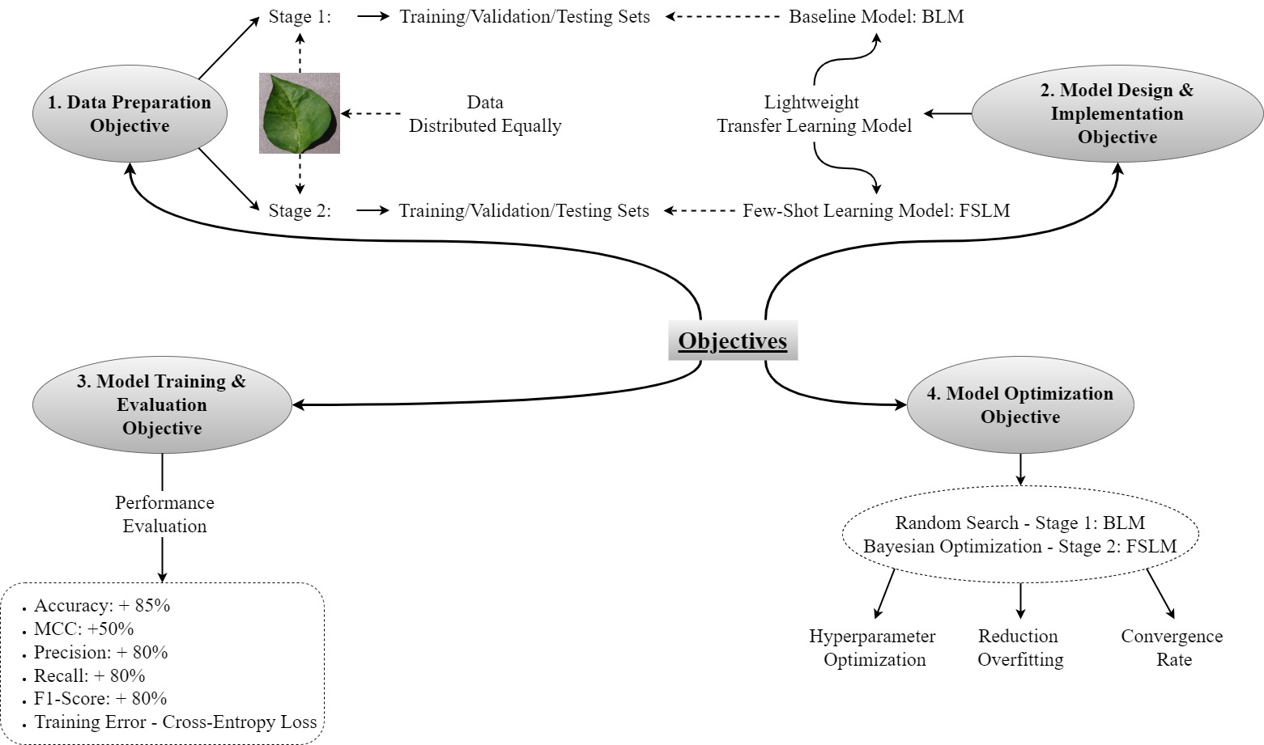A summary of the objectives of the project are illustrated in Figure 2.2.

Figure 2.2: Graphical summary of the projects objectives

# 3. Literature Review

With the explosion of investments in the field of Artificial Intelligence (AI), the amount of research across many diverse areas has grown enormously in the last few years. There are parallels associated with AI that one could make with physics; the initial research works were isolated and unconnected. James C. Maxwell unified electricity, magnetism and light, heralding the birth of unification, thus igniting many seemingly disconnected theories, most notably, General Relativity (GR) and Quantum Theory (QT), namely ER = EPR[4]. The same can be said for AI. In particular, with the fields pertinent to this project, large strides have been made in transfer learning, few-shot architectures, and a plethora of optimization techniques that have combined to launch an area of research that despite the simplicity, is producing state-of-the-art comparable results.

There is no one research paper that encompasses all of the above mentioned areas. Therefore, the review has been divided into the three subject matters that are relevant to the approach used in this project.

## 3.1 Transfer Learning

1. The authors of [7] have created an extensive exploration of deep transfer learning models for the classification and identification of plant pathogens. Although it does not use Few-Shot Learning (FSL) nor a shallow neural network[5], it does highlight relevant information on transfer learning models. The study evaluates a wide range of datasets: sunflower (4 classes totalling 467 images), cauliflower (5 classes totalling 656 images), and agri-ImageNet (a subset of ImageNet which contains 32 classes) covering 38 deep transfer learning models. The models were pre-trained using the ImageNet dataset which contains a small fraction of agricultural images. They were then subjected to the three datasets utilizing their current weights. The best performers were EfficientNetV2B2 and EfficientNetV2B3. Table 3.1, [7] extracts the results from the paper for both the winning models, and, for comparison purposes MobileNetV2 has been included.

|  |  |  |  |
| --- | --- | --- | --- |
| **Models** | **Accuracy** | | |
| **Sunflower** | **Cauliflower** | **Agri-ImageNet** |
| EfficientNetV2B2 | 100.00 | 96.825 | 90.3125 |
| EfficientNetV2B3 | 100.00 | 97.354 | 92.4375 |
| MobileNetV2 | 83.459 | 59.259 | 78.875 |

Table 3.: Extracted accuracy results [7]

Normally when implementing deep transfer models, large amounts of annotated data is required, however, the results depicted in Table 3.1, imply quite a different outlook showing a substantial reduction in data while still maintaining impressive predictive accuracies. The two superior models of EfficientNetV2B2-3 far outperform MobileNetV2 and so, MobileNetV2 being lightweight in nature and ideal for IoT devices, lends itself to being a good candidate to be subjected to hyperparameter optimization.

1. [8] gives a detailed overview of the numerous real-world applications of convolutional neural networks (CNN). The deep learning architectures are comprehensively discussed with their varying techniques of analysis in relation to their datasets.

Table 3.2 shows the MobileNetV2 architecture having 53 layers with only 3.4 million parameters which is somewhat meagre when compared to the heavy weights that can have up to 130 million parameters.

| **Architecture** | **Layers** | **Parameters** |
| --- | --- | --- |
| VGG16 | 13 convolution + 3 fully connected | 134 million |
| Inception V4 | 75 convolution | 41 million |
| ResNet50 | 50 convolution | 25.6 million |
| MobileNetV2[6] | 53 convolution | 3.4 million |

Table 3.: Extracted results of architectural comparisons of 3 models plus the MobileNetV2

|  |  |  |  |
| --- | --- | --- | --- |
| **Plant** | **# of Diseases** | **Dataset - PlantVillage** | **Results** |
| Apple | 1 | 2086 images | 1st VGG16 – 90.4%  2nd VGG19 – 90.0% |
| Tomato | 9 | 5000 images | 1st VGG16 – 83.06%  2nd ResNet50 – 75.37% |
| Tomato | 8 | 5550 images | 1st ResNet – 97.28% |

Table 3.3: Extracted results of varying PlantVillage dataset results

Table 3.3 highlights the performances of VGG16, and ResNet50, and their ability in detecting a myriad of diseases while coping with the labyrinth of a variety of plant conditions. Both VGG16 and ResNet50 contain 134 million and 26 million parameters respectively. These are indeed large CNN models which will be computationally expensive, therefore, not ideal for IoT devices. Although MobileNetV2 was not part of the study, with a fraction of the total number of parameters, it has the potential to compete with the larger models if subjected to hyperparameter optimization, while essentially having the ability to be deployed on mobile platforms, thus allowing it to operate in real-world scenarios.

1. To understand the architectural nuances of why MobileNetV2 was the preferred model of choice besides the fact that it is an ideal vehicle to operate on resource starved devices, we need to look firstly at the seminal paper that pioneered the new wave of research and development of residual networks which led to the development of the MobileNetV1 and subsequently to MobileNetV2.

Residual structures[7] was first introduced by ResNet [9] which allowed for connections that skip layers. This process mitigated the problem of vanishing gradient which essentially ensured a smoother backpropagation process. The problem was resolved by adding the residual to each block, which although boosts the signal, (if the gradient does significantly diminish), it was not the primary or intended goal of the residual structures. It was to simplify the function that each block needs to learn. Furthermore, these residual blocks can be viewed as being independent layers, however, it is better to consider them as units within a larger network and their combinations contributing to learning the overall function, as depicted in Figure 3.1. By mitigating the vanishing gradient, which culminates in the learning processes for each residual block to be simplified, it has now opened an avenue for these architectural types to be considered for training deep networks.

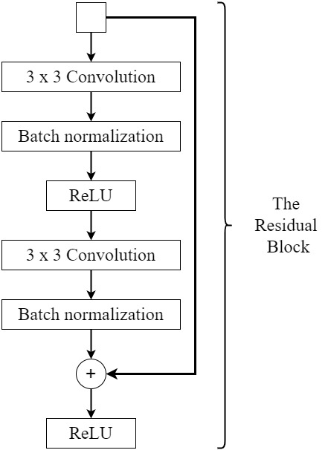The ResNet architecture uses standard convolutional or full convolutional layers – a resource intensive method. One of the key building blocks in MobileNetV1 architecture [10] is factorized convolutions. Factorization replaces the standard convolutional layer (which is somewhat cumbersome) with a faster, lighter version. There are many techniques to achieve this, however, the authors of [10] implemented depthwise separable convolutional blocks (DSC) which can be seen in Figure 3.2 and was first published in a PhD thesis in 2014 [11]. The reduction in computational cost from using a standard convolutional layer ($X_{1}$) to using a DSC block ($X_{2}$) can be viewed in the mathematical illustration of Equation (3.1) and Equation (3.2):

Figure .1: A simplistic illustration of a residual block from the ResNet model

|  |  |
| --- | --- |
| $$X_{1}=D_{F}^{2}×D_{k}^{2}×M×N$$ $$X_{2}=\underset{Depthwise Conv.}{\underbrace{D_{k}^{2}×M×D_{F}^{2}}}+\underset{Pointwise Conv.}{\underbrace{M×N×D_{F}^{2}}}$$ | (3.1) |
| $$R=\frac{X_{1}}{X_{2}}×100 \\ =\left(\frac{1}{N}+\frac{1}{D_{k}^{2}}\right)×100$$ | (3.2) |

Where:

* + The input spatial dimensions are $D_{F}×D_{F}$.
  + The kernel spatial dimensions are $D_{k}×D_{k}$.
  + $M$ is the number of input channels.
  + $N$ is the total number of kernels.

The authors used $N=32,D_{k}=3$ resulting in [8] implying that DSC is seven times faster than the standard convolution, with a maximum accuracy reduction using the ImageNet dataset of 4%. The trade-off for having a slightly less accurate model while increasing the speed 7-fold is deemed as being acceptable.

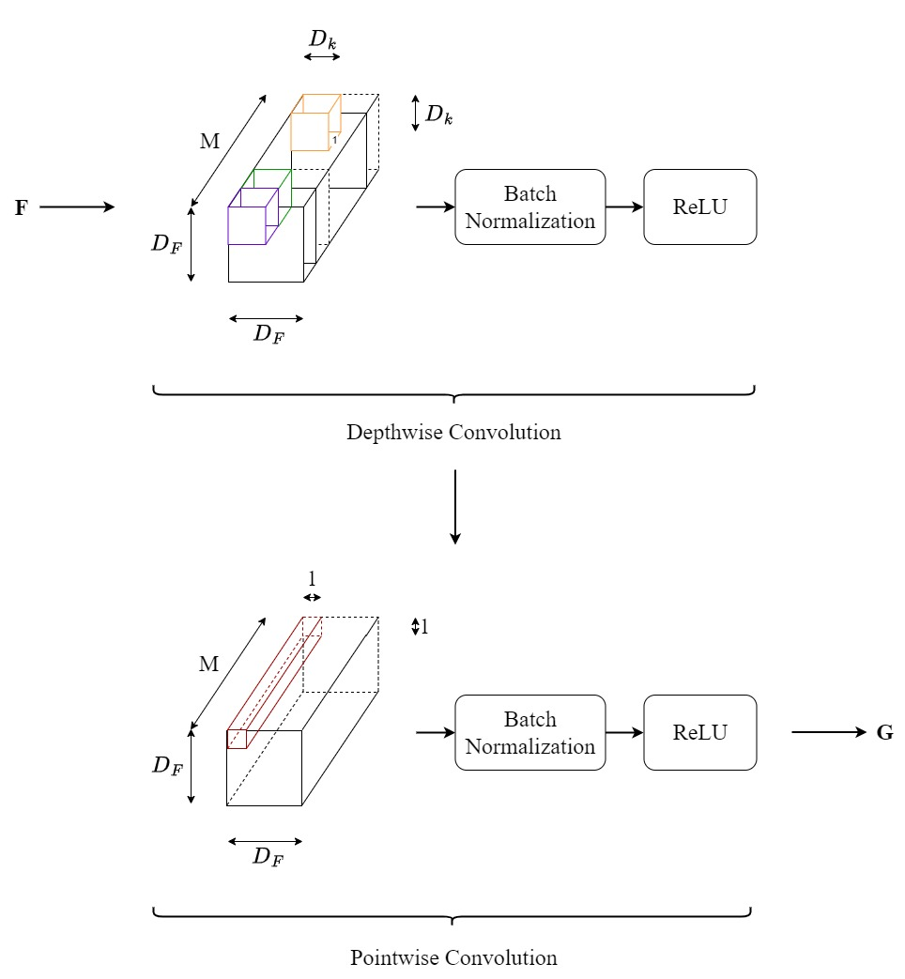The number of weights in DSC blocks are vastly reduced, thereby reducing the complexity of the model. If no further manipulations were undertaken, the net result would show a significant reduction in performance, with accuracy being a major consequence. To overcome this, batch normalization and non-linear activations are applied to each depthwise and pointwise convolutional layers (as illustrated in Figure 3.2), thereby boosting the model’s complexity.

To summarize: depthwise and pointwise convolutions which are two factorization layers, significantly reduce the model’s complexity. By implementing a non-linear activation within each of these layers, substantially increases the model’s complexity, thus eliminating the threat of poor performance/accuracy due to underfitting.

Figure 3.2: A simplistic interpretation of the depthwise and pointwise convolutions are considered to be separate layers that make-up the DSC block

The authors have introduced two shrinking hyperparameters to decrease the size of the model further, thus enhancing the speed.

* + Width Multiplier: $α∈\left(0,1\right]$ effectively reduces the number of kernels used in the convolutional layer, which has a direct implication on the number of activations, thereby reducing the output. The reduction computationally is of the order ${≈α}^{2}$. To give some context, if we let $α=0.5$, the amount of computations for the reformulated model would be 25% of the unaltered model which is a considerable saving.
  + Resolution Multiplier: $ρ∈\left(0,1\right]$ reduces the input resolution to the architecture and again the computational saving is of the order of $≈ρ^{2}$.

When comparing the results, there is no clear advantage to using one hyperparameter over the other. Therefore, the predefined width multiplier values will be used: $α∈\{0.35, 0.5, 0.75, 1$.0}.

The authors claim that the model needs less data augmentation. However, there is opposing empirical evidence to this claim [12]. This research is concerned with a deep learning line segment detector called Mobile LSD. The authors used the model as a feature extractor, and applied a considerable amount of augmentation to the data. The increase in performance was non-trivial when the data was subjected to augmentation.

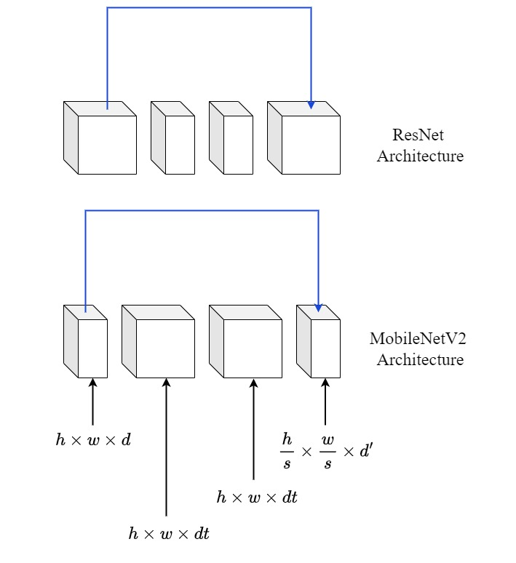The MobileNetV2’s authors [13], used its predecessor’s V1 architecture [10], but with certain changes to enhance performance in image classification, amongst others. The new version implemented an inverted residual structure with linear bottlenecks thus greatly reducing the computational resources while ensuring a good level of accuracy. ResNet [9] used the fat-thin-thin-fat residual structure format, while in MobileNetV2 [13], this is inverted which is described in Figure 3.3[9]. The inverted residual structure, connects the low-dimensional input signal directly to the low-dimensional output layer, thereby avoiding the need to have intermediate representations which essentially reduces the memory requirements and in turn, making it an ideal vehicle for devices that have limitations on resources.

Figure 3.3: Comparisons between ResNet and MobileNetV2 architectures using fat and thin layers

There are two fundamental ideas that underpin MobileNetV2:

* + Information loss occurs when a non-linear activation is applied to a low-dimensional image. In other words, a non-linearity activation preserves information only when it is applied on high-dimensional data, and this key idea, led to the inverted residual architecture.
  + Real-world images (e.g. the PlantVillage dataset) can be encoded on low-dimensional activations, as these images can be considered to be a set called a manifold of interest (MoI) and is a subset of all possible captured images ($S$). MoI is very small when compared to $S$.

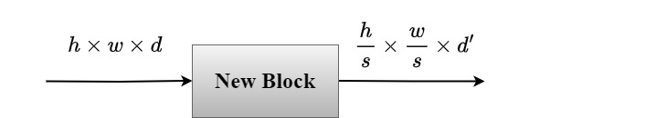Where:

Figure 3.4: High level depiction of MobileNetV2

* + are relatively small when compared to other architectures.
  + $s$ is the stride.

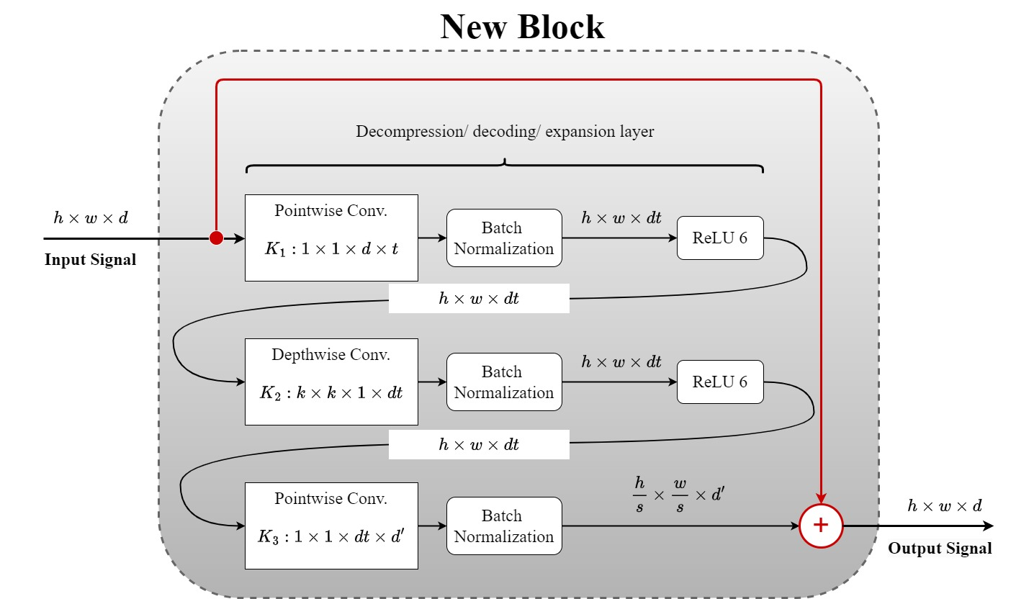Figure 3.4 is a high-level overview of MobileNetV2’s new block, with Figure 3.5 being a more detailed inspection of the new block. For a residual connection to take place, the spatial dimensions of the input signal must equate to the spatial dimensions of the output signal. If this is not the case, then no connection is made. In order for a connection to occur, the following needs to exist: $s=1, d=d^{'}$. To re-iterate the point, the requirement for $d, d^{'}$ parameters to be small, stems from the real-world images, namely, MoI, which are encoded on low-dimensional activations.

Figure 3.5 indicates the input to the new block, which is considered to be low-dimensional, namely that $d$ is small. Before a non-linear activation can be applied, the input is first expanded by a pointwise convolutional layer $K_{1}$, where $t$ is the expansion factor. This expansion layer ensures that information preservation is maintained when a non-linear activation function is applied to it. The authors of [13] use $t=6$, ReLU 6. The claim is that $t=6$ is the best value and when dealing with low-precision computations ReLU 6 is better suited than the standard ReLU activation function. The pointwise convolutional layer does not have a non-linear activation applied to it, and is thereby called the Linear Bottleneck. Information preservation is again the reason for this as the spatial dimensions are low-dimensional. This innovative feature is fundamental to MobileNetV2 as traditionally, neural networks incorporate non-linear activation functions after each convolutional implementation, giving it the ability for the network to learn highly complex features.

Figure 3.5:MobileNetV2 new block construction

When comparing the results of both versions in a classification environment, V2 is 1.5 times faster than V1, and the Top-1 accuracy metric[10] was used showing that V2 scored higher than V1.

|  |  |  |
| --- | --- | --- |
| **Input Size** | **Operator** | **Number of Repeated Layers** |
| 224x224x3 | Conv2D | 1 |
| 112x112x32 | Bottleneck | 1 |
| 112x112x16 | Bottleneck | 2 |
| 56x56x24 | Bottleneck | 3 |
| 28x28x32 | Bottleneck | 4 |
| 14x14x64 | Bottleneck | 3 |
| 14x14x96 | Bottleneck | 3 |
| 7x7x160 | Bottleneck | 1 |
| 7x7x320 | Conv2D 1x1 | 1 |
| 7x7x1280 | Avg Pooling 7x7 | 1 |
| 1x1x1280 | Conv2D 1x1 | - |

Table 3.4: The MobileNetV2 architecture. [13][11]

From inspecting the architecture (Table 3.4) two questions arise to which [13] does not address:

1. Why was a non-linear function not used in the fully connected layer $\left(Conv2D 1×1\right)$?
2. Why was a standard convolution used at the beginning instead of separable convolution (Conv2D)?

## 3.2 Few-Shot Learning

1. [14] achieved good performance statistics while accessing 10% of the data, indicating that few-shot learning (FSL) is comparable to large deep learning neural networks that have access to 100% of the data. The Siamese Network was employed and they found that the triplet loss (squared *l2* norm) outperformed the contrastive loss (pairwise similarity score – *l1* norm) in accuracy. Notably, tuned transfer learning algorithms performed poorly when compared to FSL with Siamese Networks employing triplet loss and in addition the classifier was a multi-class support vector machine. The data was taken from the full complement of PlantVillage utilizing 38 classes with more than 54,000 images. The preprocessing task simply allowed for the re-sizing of the images to 256x256. Two domains were created, comprising a source domain (32 classes) and a target domain (6 classes). Within each domain the data was further divided for training and testing (80% : 20%). They claim notable improvements were made when applying a distance metric – Triplet loss – on a FSL algorithm. Once a transfer learning regime was implemented, namely InceptionV3, accuracies in excess of 90% were achieved with as little as 80 images per class, furthermore if the training dataset was significantly reduced, then only a slight decay in the model’s performance was experienced.
2. The review paper [15], highlights the problems of obtaining annotated images from experts when applying deep learning algorithms on detection systems for plant pathogens. The primary study is on FSL. It describes two data augmentation architectures; image transformation and deep learning. It further describes the applications of FSL: as a feature extractor or embedding, multitask learning, transfer learning and finally meta-learning (such as Siamese Networks). It goes on to clarify that transfer learning, multitask learning and meta-learning are often considered the same methods. Conceptually they are clearly different entities, however, they do strive to accomplish similar tasks, and may even be grouped together. An important feature of FSL, is its capacity to generalize well, when presented with a limited number of sample images which in light of the agricultural environment bodes well for the detection of plant pathogens as currently there is insufficient labelled data that has been documented.
3. The authors [16] claim that although cross-entropy loss function is not a new concept for training during the hyperparameter-tuning stage on a support dataset, it has gone largely unnoticed which is surprising as it has outperformed other FSL models. Empirical evidence suggests that hyperparameter-tuning significantly improves prediction accuracy. They report the performance increases to 2% ~ 5% for 5-way 1-shot and 1.5% ~ 4% for 5-way 5-shot. Similar conclusions were also suggested by [17]. The weights ($w$) and the bias ($b$) are trainable parameters during the fine-tuning stage. As with most neural networks these parameters are randomly initialized. However, the authors suggest to initialize all the feature vectors by normalizing them to the unit *l2* norm and the attached bias to zero:

|  |  |
| --- | --- |
|  | (3.3) |

Where:

* + *z* is the latent feature vector.
  + *x* is the input image of the support set.
  + $θ$ are the parameters.

Overfitting is a common problem due to the under-represented support set. To alleviate this recurring problem while at the same time making the model more robust to naïve data, a regularizer such as Shannon entropy was attached to the loss function and updated from the query set which lowered the model’s variance, thus improving it’s generalization capabilities.

1. The biggest take-away from [17], is that the authors modified the classifier’s input during the fine-tuning stage from a linear layer to a cosine distance layer, which can be seen in Figure 3.6. The vectors in essence are normalized and their inner products computed. The Softmax classifier then produces a categorical output distribution and prevents the trained weights from being mapped to zero.

|  |  |
| --- | --- |
|  | (3.4) |

Where:

* + *si, j* is the cosine similarity[12] score.
  + *w* are the weights.
  + $f_{θ}\left(x_{i}\right)$ are the feature vectors.

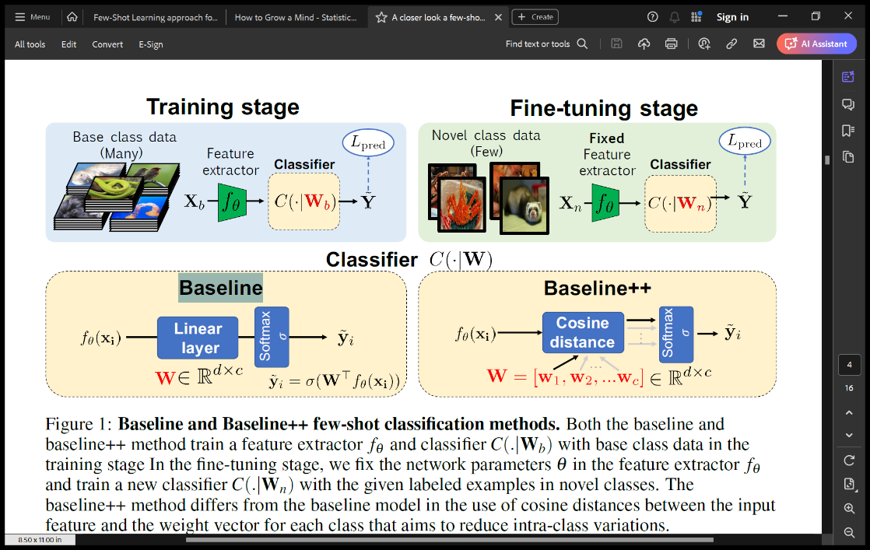

Figure 3.6: “Baseline and Baseline++ few-shot classification methods” [17]

## 3.3 Bayesian Optimization

[19] reviews the methodologies of Bayesian optimizations, which is part of a larger class of solutions called a sequential model-based solution. Conceptually speaking, Bayesian optimization is an updating mechanism for objective functions that do not have a closed form solution such as the hyperparameter response surface. An assumption is made for a prior belief of the objective function and through the acquisition of information the posterior is updated. The variance or uncertainty that is present within the model dictates the next location from the hyperparameter feature space. There are numerous controlling algorithms that assess the variance, known as acquisition functions, which will be discussed in due course.

There are two key ingredients that are the bedrock of Bayesian optimization. Firstly, the assumed prior distribution – known as a surrogate model – highlights our belief and second the loss function[13] which describes the optimal sequence of queries. The authors highlight the limitations of this algorithm, stating that it is ideal for problems that have a low-dimensional parameter space due to the difficulties encountered in finding the global optimum while tackling high-dimensional problems. For this reason, [20] proposed to use a random search instead of Bayesian optimization, although when combined, there were significant improvements in the performance than both of the individual elements taken in isolation. The proposal’s rationale is to embrace the higher-dimensionality capabilities of random search in the early analysis and then find the optimal hyperparameters in a reduced dimensional space at a later evaluation.

## 3.4 Summary

Some of the outcomes from the literature review form the fundamental structure of our model which is summarized in Table 3.5.

|  |  |  |  |
| --- | --- | --- | --- |
|  | **Research Paper** | **Relevant Experimentation** | **Outcome** |
| Transfer learning | [7] | The Agri-ImageNet dataset was used and the performances were compared with varying deep learning models. | Deep learning models perform well on small datasets. |
| [8] | No pathogen-based experimentation on plant diseases. |
| [10],[13] | No pathogen-based experimentation on plant diseases. | MobileNetV1-2: The evolution from the factorization on the convolutional layer; the DSC blocks, and the inverted residual linear bottlenecks.  The hyperparameter width multiplier can significantly reduce the computational cost. |
| Few-shot learning | [14] | It leverages the PlantVillage dataset and inferences were made while contrasting the FSL paradigm with models that are of a classical nature. | Triplet loss outperforms contrastive loss on Siamese Networks. |
| [16] | No pathogen-based experimentation on plant diseases. | Cross-entropy loss function outperforms other loss functions.  Use Shannon entropy as a regularizer.  Do not use random initialization of parameters. Initialize the feature vector to a normalized unit *l2* norm and the bias to zero. |
| [17] | No pathogen-based experimentation on plant diseases. | Swap-out the linear layer (*wT x + b*) to the cosine similarity (*sim(w, x) + b*) in the Softmax classifier $→$ reduces the intra-class variance. |
| Random search  &  Bayesian optimization | [19],[20] | No pathogen-based experimentation on plant diseases. | Random search performs better in high-dimensional problems, whereas Bayesian optimization performs better in lower-dimensional problems. |

Table 3.5: Summary of the literature review with pertinent empirical evidence leveraging the PlantVillage dataset. Some of these outcomes will be implemented in our model

# 4. Methodology

## 4.1 Overview

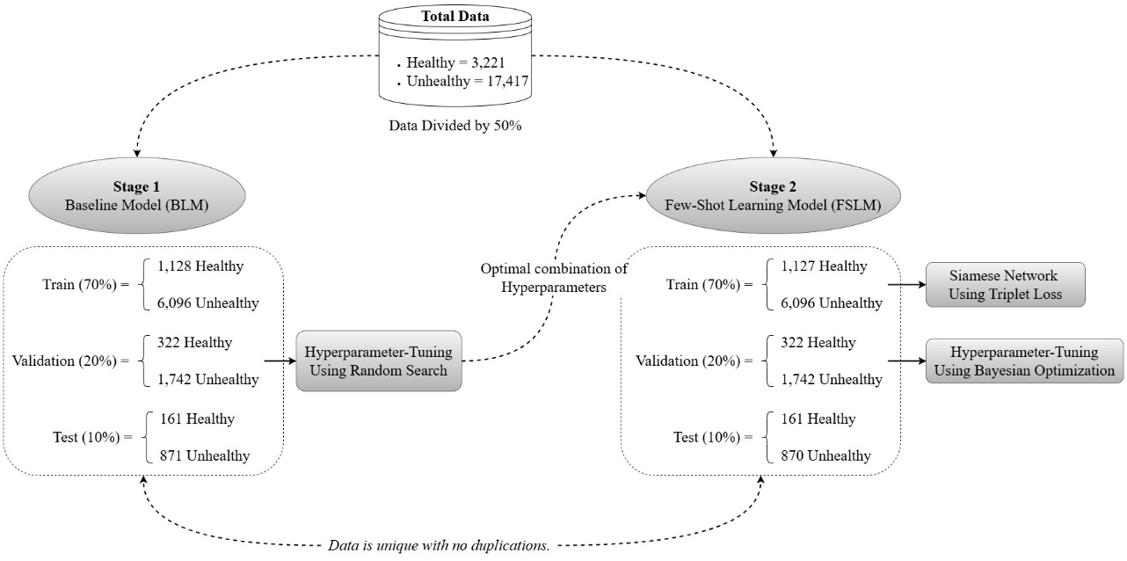The aim is to create a model that can operate on resource starved platforms while exhibiting performance scales that are similar to deep learning networks. The project is concerned with using a lightweight transferable learning model using a FSL paradigm, incorporating a Siamese Network while employing a triplet loss algorithm. The objective is to design the model and subsequently optimize the maximum performance by means of selecting the optimal hyperparameters using a Bayesian optimization technique. However, in order to reduce the complexity of obtaining the most effective hyperparameters, a random search is initially applied (Stage 1). The generated hyperparameters will be incorporated from the outset in the newly created transfer learning model in Stage 2, where it will undergo further hyperparameter-tuning of different hyperparameters that reside in the hyperparameter search space, using Bayesian optimization. Figure 4.1[14] is an illustration that shows a structural template of the intended processes depicting a high-level overview of both stages[15]. FSLM only inherits the optimal hyperparameters from the previous stage, which is generated using a random search over a high-dimensional hyperparameter space during hyperparameter-tuning. The architectural parameters from BLM are not transferred to FSLM. The underlying reason for incorporating this strategy stems from [20] which showed that Bayesian optimization is better suited to a lower-dimensional environment, while random search is a more robust workhorse that can cater for large complex hyperparameter spaces. Thus, the architecture of FSLM initially will incorporate the hyperparameters that are deemed to be optimal from BLM. Further hyperparameter-tuning will be conducted on FSLM with different key parameters.

Figure 4.1: Stages of the investigation. The calculated numbers are only estimates and will be verified during the implementation of the data preprocessing phase

### 4.1.1 Machine Learning Pipeline

MobileNetV2 is the preferred transfer learning classifier and will be used as a feature extractor. The main reason for using this preferred model, is that MobileNetV2 uses a DSC factorization method which is an integral part of the adapted convolutional layer coupled with the inverted residual linear bottlenecks, making this architecture extremely efficient and computationally ideal for resource limited devices[16]. Each stage evaluates three phases: training, hyperparameter-tuning and testing. The hyperparameter-tuning phase is subjected to the validation set in order to discover the optimal permutation of hyperparameters, which if established will result in a more malleable model that characterizes the data more accurately without incurring overfitting issues caused by closely representing the inherent noise that generally resides in most datasets. The distribution of data to both stages will be unique with the proportionality among the classes maintained thus eliminating an data leakage issues that may arise.

* Stage 1: The BLM will provide crucial insights to an array of different hyperparameters through a random search mechanism. It will be assumed that the optimal combination of hyperparameters will be achieved on the first pass of being tuned, thereby resulting in the best performance given the current selection of hyperparameters. These valuable insights will then be migrated to the next stage where they will form part of the architectural make-up of the new model.
* Stage 2: The FSLM will be trained using a Siamese Network with a triplet loss. The hyperparameter-tuning of the FSLM will develop more pertinent hyperparameters to investigating the infinitely large search space. This will be conducted by leveraging the Bayesian optimization algorithm with a Gaussian Process (GP) as it’s surrogate function using a Martérn kernel and the Expected Improvement (EI) operating as the acquisition function. The final phase of this stage will be to test the model on unseen data, while integrating the optimal hyperparameters.

For the hyperparameter-tuning and testing phases, it is necessary to conduct some data preprocessing of the validation and test sets in order to align with the FSL paradigm. A 2-way 5-shot environment will be employed, where 2 indicates a binary class and 5 implies that there will be 5 images from each class.

* Stage 1 & 2: These stages are loosely independent environments. There will not be any comparative analysis made between the BLM and the FSLM as the data is unique to their respective models. The BLM is essentially a slave model for the FSLM where it will generate hyperparameters using a random search mechanism that will eventually migrate over to the FSLM. The only similarities between the models lie in the choice of the transfer learning model, namely MobileNetV2, the various datasets that are sampled from the original PlantVillage data and the deployment of the hyperparameters that are generated from Stage 1 for the FSLM.

## 4.2 Few-Shot Learning (FSL)

The supervised learning paradigm allows for an algorithm to be trained on large amounts of data, where the outcome is known. If the trained model is operating within a classification environment with annotated data, predictions on whether an unseen object belongs to a certain class is made possible with an assigned probability.

FSL is an altogether different paradigm that learns from learning (meta-learning). It is initially exposed to a reasonable amount of annotated data in order to predict similarities among the target variables. It can enlist various algorithms that look for these similarities. One such function is the Siamese Network incorporating triplet loss.

During the hyperparameter-tuning and testing phases, an unknown class from an unknown object that was not present during the training phase is presented (the query set), thereby making a prediction somewhat impossible. To assist with this query a support set[17] is also presented with a very small number of annotated objects. The model tries to establish if there exists any similarities between the objects in the support set and the query set. A prediction is then made by assigning a probability based on the similarity or dissimilarity as the case may be.

More formally a task $τ_{i}$ is sampled from a probability distribution of tasks (*T*), where each task $τ_{i}$ is a set containing a support set and a query set.

|  |  |
| --- | --- |
| $$τ_{i} \sim p\left(T\right) → τ_{i}=\left\{S_{i}, Q_{i}\right\}$$ | (4.1) |

During the hyperparameter-tuning phase both the support and query sets have associated labels: $S∪Q$*,* similarities that can be seen in supervised learning – but altering the last few layers to accommodate for the changes in the associated classes: $τ_{1}, τ_{2}, …$. However, the query sets in the test phase are not annotated.

The principle of learning from a few examples which in essence is the fundamental concept of FSL and using this transfer knowledge essentially opens the door to a transfer learning approach.

### 4.2.1 Training Phase

The training of a the FSLM can be conducted by several methods, however, the one that was deemed to be offering better performance results was the Siamese Network with triplet loss [14] which was highlighted under the ‘*Model Design & Implementation Objective*’. A more detailed description and review of the method that will be used is discussed here. Training the Siamese Network, requires some preparation of the data. Three images are to be selected. The process is as follows:

* The anchor image is randomly selected from the entire training dataset.
* From within the same class another image is selected and this is known as the positive image.
* Excluding the anchor class, another image is randomly selected from the remaining training dataset and this is known as the negative image.

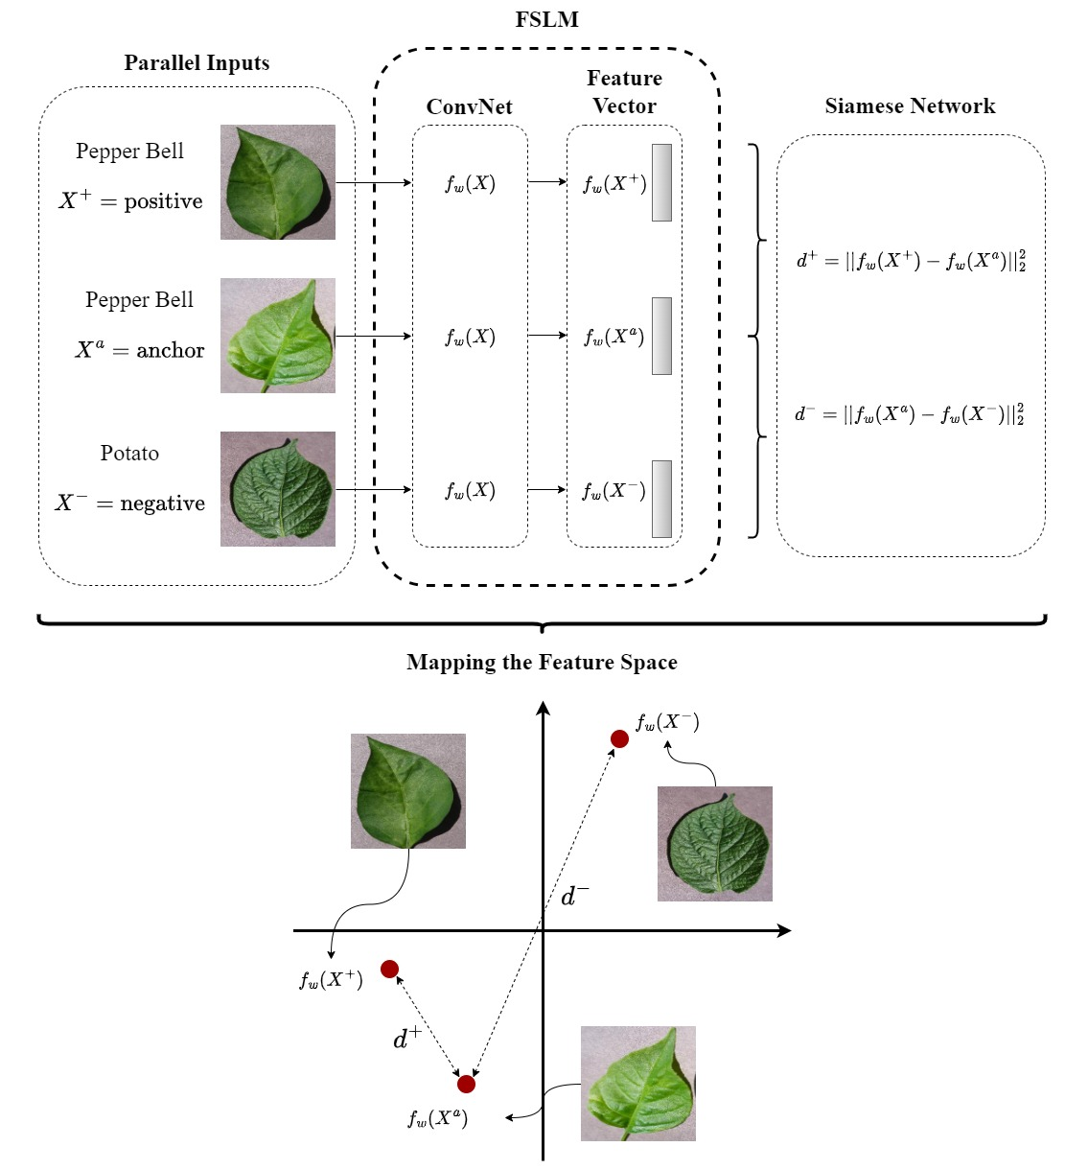The three images $\left(x^{+},x^{a},x^{-}\right)$ are then fed in parallel to the CNN which generates three flattened vectors which make up the input signals to the feature space. The squared *l2* norms are calculated with respect to the anchor image. This is illustrated in Figure 4.2.

Figure 4.2: Calculating the square l2 norm of anchor, positive and negative feature vectors, where $f_{w}(X)$ is the CNN

|  |  |
| --- | --- |
|  | (4.2) |

The variances of each similarity metric plays a vital role in creating separation which will facilitate in the predictive accuracy of the model. With this in mind we need the metric $d^{+}$ (similar class) to have a low variance and $d^{-}$ (dissimilar class) to have a high variance. In order to mathematically engineer a distinctive separation, a hyperparameter is introduced )[18].

* *,* such that $d^{-}$ is persuaded to be larger than $d^{+}$. If $d^{-}$ is greater than $d^{+}$ by a margin of $α_{trip}$, we then believe with a high degree of confidence that the classification is correct. If this is not the case, then the model cannot distinguish the classes and a loss is incurred.
* If a loss does occur, then engineering a small loss (namely by using the max function), will aid in the stability of the convergence and thereby, not simulating large oscillatory swings during convergence.

|  |  |
| --- | --- |
| $$\underset{Triplet Loss}{\underbrace{Loss\left(x^{+},x^{a},x^{-}\right)}}=\max\left\{0, d^{+}+α_{trip} -d^{-}\right\}, s. t. d^{+}+α_{trip} -d^{-} >0$$ | (4.3) |

The triplet loss is based on a triplet of samples $\left(x^{+},x^{a},x^{-}\right)$. Once the loss $\left(L\right)$ has been calculated, the triplet loss gradient[19] is then computed with respect to the MobileNetV2 structural parameters (i.e. weights and biases). Backpropagation of the error signal (or computed gradient), from the output to the input layer occurs in order to determine how each parameter contributed to the loss. The error signal is then integrated into the gradient descent, (Equation (4.4)) which is an updating mechanism for the model’s parameters.

|  |  |
| --- | --- |
| $$θ_{new}← θ_{old}- η\frac{∂L}{∂θ}$$ | (4.4) |

Where:

* $θ$ are the parameters of the network.
* $η$ is the learning rate or step-size.
* $\frac{∂L}{∂θ}=$ computed gradient.

### 4.2.2 Softmax Function & Classifier

To make a distinction between the two competing classes, a binary classifier will be executed. Stage 1 will use a logistic classifier while Stage 2 will employ a Softmax classifier. The mapping of the Softmax function which can be seen in Figure 4.3[20], is considered to be a common activation function. The function operates in a similar manner to the max function, but in some respects less forceful, as the max function maps the largest entry to 1 and the smallest to 0. The Softmax function conversely maps the vectors that are embedded within the feature vector space to a probability distribution. The subtle difference is that the Softmax function promotes the largest vectors and demotes the smallest vectors, and so encourages a wider separation/variance among the input vectors.

* $Φ=\left[ϕ_{1},ϕ_{2}, …,ϕ_{k}\right]∈ R^{k}$ is the k-dimensional input vector.
* $p = normalize\left(\left[e^{ϕ_{1}}, e^{ϕ_{2}}, …,e^{ϕ_{k}}\right]\right)∈R^{k}$, where the Softmax function applies the exponential function to each element of $ϕ$ to obtain *k* positive numbers which are normalized so that it complies with the fundamental axioms of probability.

${\left\{p_{i}\right\}}_{i=1}^{k}>0$

$\sum_{i=1}^{k}{p_{i}=1}$

The classifier resides in the Dense layer containing the Softmax activation function.

|  |  |
| --- | --- |
| $$p_{k×1}=Softmax\left[W_{k×d}∙x_{d×1}+b_{k×1}\right]$$ | (4.5) |

Where:

* $x_{d×1}$ is the input signal (the feature vector that has been flattened).
* $W_{k×d}, b_{k×1}$ are weights and biases respectively.
* $p_{k×1}$ is a probability distribution contained in a vector where *k* denotes the number of classes.

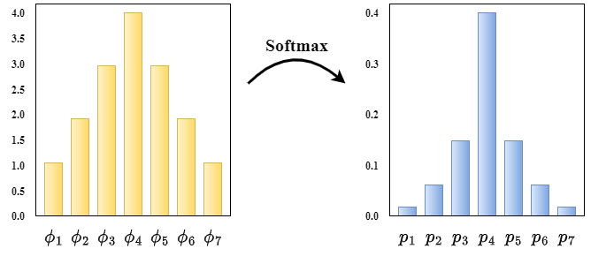These are trainable parameters which are learnt during the training phase.

Figure 4.3: The Softmax function makes the larger entries bigger in the output space and conversely for the smaller entries even smaller, creating a good separation among the various classes, thus making this an ideal classifier for FSL [21]

## 4.3 Hyperparameter Optimization

One of the main focal areas in machine learning when crafting a model to represent the system that it resides in, is to obtain a good generalization error, enabling the model’s performance to be invariant across different naïve datasets, in other words, exhibiting the same distribution, resulting in good predictive qualities. The ‘*Model Optimization Objective*’ highlights the Bayesian optimization search algorithm as the desired technique for obtaining the best combination of hyperparameters. There are several reasons why this is the method of choice:

* The PlantVillage dataset can be considered a real-world dataset that is encapsulated in the Manifold of Interest set (MoI) of images – forming a subset of all captured images (*S*) $→MoI∈S$. MobileNetV2 is primarily designed to cater for low-dimensional data which is ideal for leveraging the MoI, resulting from the innovative assembly of the inverted residual architecture and the depthwise separable convolutions that is encoded in the model.
* Taking the full advantage of MobileNetV2’s low-dimensional preferences, coupled with the improved performances of Bayesian optimization when subjected to low-dimensional response surface environments, the compatibility between these two entities is undeniable. Therefore, MobileNetV2 is the perfect vehicle to harness Bayesian optimization on data that exhibits low-dimensionality (MoI) without incurring costly computational resources while processing hyperparameter-tuning.

Some clarification on the structural differences between hyperparameters and the encoded parameters that are explicitly found within a given model needs to be explained. Parameters are a manifestation from the algorithm during the training phase and is the primary constituent that enables a given model to be a good representation of the dataset. Conversely, hyperparameters cannot be learnt during any phase. The number and the associated arguments that are assigned to each hyperparameter is simply studied during a tuning phase and the results are evaluated. If further improvements can be made, then further adjustments are made to the arguments and the model is re-evaluated. The importance of achieving the optimal permutation of hyperparameters cannot be understated. The model acquires the ability to exert a degree of flexibility to it’s architecture and in doing so obtains a better fit to the data and more critically to new and unseen data.

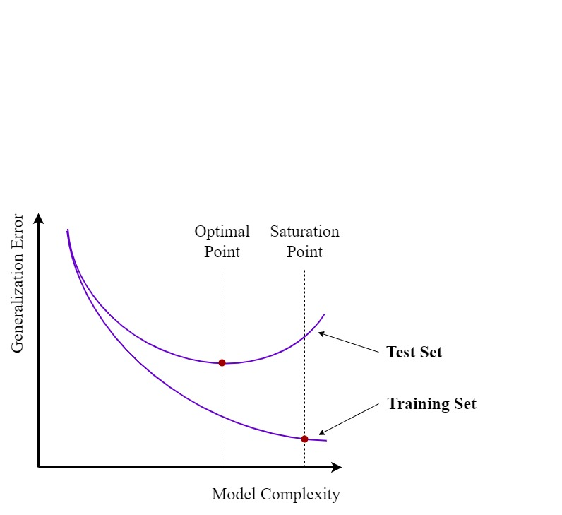When dealing with highly complex algorithms, a key criteria is the computational cost involved in finding the optimal combination of hyperparameters. In order to combat the high resource costs placed on a system, choosing hyperparameters with low-effective dimensions[21] is necessary. If resources were not an issue, then adding more and more features will help the prediction error-rate during the training phase as it will decrease, up to a saturation point. While this sounds great, the underlying effect, is that the model then becomes highly sensitive to the inherent noise within the data, risking the potential of overfitting and this can be seen in Figure 4.4[22]. When the model is subjected to new data, i.e. the test set, the generalization error increases, and the overfitting issues become apparent, ushering in poor predictive qualities.

Figure 4.4: Generalization error -vs- model complexity [22]

All combinations of hyperparameters live within the hyperparameter search space. For a given dataset and a performance metric, the optimal hyperparameter permutation ($λ^{*}$) can be depicted by a hyperparameter response surface, $Ψ\left(λ\right)$, where $λ$ represents the hyperparameter that is being operated on. We want the smallest combination of hyperparameters, resulting in the lowest generalization error and acquiring the maximum amount of accuracy while not incurring an overbearing strain on the available resources, ensures that this is an optimization problem. Depending on the type of performance metrics required, it could be a minimization/maximization problem.

|  |  |
| --- | --- |
| $$λ^{*}=\underset{λ ∈ Λ}{arg max}{Ψ\left(λ\right)}$$ | (4.6) |

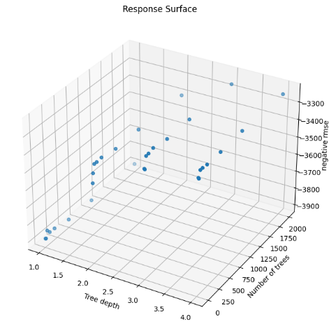The objective function, $Ψ\left(λ\right)$, has no known mathematical structure, as illustrated in Figure 4.5 [23], thereby rendering gradient descent obsolete in obtaining the optimal configuration. Commonly known as a black-box function, there are other techniques that can be employed to obtain the ideal combination. One such technique is Bayesian optimization, which is the method that will be used in this investigation.

Figure 4.5: Hyperparameter response surface is dependent on a dataset, performance metric and an algorithm [23]

### 4.3.1 Bayesian Optimization

To give a brief appraisal of this review [24]: the paper gives a comprehensive in-depth investigation into Bayesian optimization. It is a sequential model-based probabilistic process that uses the Bayes’ rule. This method is an ideal mechanism to use when dealing with expensive-to-evaluate environments, such as neural networks. Bayes’ rule is a mathematical updating machine that links the relationship between a prior (which captures the degree of credibility of the probability distribution) and the posterior, subject to new evidence which is illustrated in Figure 4.6. The advantage of employing such a technique, is that this hyperparameter search algorithm uses all the new evidence through an updating process in order to ascertain the next point to evaluate.

|  |  |
| --- | --- |
|  | (4.7) |

Where:

* $λ$ represents the hyperparameters.
* $D$ represents the dataset.
* The evidence; $P\left(D\right)$ is a normalizing agent and is intractable if the exact probability is not a requirement which essentially reduces the computation.

Bayesian optimization has two major design components encoded within it’s algorithm.

* A prior in the form of a surrogate model – Gaussian process – that encodes our belief with what we hope is the same probability distribution as the hyperparameter response surface. Whether this is the correct hypothesis or not, is not overly important as Bayesian inference searches the space of the hyperparameter response surface. Bayes’ rule is evaluated, conditioned on the data, and the posterior is updated.
* 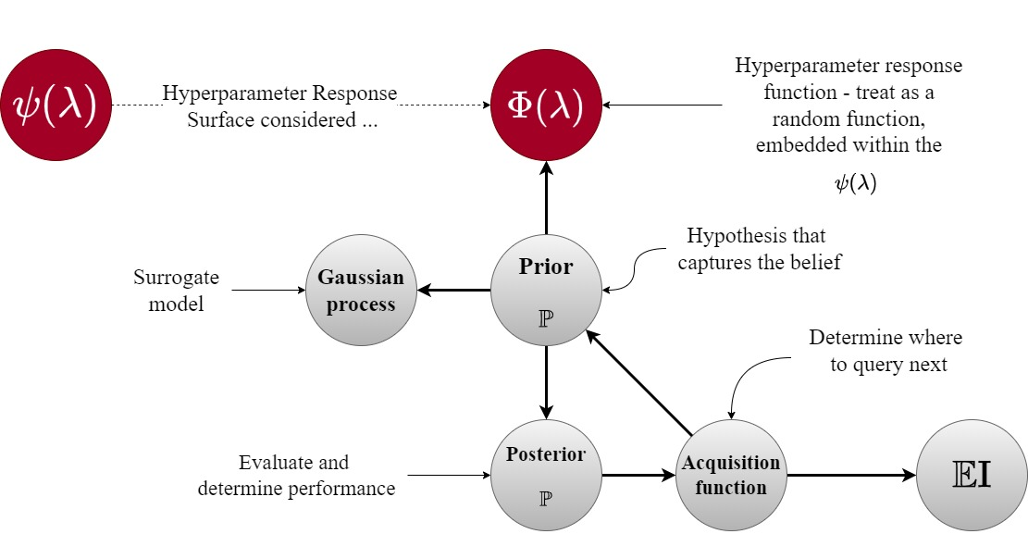An acquisition function is employed to acquire the next sample point. In order to make that selection, it extracts the posterior value and by utilizing one such acquisition method, namely, the Expected Improvement (EI) algorithm through a process of exploration and exploitation, the next point is found.

Figure 4.6: Bayesian optimization algorithm using surrogate and acquisition functions

### 4.3.2 Gaussian Process

Hyperparameter optimization is essentially there to minimize the empirical error [25], [26], by averaging the sum of all the individual errors; for a given hypothesis $h$, and training samples $S={\left\{\left(x_{i},y_{i}\right)\right\}}_{i=1}^{n}$:

|  |  |
| --- | --- |
| $$\hat{E}\left(h\right)=\frac{1}{n}\sum_{i=1}^{n}{1\left\{h\left(x_{i}\right)≠y_{i}\right\}}$$ | (4.8) |

Where:

* $\hat{ε}\left(h\right)$ is the empirical risk for a given hypothesis *h*.
* *n* is the number of samples in the sample set *S*.
* $h\left(x_{i}\right)$ is the estimated prediction of the hypothesis for a given input $x_{i}$.
* $y_{i}$ is the label of the given input $x_{i}$.
* $1\left\{h\left(x_{i}\right)≠y_{i}\right\}$ is the indicator function:
  + If $h\left(x_{i}\right)≠y_{i}$, where the prediction is wrong, then the indicator function equates to 1;
  + Otherwise, 0.

The hyperparameter response surface, $(Ψ\left(λ\right))$, can be thought of as an independent vector-valued random variable (as stated in Figure 4.7). By using the multi-dimensional central limit theorem, the average of $Ψ\left(λ\right)$, will tend towards a multivariate Gaussian distribution. Here lies the problem: multivariate Gaussian distribution assumes a finite number of dimensions, however, the $Ψ\left(λ\right)$ can have, hypothetically speaking, an infinite number of possible dimensions within the hyperparameter space. In order to cater for this apparent misalignment, we can invoke a Gaussian Process (GP) to be our preferred prior, as it assumes that there are infinitely many dimensions. It is therefore fair to suggest that GP’s are the infinite-dimensional counter-part to the multi-dimensional Gaussian distribution.

|  |  |
| --- | --- |
| $$f\left(x\right) \sim GP\left(\overset{mean}{\overbrace{m\left(x\right)}},\underset{Kernel}{\underbrace{K\left(x_{i},x_{j}\right)}}\right)$$ | (4.9) |

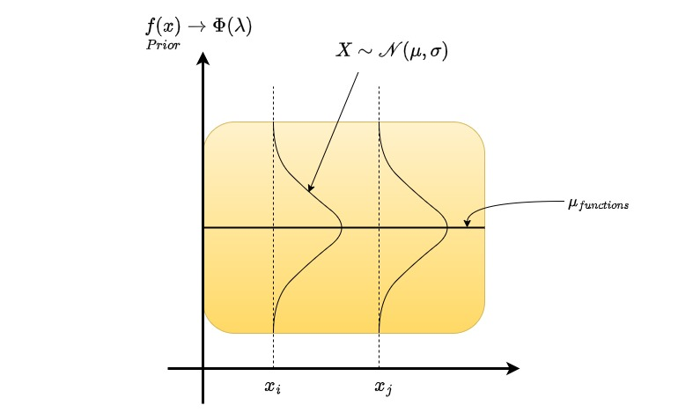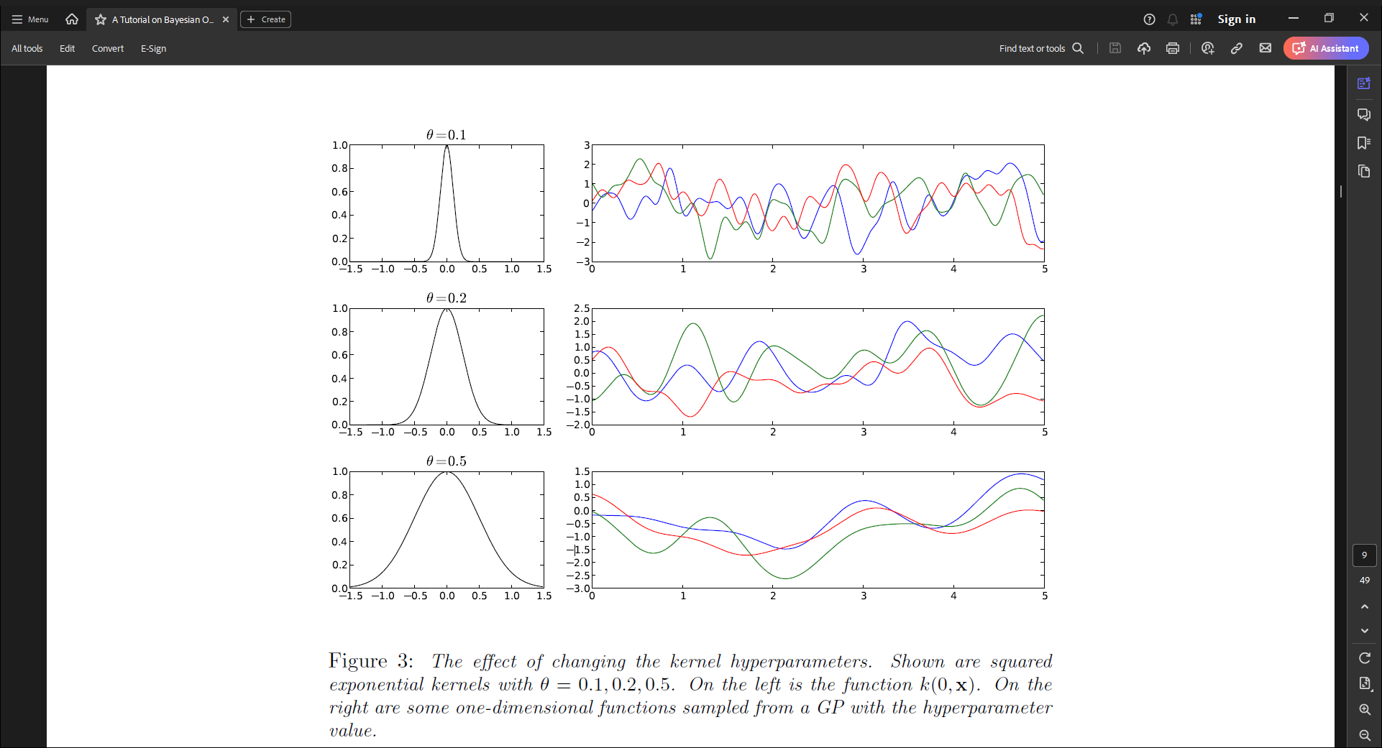where $f\left(x\right)$ is the joint distribution of infinitely many random variables/functions;

Figure 4.8: Gaussian process prior hypothesis’ the hyperparameter response surface, where $x_{i},x_{j}$ are 2 hyperparameters [23]

Figure 4.7: “ The effect of changing the kernel hyperparameters. Shown are squared exponential kernels with $θ= 0.1, 0.2, 0.5$. On the left is the function $K\left(0;x\right)$. On the right are some one-dimensional functions sampled from a GP with the hyperparameter value.” [24]

|  |  |
| --- | --- |
| $$m\left(x\right)=E\left[f\left(x\right)\right]$$ $$K\left(x_{i},x_{j}\right)= E\left[\left(f\left(x_{i}\right)-m\left(x_{i}\right)\right)∙\left(\left(f(x_{j})-m(x_{j}\right)\right)\right]$$ | (4.10) |

The similarity between the inputs $x_{i},x_{j}$ are encoded within the kernel matrix which is essentially a covariance matrix. A crucial property of the kernel is that inputs that are closer to each other within the input space are more correlated than those that aren’t, thereby controlling the smoothness of the Gaussian process which can be seen in Figure 4.7, [24]. By using varying methods to denote the kernel, it can have a considerable impact on the shape of the distribution and could encourage better estimations of $f\left(x\right)$– the joint distribution (Equation (4.9)).

To give a graphical interpretation of how the Gaussian process hypothesis’ the hyperparameter response surface, an abstract illustration is shown in Figure 4.8 [23]. The two most widely used kernels in the context of Bayesian optimization, are Squared Exponential Kernel and Martérn Kernel. For completeness, both have been documented here:

* Squared Exponential Kernel:

|  |  |
| --- | --- |
|  | (4.11) |

Where $\left(α,θ\right)$ are hyperparameters. Some observations that could help steer the direction of estimation: if $\lim_{x_{i} – x_{j} ≈ 0}{ K\left(x_{i},x_{j}\right)→1}$ and if $\lim_{x_{i} –{ x}_{j} ≈ ∞}{ K\left(x_{i},x_{j}\right)→0}$. The smaller $θ$ is the more the Gaussian process will be oscillatory/noisy.

* Martérn Kernel:

|  |  |
| --- | --- |
|  | (4.12) |

Where:

* $Γ\left(∙\right),H_{ξ}$ are the gamma and Bessel (of order $ξ$) functions respectively.
* $ξ$ is a smoothness hyperparameter which operates in a similar fashion to $θ$ for the squared exponential kernel.

### 4.3.3 Acquisition Function

The function’s role is to guide the hyperparameter search space to find the optimal prior; the Gaussian process, $f\left(x\right)$, [26]. This is where the magic of Bayesian optimization is crafted. It extracts the information from the objective function (posterior: $P\left(λ | D\right)$) and optimizes the search for the next sample point by using the predicted mean and the predicted variance. These two values are generated by the Gaussian process. To recap on the overarching goal: the criteria is not to establish a complete understanding of the hyper-dimensional geometrical structure of the hyperparameter response surface, but simply to achieve a global minima/maxima depending on the performance metric that is being investigated. Within the machine learning environments, trade-offs are ubiquitous and here is no exception. If the acquisition function takes high values, it is either close say to a maximum or there is a large amount of uncertainty in the system. This will be highlighted shortly. Thus the trade-off asks the question; does it pursue a regime of exploration (searching within the regions where the level of uncertainty is high) or exploitation (searching within the local neighbourhood)?. By mathematically engineering the algorithm, we have the possibility to manipulate the acquisition function to either steer it towards an aggressive explorative or exploitative narrative or simply to have a balance between both of these competing regimens. This is explicitly done through the introduction of a hyperparameter $ξ_{EI}$.

### 4.3.4 Expected Improvement

There are many different types of acquisition functions that can help in the discovery of the global maximum/minimum locations within the hyperparameter response surface such as Probability of Improvement, Upper Confidence Bound, Thompson Sampling, to name a few. The method of choice is Expected Improvement $\left(E\left(I\right)\right)$ as it is a good general-purpose method, that is robust when dealing with the trade-off between exploration and exploitation.

Let $δ\left(θ\right)=μ\left(θ\right)-f\left(θ^{*}\right)$*,* where $μ\left(θ\right)$ is the current mean of the performance metric $θ$, and $f\left(θ^{*}\right)$ is the current best Gaussian process estimate of the metric.

Note: $f\left(θ\right)\sim N\left(μ\left(θ\right), σ^{2}\left(θ\right)\right)$. Using a reparameterization technique such that $z \sim N\left(0, 1\right)$; the random variable *z*, has a standard normal distribution. The Gaussian probability density function and a standard normal density function for a scalar is:

|  |  |
| --- | --- |
| $$f\left(x\right)= \frac{1}{\sqrt{2π}σ}e^{-\frac{1}{2}∙{\left(\frac{x-μ}{σ}\right)}^{2}}, ϕ\left(z\right)=\frac{1}{\sqrt{2π}}e^{-\frac{1}{2}z^{2}} ⟶ z =\frac{μ-x}{σ}$$ $$∴ z\left(θ\right)=\frac{μ\left(θ\right)- f\left(θ^{*}\right)}{σ\left(θ\right)} →\frac{δ\left(θ\right)}{σ\left(θ\right)}$$ | (4.13) |

Therefore:

|  |  |
| --- | --- |
| $$E\left(I\right)\left(θ\right)=δ\left(θ\right)∙\underset{\begin{aligned}Cumulative \\ Standard \\ Normal\end{aligned}}{\underbrace{Φ\left(\frac{δ\left(θ\right)}{σ\left(θ\right)}\right)}}+σ\left(θ\right)∙\underset{\begin{aligned}Probability Density \\ Function of the \\ Standard Normal\end{aligned}}{\underbrace{ϕ\left(\frac{δ\left(θ\right)}{σ\left(θ\right)}\right)}}$$ | (4.14) |

As previously mentioned, when the $E\left(I\right)$ is high, this could indicate that either the certainty is high, which could indicate an approaching maximum ($μ\left(θ\right)>f\left(θ^{*}\right)$)*,* or that the uncertainty is high, namely the variance is large ($σ\left(θ\right)>1$). This can be seen in the following:

|  |  |
| --- | --- |
| $$\overset{If large…}{\overbrace{E\left(I\right)\left(θ\right)}}=\overset{\begin{aligned}Improvement \\ is high\end{aligned}}{\overbrace{δ\left(θ\right)}}∙\underset{\begin{aligned}Certainty on \\ improvement \\ is high\end{aligned}}{\underbrace{Φ\left(\frac{δ\left(θ\right)}{σ\left(θ\right)}\right)}}+\overset{\begin{aligned}Variance \\ is high\end{aligned}}{\overbrace{σ\left(θ\right)}}∙\underset{\begin{aligned}Uncertainty is \\ high\end{aligned}}{\underbrace{ϕ\left(\frac{δ\left(θ\right)}{σ\left(θ\right)}\right)}}$$ | (4.15) |

In order to massage the expected improvement to steer the system towards one of the desired regimes (such as, exploration, exploitation or simply a balance of both), the hyperparameter $ξ_{EI}$ is introduced.

|  |  |
| --- | --- |
| $$E\left(I\right)\left(θ;ξ_{EI}\right)=\left(δ\left(θ\right)-ξ_{EI}\right)∙Φ\left(\frac{δ\left(θ\right)-ξ_{EI}}{σ\left(θ\right)}\right)+σ\left(θ\right)∙ϕ\left(\frac{δ\left(θ\right)-ξ_{EI}}{σ\left(θ\right)}\right)$$ | (4.16) |

When $ξ_{EI}=0$, we revert back to the original equation. For large $ξ_{EI}$, the hyperparameter encourages the algorithm to think that the current best value is actually bigger than it really is. This inadvertently guides the Bayesian optimization algorithm towards conducting more exploration, than exploitation.

# 5. Implementation

There are two models that will be implemented:

* BLM – Stage 1: This is a MobileNetV2 transfer learning model that will be tuned using a random search. The optimal hyperparameter permutation that is generated will then encoded in the model’s architecture that is introduced in Stage 2.
* FSLM – Stage 2: This will comprise of many interconnected components. It will inherit the hyperparameter values from the previous stage. The training of this model will follow the Siamese Network process using a triplet loss, hyperparameter-tuning using Bayesian optimization, and subsequently tested on naïve data.

All of the outcomes from the literature review will either form the fundamental structure of the FSLM or become recommendations for further studies. This section is concerned with providing a more in-depth discussion on the procedure that will be employed to achieve our objectives.

## 5.1 Data

There has been an exhaustive amount of research conducted on plant disease detection using the dataset: PlantVillage. To recap, the images have been taken in a controlled environment with little to no noise. It is publicly available on Kaggle and spMohanty’s GitHub repo, [6], [27]. The class of plants and the number per class can be seen in Table 5.1.

|  |  |  |
| --- | --- | --- |
|  | **PlantVillage Categories:** | **Number of Images:** |
| 1. | Pepper Bell Bacterial Spot | 997 |
| 2. | Pepper Bell Healthy | 1,478 |
| 3. | Potato Early Blight | 1,000 |
| 4. | Potato Late Blight | 1,000 |
| 5. | Potato Healthy | 152 |
| 6. | Tomato Bacterial Spot | 2,127 |
| 7. | Tomato Early Blight | 1,000 |
| 8. | Tomato Late Blight | 1,909 |
| 9. | Tomato Leaf Mold | 952 |
| 10. | Tomato Septoria Leaf Spot | 1,771 |
| 11. | Tomato Two Spotted Spider Mites | 1,676 |
| 12. | Tomato Target Spot | 1,404 |
| 13. | Tomato Yellow Leaf Curl Virus | 3,209 |
| 14. | Tomato Mosaic Virus | 373 |
| 15. | Tomato Healthy | 1,591 |
|  | Total: | 20,639 |

Table 5.1: Breakdown of the various class categories in the Kaggle dataset [6]

## 5.2 Data Preprocessing & Analytics

Figure 5.2: Graphical representation of the class distribution of the 15 categories from the Kaggle dataset where the green bars represent healthy categories. The Pie chart shows the imbalance between healthy and unhealthy target variables [6]

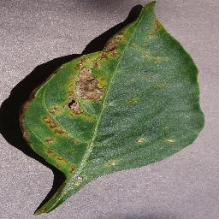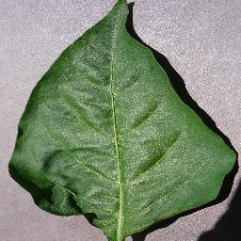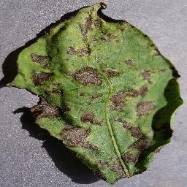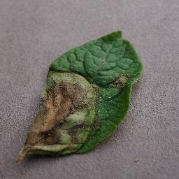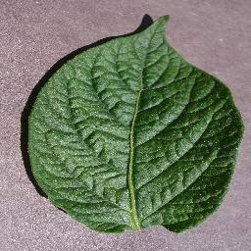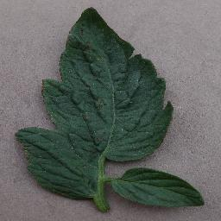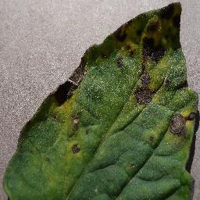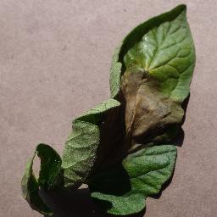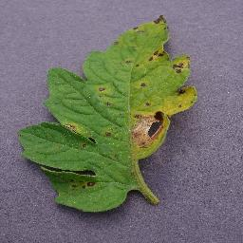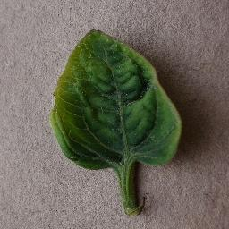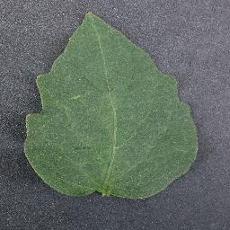

Figure 5.1: The first image of each of the 15 categories from the Kaggle dataset [6]

The data will be divided into two classes; healthy and unhealthy. From Table 5.1, the numerical image count for the binary classes are: 3,221 for healthy and 17,417 for unhealthy – an imbalance of approximately 1:5 which can be clearly seen from the Pie chart in Figure 5.2. The reason for dispensing with the various sub-categories is to make the problem not overtly hard, so as to concentrate on monitoring the various effects of hyperparameter optimization while using a Siamese Network in a FSL paradigm[23]. The BLM and the FSLM are independent from each other, and this is reflected in the datasets that these models will be subjected to as each dataset will be unique. To that end, the binary classes will be split evenly between both stages. From there, the data will be distributed again. The precise distribution is described in detail in Table 5.2. The class distribution among the train, validation and test sets for both stages will be proportional to 7:2:1.

|  |  |  |  |  |  |  |
| --- | --- | --- | --- | --- | --- | --- |
| **Stage/ Model** | **Training Set $$≈70\%$$** | | **Validation Set $$≈20\%$$** | | **Testing set $$≈10\%$$** | |
| **Dataset** | **Analysis** | **Dataset** | **Tuning** | **Dataset** | **Analysis** |
| Stage 1  **BLM** | Healthy: 1,128  Unhealthy: 6,096 | $${MCC}^{++}$$ | Healthy: 322  Unhealthy: 1,742 | Random Search | Healthy: 161  Unhealthy: 871 | $${MCC}^{++}$$ |
| Stage 2  **FSLM** | Healthy: 1,127  Unhealthy: 6,096 | $${Accuracy}^{++}$$ | Healthy: 322  Unhealthy: 1,742  2-way 5-shot  32 Support &  Query Sets[24] | Bayesian Optimization | Healthy: 161  Unhealthy: 870  2-way 5-shot  16 Support & Query Sets[25] |  |

Table 5.2: The structure of the data split into the various constituent parts for the models analysis, where BLM is the baseline model, FSLM is the Few-Shot Learning model, and $∙^{++}$, refers to additional metrics

Each dataset (6 in total) is unique with no overlapping or duplication of images. The training set is approximately 70% of the totals of each binary class, whereas the validation and test sets approximately make-up the remaining 20% and 10% respectively, allowing for a 7:2:1 ratio split. The Stage 2 datasets are structured differently from Stage 1. This is a necessary preprocessing criteria in order to accommodate the architectural requirements of a FSL paradigm.

The following description is an explanation of the calculations made to establish how many support and query sets can be created with their respective allocation of images, in the latter two phases of Stage 2.

* Validation Set:  
  + There are 322 healthy plant images and 1,742 unhealthy plant images. As the designated method is a 2-way 5-shot environment, the minority class becomes the dominant constraint thereby resulting in $\left(\frac{322}{10}≈32\right)$, where the denominator refers to the number of images distributed from each class (e.g. support set having 5 healthy images + query set having 5 healthy images).
  + There will be 32 uniquely created support and query sets, with each set having 5 annotated images from each class. In light of the sampling process, each query set by definition will be unique and will contain 2 stratified classes each having 5 images.
* Test Set:  
  + Using the same method of calculation and arguments from the validation set; there will be $\left(\frac{161}{10}≈16\right)$, thereby resulting in 16 support sets containing annotated images and 16 query sets containing unannotated images. The number of images and uniqueness arguments are again replicated from the validation set.

The selection process for the support set for each class is done randomly without replacement. This ensures that no two support sets will have repeating images. Once a support set has been created, its associated query set is then created by randomly sampling without replacement from the remaining images of the dataset. The ‘*without’* protocol ensures uniqueness across all support/query sets.

More formally:

|  |  |
| --- | --- |
|  | (5.1) |

Where:

* $S_{n}, Q_{n}$ is the *n*th Support set and Query set respectively.
* $X_{i,j}^{n}$ is the *j*th image of the *i*th class, where $i=1,2$.
* $j=1, 2,…, 5$ indexes the images from each class.
* $X_{i,k}^{n}$ is the *k*th image of the *i*th class, where $i=1,2$.
* $k=1, 2,…, 5$ indexes the images from each class.
* $N=\left\{16, 32\right\}$: The values depend on whether the validation or test set is being operated on.

## 5.3 Statistical Metrics

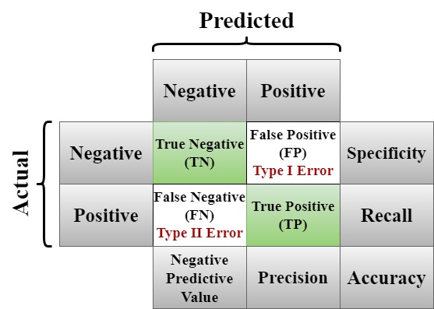Statistics that will be used throughout the analytical process are generated from Figure 5.3 and documented in Equation (5.2).

Figure 5.3: The confusion table and its related metrics

|  |  |
| --- | --- |
| $$Accuracy= \frac{TP+TN}{TP+TN+FP+FN} \\ Matthews Correlation Coefficient= \frac{TP∙TN-FP∙FN}{{\left[\left(TP+FP\right)\left(TP+FN\right)\left(TN+FP\right)\left(TN+FN\right)\right]}^{1/2}} \\ Precision = \frac{TP}{TP + FP} \\ Recall = \frac{TP}{TP + FN} \\ F1 Score= 2∙\frac{Precision ∙Recall}{Precision+Recall}$$ | (5.2) |

* Where TP = True Positive, TN = True Negative, FP = False Positive, FN = False Negative.

## 5.4 Transfer Learning Architecture

The authors of [13] state the architecture of MobileNetV2, which has been graphically presented in Figure 5.4 is as follows:

|  |  |  |  |  |  |
| --- | --- | --- | --- | --- | --- |
| **Input Size** | **Operator** | ***t*** | ***c*** | ***n*** | ***s*** |
| 224x224x3 | Conv2D | - | 32 | 1 | 2 |
| 112x112x32 | Bottleneck | 6 | 16 | 1 | 1 |
| 112x112x16 | Bottleneck | 6 | 24 | 2 | 2 |
| 56x56x24 | Bottleneck | 6 | 32 | 3 | 2 |
| 28x28x32 | Bottleneck | 6 | 64 | 4 | 2 |
| 14x14x64 | Bottleneck | 6 | 96 | 3 | 1 |
| 14x14x96 | Bottleneck | 6 | 160 | 3 | 2 |
| 7x7x160 | Bottleneck | 6 | 320 | 1 | 1 |
| 7x7x320 | Conv2D 1x1 | - | 1280 | 1 | 1 |
| 7x7x1280 | Avg Pooling 7x7 | - | - | 1 | - |
| 1x1x1280 | Conv2D 1x1 | - | k | - | - |

Table 5.3: The MobileNetV2 architecture. “The expansion factor t is always applied to the input size. All spatial convolutions use a 3x3 kernel” [13]

* *t* is the expansion factor. This parameter expands the number of channels.
* The number of channels is denoted by *c*.
* *n* indicates how many times the layer is repeated.
* *s* is the stride of the given block.
* The final layer Conv2D 1x1 is a Dense layer (fully connected) which increases the depth of the channels to 1280, and *k* is the number of categories that are required for classification, which in this case is 2.

## 5.5 Code Implementation

### 5.5.1 Stage 1 - BLM

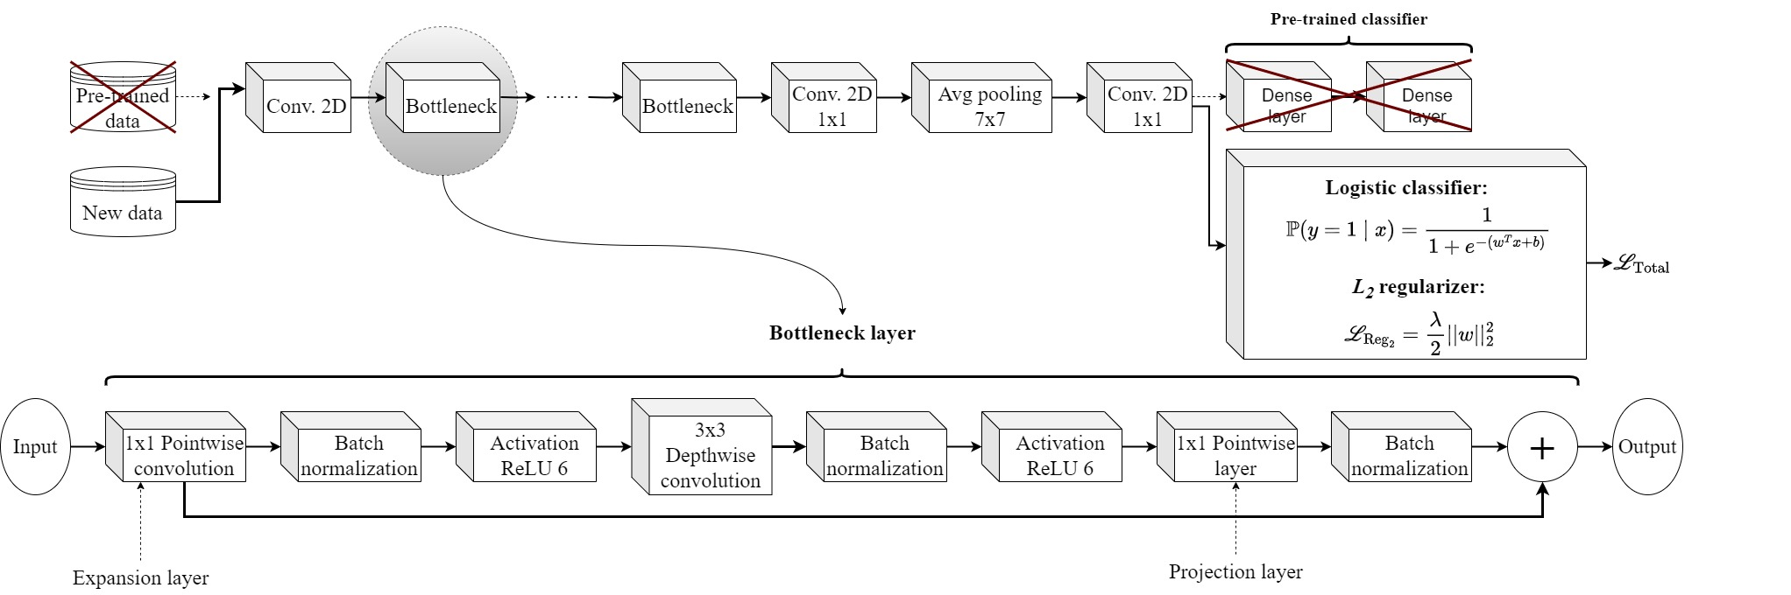

Figure 5.4 MobileNetV2 is used as a feature extractor using a Logistic classifier where the threshold is set to $P(y=1 | x)>0.3$ and an $L_{2}$ regularizer bolted onto the binary cross-entropy loss function. This is the baseline model (BLM)

The BLM is a transfer learning algorithm with a Logistic Classifier (Equation (5.3)), and this is illustrated in Figure 5.4. The Logistic classifier will be built into the binary cross-entropy loss function $\left(L_{BCE}\right)$. An $L_{2}$ regularizer will be attached to the loss function which will mitigate any overfitting issues as it penalizes large weights. The $λ$ regularization parameter will not be altered from it’s default value of 1.

A noteworthy point to mention: the model will need to perform well with the Recall metric. This is a prominent indicator when dealing with disease detection. A common technique to improve Recall is to lower the threshold of the Logistic classifier from the default value of 0.5 to 0.3 which was alluded to in Figure 5.4, thereby encouraging more positive classifications (unhealthy plants). However, this may reduce Precision which is tantamount to saying that the reduction is highly dependent on the cost of false positives versus false negatives.

The binary cross-entropy loss function notably aids in the minimization of the difference between the predicted $i^{th}$ probability ($P_{i})$ and the true $i^{th}$ label (where $y_{i}∈\left\{0,1\right\}$ are the binary targets). For *N* samples, with targets $y_{i}$ and an $L_{2}$ regularizer, the binary cross-entropy loss function is defined as:

|  |  |
| --- | --- |
|  | (5.3) |

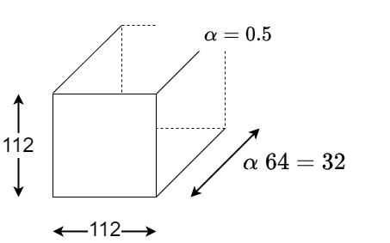One of the most influential hyperparameters that will be tuned is the width multiplier. The width multiplier was implemented in MobileNetV1 [10] and has been made an integral part of the architectural make-up of MobileNetV2. It is a significant hyperparameter that shrinks the number of kernels used within the convolutional layers, effectively reducing the number of outputs; an example has been illustrated in Figure 5.5.

Figure 5.5: Example of using a width multiplier hyperparameter $(α)$ which was introduced in MobileNetV1. It efficiently reduces the number of outputs [10]

By manipulating the width multiplier hyperparameter, a considerable amount of resource saving can occur, thereby reducing the strain on IoT platforms. To mathematically illustrate this, let’s assume that $X_{V1}$ is the standard MobileNetV1 model and $X_{V1}^{α}$ is the modified version using the width multiplier.

|  |  |
| --- | --- |
| $$X_{V1}= \underset{Depthwise Conv.}{\underbrace{D_{k}^{2}×M×D_{F}^{2}}}+\underset{Pointwise Conv.}{\underbrace{M ×N×D_{F}^{2}}} \\ X_{V1}^{α}= D_{k}^{2}×αM×D_{F}^{2}+αM ×αN×D_{F}^{2}$$ | (5.4) |
| $$\frac{X_{V1}}{X_{V1}^{α}}= \frac{D_{k}^{2}×M×D_{F}^{2}+M ×N×D_{F}^{2}}{D_{k}^{2}×αM×D_{F}^{2}+αM ×αN×D_{F}^{2}} \\ = \frac{N\left(\frac{D_{k}^{2}}{N}+1\right)}{N\left(\frac{αD_{k}^{2}}{N}+α^{2}\right)}$$ | (5.5) |

Assuming that in the limit the two conditions hold true:

|  |  |  |
| --- | --- | --- |
| $$\lim_{N⟶∞}{\frac{D_{k}^{2}}{N}=0}$$ | $$\lim_{N⟶∞}{\frac{αD_{k}^{2}}{N}=0}$$ | (5.6) |

As *N* tends to infinity (Equation (5.6)), the result (Equation (5.5)) becomes Equation (5.7):

|  |  |
| --- | --- |
| $$\frac{X_{V1}}{X_{V1}^{α}}≈ \frac{1}{α^{2}} ⟹ X_{V1}^{α}≈α^{2}X_{V1}$$ | (5.7) |

Where:

* The input spatial dimensions are $D_{F}×D_{F}=D_{F}^{2}$.
* The kernel spatial dimensions are $D_{k}×D_{k}=D_{k}^{2}$.
* $M$ is the number of input channels.
* $N$ is the total number of kernels.

The result shows a sizable reduction in computational cost, namely, $α^{2}$. For example, let $α=0.5$. The computational cost saving is approximately 25% of what the standard model $\left(α=1\right)$ would require. The predefined values of $α=\left\{0.35, 0.5, 0.75, 1.0\right\}$, will be incorporated in conjunction with other prominent hyperparameters in the random search as illustrated in Table 5.4. Once the optimal hyperparameter permutation is acquired, these will progress to become part of the architectural make-up of the FSLM.

|  |  |  |
| --- | --- | --- |
| **Hyperparameter** | **Description** | **Range** |
| Width Multiplier | Reduces the number of kernels used in the convolutional layer | $$α∈\left\{0.35, 0.5, 0.75, 1.0\right\}$$ |
| Learning Rate | Determines the step-size of each iteration. Smaller step-sizes may help in the prevention of overshooting especially within FSL environments | $$η∈\left\{{10}^{-4}, {10}^{-5},{10}^{-6}\right\}$$ |
| Dropout Rate | This regularization parameter randomly selects neurons to be dropped, thereby aiding in the prevention of overfitting | 0.1, 0.3, 0.5 |

Table 5.4: Key hyperparameters that will be investigated during Stage 1 using a random search algorithm

### 5.5.2 Stage 2 - FSLM

This stage is concerned with developing the FSL paradigm with the MobileNetV2; the transfer learning model. The construction of the validation and test sets will be in accordance with the discussion in section ‘*5.2 Data Preprocessing & Analytics*’ and has been detailed explicitly in Table 5.2.

**Training Phase:**

The CNN in Figure 5.6 is a new representation of the transfer learning model – MobileNetV2. Note that the single ConvNet shares its weights across all three inputs or branches ($X^{a}, X^{+}, X^{-}$) and is simply one network that is applied to each branch. It will incorporate the three optimal generated hyperparameters from Stage 1 and will be trained by implementing a Siamese Network with a triplet loss function. In order to minimize the learning loss metric (Equation (5.8)), the shared weights of the ConvNet $\left(f_{w}(X)\right)$ which is a single CNN, is optimized by a backpropagation process (Equation (5.9)), where the structural parameters are updated using gradient descent (Equation (5.10)).

There are three images: $X^{a}=Anchor, X^{+}= Positive$, both representing images from the same class and $X^{-}=Negative$, representing an image from a different class. All images are randomly chosen from their respective categories.

|  |  |
| --- | --- |
|  | (5.8) |

Where:

* $d^{+}$ is the square *l2* norm of the feature vector of $X^{+}$ and $X^{a}$.
* $d^{-}$ is the squared *l2* norm of the feature vector $X^{a}$ and $X^{-}$.
* $α_{trip}$ is a tuneable hyperparameter that encourages the separation of the feature vectors in the feature space.

$α_{trip}$ ensures a minimum distance difference between $d^{+},d^{-}$. A small margin may not create enough variance, while too large and it could lead to too many triplet errors, causing training instability. For simplicity let $α_{trip}=0.2$, as demonstrated by the authors of [28] whom decided on this value from experimental performance.

Backpropagation: For a non-zero loss (active hinge[26]), the gradients with respect to the $l_{2}$ norms are as follows:

|  |  |  |  |
| --- | --- | --- | --- |
| * Anchor: | $$\frac{∂L}{∂f_{w}\left(X^{a}\right)}=2\left[\left(f_{w}\left(X^{a}\right)-f_{w}\left(X^{+}\right)\right)-\left(f_{w}\left(X^{a}\right)-f_{w}\left(X^{-}\right)\right)\right]$$ | | (5.9) |
| * Positive: | $$\frac{∂L}{∂f_{w}\left(X^{+}\right)}=-2\left[f_{w}\left(X^{a}\right)-f_{w}\left(X^{+}\right)\right]$$ | |
| * Negative: | $$\frac{∂L}{∂f_{w}\left(X^{-}\right)}=-2\left[f_{w}\left(X^{a}\right)-f_{w}\left(X^{-}\right)\right]=-2\left[f_{w}\left(X^{a}\right)-f_{w}\left(X^{-}\right)\right]$$ | |
| * These partial derivatives are computed using the chain rule with respect to the structural network parameters ($θ)$: | | $$\frac{∂L}{∂θ}=\frac{∂L}{∂f_{w}\left(X\right)}∙\frac{∂f_{w}\left(X\right)}{∂θ}$$ |

Gradient Descent: Using the computed gradient, the structural parameters are updated with a learning rate $\left(η\right)$:

|  |  |
| --- | --- |
| $$θ_{new}← θ_{old}- η\frac{∂L}{∂θ}$$ | (5.10) |

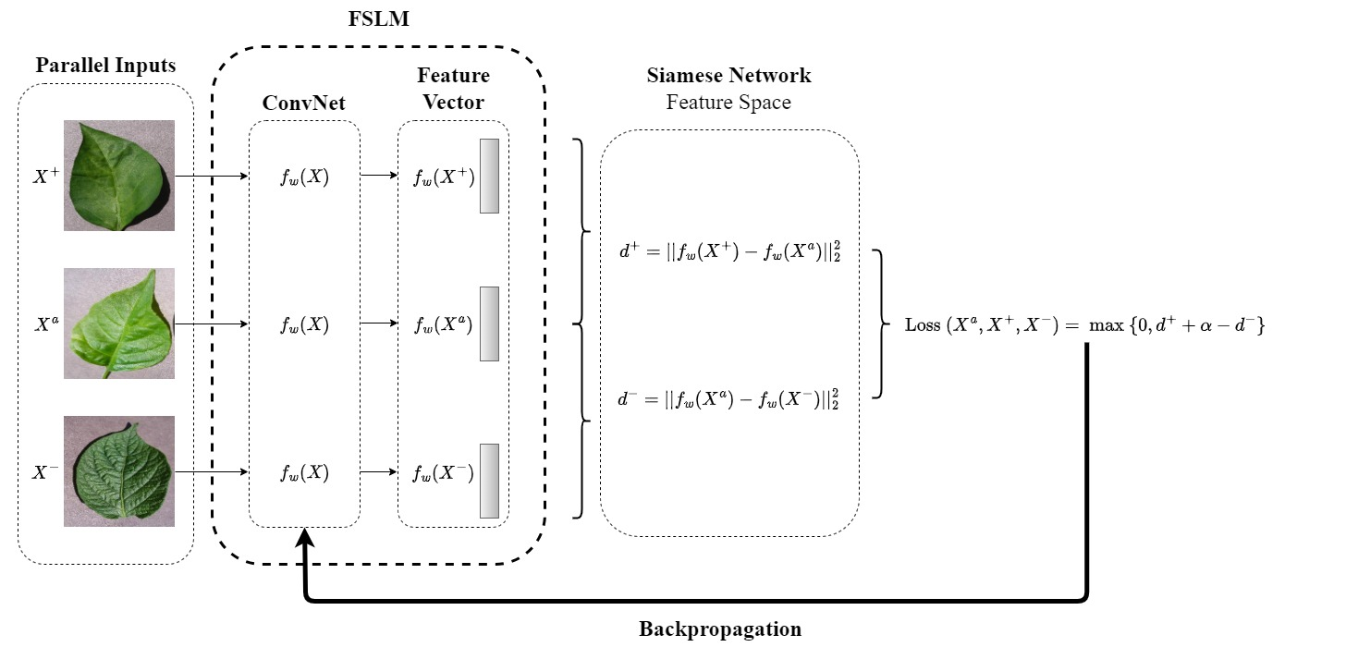**Hyperparameter-Tuning Phase:**

Figure 5.6: Siamese Network implementing triplet loss

Once the FSLM has been trained on the Siamese Network, the model will need to be tuned on the validation set. The hyperparameters that will be investigated are described in Table 5.5. The validation set is restructured to align with the FSL and the 2-way 5-shot environment. There will be 32 unique support sets and their associated query sets. The support/query sets will contain 5 images from both the binary classes.

The hyperparameter-tuning has a Softmax classifier applied to the binary cross-entropy loss function, and a Shannon regularizer attachment. The composition of the loss function is described here:

* $X∈R^{N×d}→X$ is the *d*-dimensional data matrix containing *N* samples.
* $W∈R^{C×d}→W$ is the *d*-dimensional weight matrix and *C* is the number of classes; binary classification: $C=2$.
* $b∈R^{C}→b$ is the bias vector.
* $1_{N}$ is an *N*-dimensional column of vector of ones, thereby ensuring *b* to be broadcast across samples.

Softmax Function:

|  |  |
| --- | --- |
| $$Φ=XW^{T}+ 1_{N}b \\ Softmax Function: P_{ij}=\frac{e^{Φ_{ij}}}{\sum_{k=1}^{2}{e^{Φ_{ik}}}}$$ | (5.11) |

* For $i=1,…, N, where i is the sample and j=\left\{1, C\right\}$, such that $C=2$.

Binary Cross-Entropy (BCE) Loss:

|  |  |
| --- | --- |
| $$L_{BCE}\left(W,b\right)= -\frac{1}{N}\sum_{i=1}^{N}{\sum_{j=1}^{C}{Y_{ij}log\left(P_{ij}\right)}}$$ | (5.12) |

* For $Y∈{\left\{0,1\right\}}^{N×C}$ is the one-hot encoded label matrix.

Shannon Regularizer:

|  |  |
| --- | --- |
| $$H\left(P_{i,∙}\right)=-\sum_{j=1}^{C}{P_{ij}log\left(P_{ij}\right)} \\ L_{reg}\left(W,b\right)=λ_{Shan}\frac{1}{N}\sum_{i=1}^{N}{\sum_{j=1}^{C}{P_{ij}log\left(P_{ij}\right)}}$$ | (5.13) |

In order to aid in achieving a low-effective dimensional feature space and to guide the learning process to a steady convergence, a Shannon regularizer $\left(λ_{Shan}\right)$ is added to the loss function $\left(L_{reg}\left(W,b\right)\right)$. It effectively is a mechanism that encourages maximum/minimum entropy and therefore controls the predictions.

* Maximum entropy → promotes exploration.
  + $λ_{Shan}>0→$ Steers the system to allowing more diversity within the space of predictions.
* Minimum entropy → promotes exploitation.
  + $λ_{Shan}<0→$ Steers the system to encourage more precision within a more localized range of predictions.

|  |  |
| --- | --- |
| $$L_{total}\left(W,b\right)={L_{BCE}\left(W,b\right)+L}_{reg}\left(W,b\right) \\ L_{total}\left(W,b\right)=-\frac{1}{N}\sum_{i=1}^{N}{\sum_{j=1}^{C}{Y_{ij}log\left(\frac{e^{Φ_{ij}}}{\sum_{k=1}^{2}{e^{Φ_{ik}}}}\right)}}+λ_{Shan}\frac{1}{N}\sum_{i=1}^{N}{\sum_{j=1}^{C}{\frac{e^{Φ_{ij}}}{\sum_{k=1}^{2}{e^{Φ_{ik}}}}log\left(\frac{e^{Φ_{ij}}}{\sum_{k=1}^{2}{e^{Φ_{ik}}}}\right)}}$$ | (5.14) |

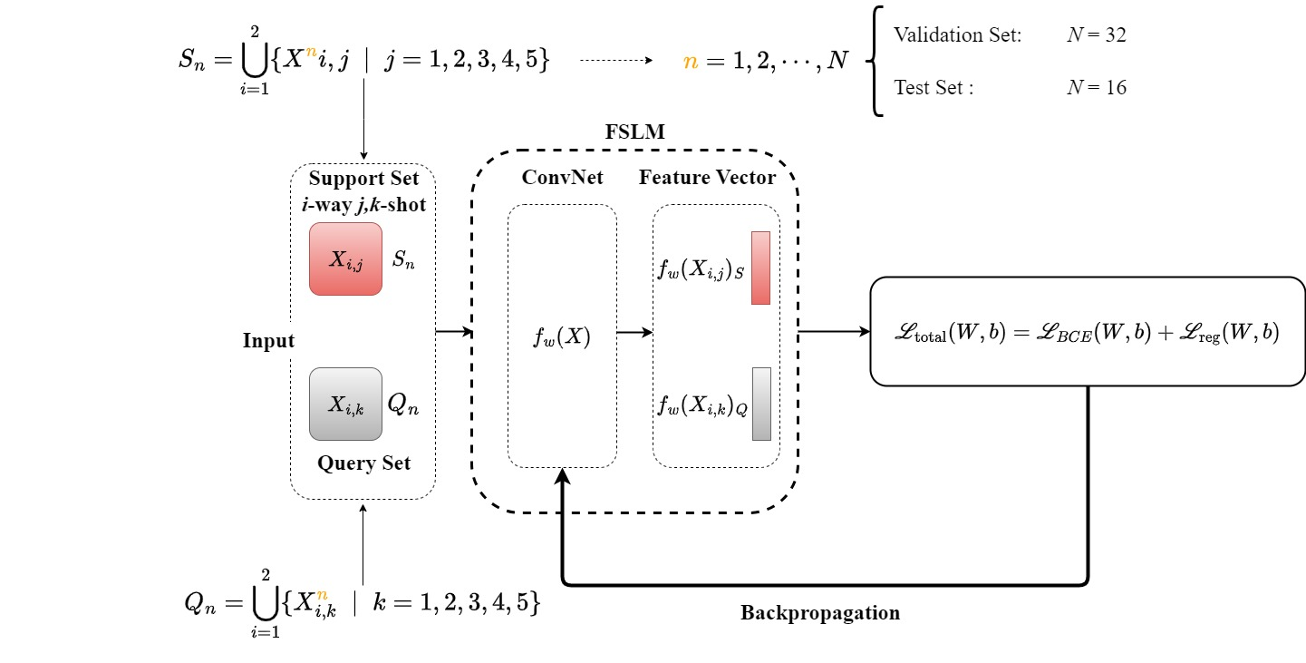Total Loss Function:

Figure 5.7: Hyperparameter-tuning utilizing the binary cross-entropy loss function which incorporates the Softmax classifier plus a Shannon regularizer

|  |  |  |
| --- | --- | --- |
| **Hyperparameter** | **Description** | **Range** |
| Shannon Regularizer | Encourages either more diversification or precision within the space of predictions.[27] |  |
| Martérn Kernel $k\left(x_{i},x_{j}\right)$ | Gaussian Process (GP): $$f\left(x\right) \sim GP\left(m\left(x\right),k\left(x_{i},x_{j}\right)\right)$$ To provide a balance of smoothness and a degree of flexibility. | $$ξ∈\left\{\frac{3}{2},\frac{5}{2}\right\}$$ |
| Expected Improvement | The acquisition function, $E\left(I\right)\left(θ;ξ_{EI}\right)$ decides where the next point of investigation will take place, whether it be exploitation or exploration. The set exhibits a range of values that investigate both exploration and exploitation regimes.[28] |  |

Table 5.5: Key hyperparameters that will be investigated

**Testing Phase:**

The testing phase simply runs inference and computes key metrics. The Query set depicted in Figure 5.7, is now unlabelled. It will be compared to each of the associated Support sets. A prediction is made by mapping it through the binary cross-entropy loss function (5.12) which incorporates a Softmax classifier (Equation (5.11)) and Shannon regularizer (Equation (5.13)).

The test set is restructured to align with the FSL and the 2-way 5-shot environment in the same manner that was conducted for the validation set. There will be 16 unique support sets together with their associated query sets. The support/query sets will contain 5 images from both the binary classes. The images in the support sets will be annotated while the query sets will no longer be labelled. The metrics that will be used to make inferences are: Accuracy, Precision, Recall and F1-Score. Accuracy is now the preferred metric over MCC, as the FSL environment negates any imbalances within the data.

# 6. Execution & Results. Stage 1 - BLM

The project comprises two stages with each stage developing it’s own model that is independent[29] from the other with clear and definitive objectives.

* Stage 1 develops the Baseline model (BLM). It’s goal is to establish a set of optimal hyperparameters[30] given the data (which is achieved using a custom encoded random search algorithm) that will migrate to the next stage. These optimal hyperparameters will be mapped from the outset in Stage 2.
* Stage 2 develops the Few-Shot Learning model (FSLM) by creating a lightweight model while initiating the FSL paradigm. It is hoped that by employing a Bayesian optimization algorithm during the tuning process, the model can achieve good predictive accuracy.

The BLM was effectively an exploratory model for investigating various hyperparameters using random search. It implements a transfer learning pipeline using MobileNetV2 which includes the following:

* Data augmentation.
* Developing a custom Matthews Correlation Coefficient (MCC) metric to cater for the distinct imbalance between the binary classes.
* Tuning hyperparameters using random search.
* Logistic classification algorithm using a lower threshold of 0.3, in an attempt to improve the Recall metric which is one of the key markers in disease detection.
* Attaching a $L_{2}$ regularizer to the binary cross-entropy loss function in order to combat overfitting issues.
* Callback system to monitor global validation metrics and test loss per epoch.
* Plotting of the loss curves.
* Evaluation through comparisons of the training, validation and test metrics.

## 6.1 Data Investigation & Preprocessing

Several processes were undertaken to establish a deeper understanding of the structure and content of the PlantVillage dataset. The following steps were conducted:

* File extension investigation was conducted in order to highlight any discrepancies among the images. All the images had *‘_.jpg’* extensions with the exception of two images that had *‘_.png’* and *‘_.jpeg’*.
* By observing Figure 6.1, it was clear how the data was structured and the inherent imbalance that lies between the binary classes, contained in the 15 categories.
* 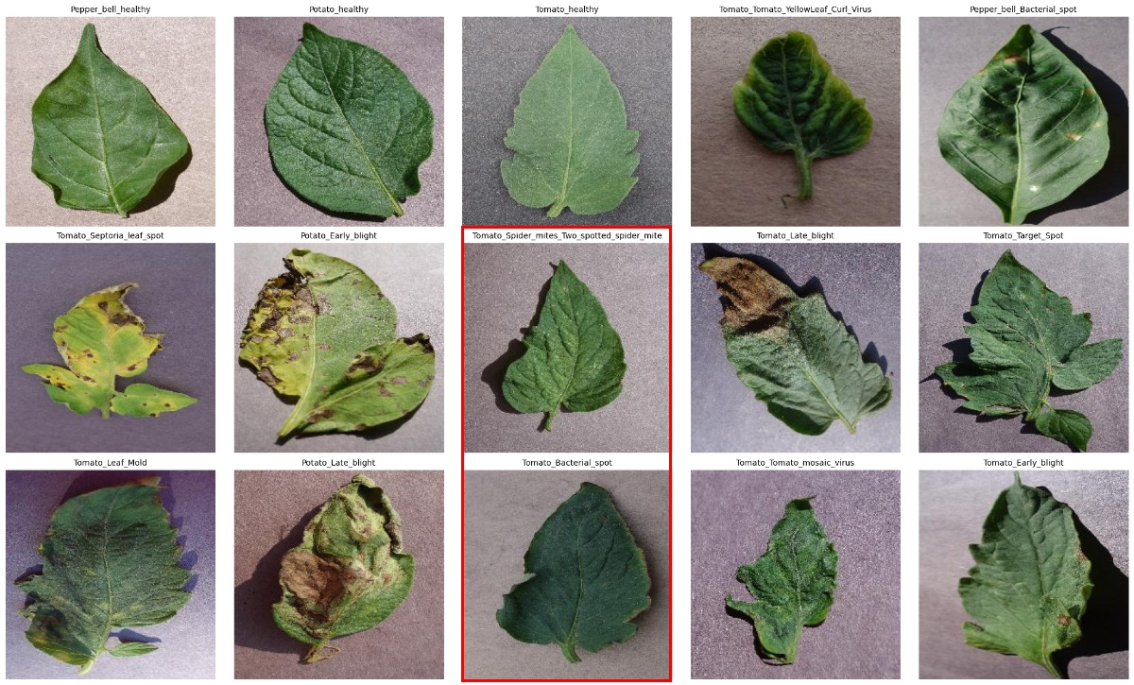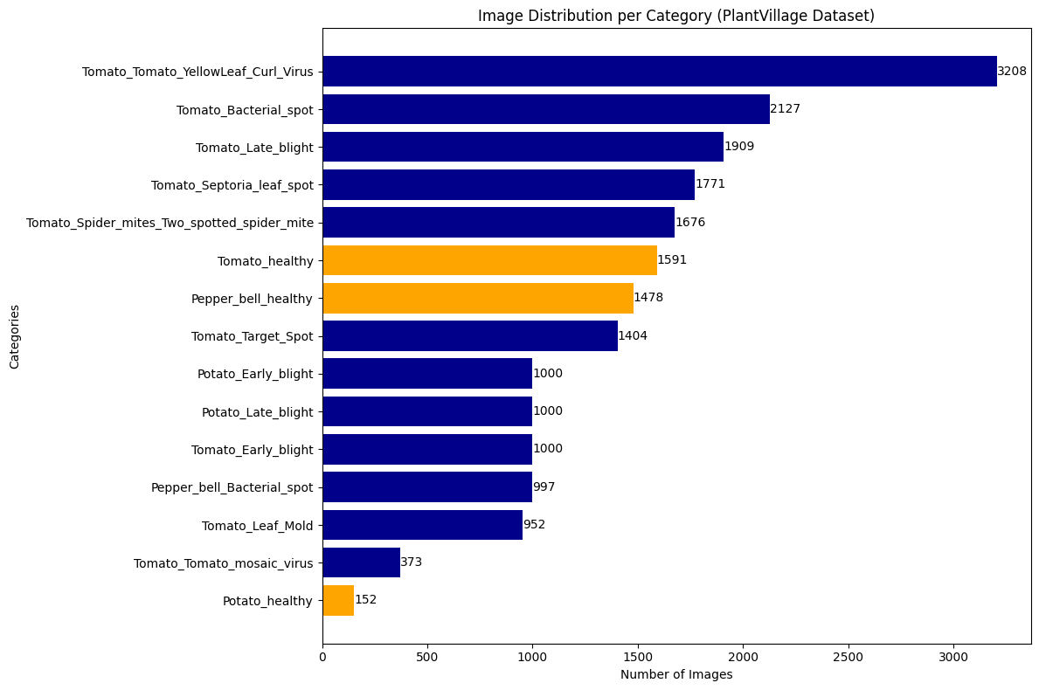One image from each category was randomly selected (Figure 6.2). The healthy images (the first three in row 1) are clearly healthy. The remaining are unhealthy, however, it is indistinguishable whether the images of ‘*Tomato Bacterial Spot*’ and ‘*Tomato Spider mite two spotted spider mite*’ (highlighted by a red box) are unhealthy. This is a noteworthy point of the challenges that is present when classifying plant leaves.

Figure 6.2: One image from each category randomly selected. The red highlighted images are unhealthy plant leaves that could be mistaken for healthy plants

Figure 6.1: The various plant categories in the PlantVillage dataset with their respective image counts in descending order. The unhealthy categories are in blue while the healthy categories are in orange

* The 15 categories were redistributed into either the healthy or unhealthy binary categories in preparation for further splitting. Summary statistics were generated (Table 6.1) together with an accompany visual (Figure 6.3).

|  |  |  |
| --- | --- | --- |
| **Category** | **Frequency** | **Percentage (%)** |
| Healthy | 3,221 | 15.61 |
| Unhealthy | 17,417 | 84.39 |
| Total: | 20,638 | 100.00 |

Table 6.1: Summary statistics for the redistributed data

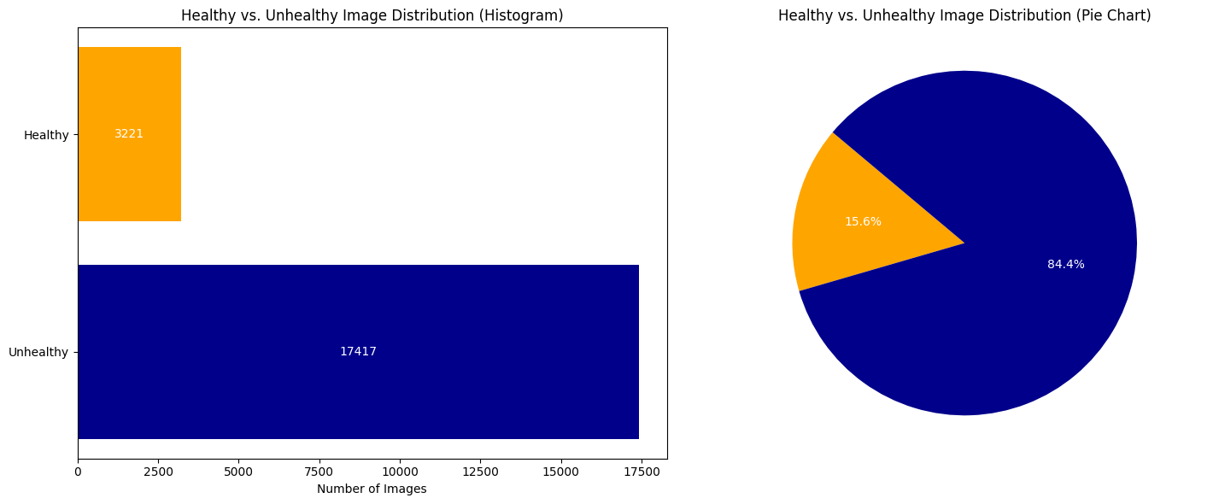The redistribution (Figure 6.3) depicts another indication of the imbalance in the data, and the proportions between the binary classes, are explicitly highlighted in the pie chart.

Figure 6.3: The redistribution of data into the binary classes. The pie chart shows the level of imbalance contained in the PlantVillage dataset

* The categorical classes were subdivided into their respective datasets, namely, train_1, valid_1, test_1, train_2, valid_2 and test_2 where the numerical suffix denotes which stage the dataset resides in. Essentially, the data was divided into two equal parts and then distributed using the 7:2:1 ratio.

The images were randomly selected from each class with no replacement, thus ensuring zero duplication and uniqueness among the datasets. The summary statistics (Table 6.2) and the accompanying visual (Figure 6.4) shows the number of images that are contained in each dataset.

|  |  |  |  |  |
| --- | --- | --- | --- | --- |
| **Stage** | **Dataset** | **Healthy** | **Unhealthy** | **Total** |
| 1 | train_1 | 1,127 | 6,095 | 7,222 |
| valid_1 | 322 | 1,741 | 2,063 |
| test_1 | 161 | 870 | 1,031 |
| 2 | train_2 | 1,127 | 6,095 | 7,222 |
| valid_2 | 322 | 1,741 | 2,063 |
| test_2 | 162 | 875 | 1,037 |

Table 6.2: Summary statistics of the 7:2:1 ratio distribution of the two classes between the two stages

## A graph of different colored bars6.2 Developing the BLM

Figure 6.4: The distribution of images per class for Stage 1 and 2 among the training, validation and testing datasets

A detailed description of the methods that were employed to create, train, hyperparameter-tune and eventually test the model is given:

* **Transfer Learning:**   
  The architecture of MobileNetV2 is considered to be lightweight and efficient making it an ideal choice to operate on platforms with low computational resources.
* **Data Preparation:**   
  ImageDataGenerator: From the Keras library, this class is applied to facilitate data augmentation during the training process only. The image transformations (rotation, shifting, zooming and horizontal flipping) are designed to improve generalization as well as reducing overfitting. However, with regard to the validation and test sets, no image transformations were implemented. Only rescaling is initiated, thus leading to an unbiased evaluation.  
    
  Directory Structure: Each folder; train_1, valid_1, test_1 possess two further binary class subfolders. The images for each target variable are contained in each subfolder which is a requirement from the generators, thus enabling Keras to map them to their respective binary labels; {0, 1}.
* **Callbacks:**  
  Global Validation Metrics: The metrics are not calculated per batch, instead, the aggregate predictions are taken over the whole validation set (i.e. at the end of every epoch) and computed. This is expressed in a confusion matrix and is accompanied by the Accuracy, Precision, Recall, F1-Score and MCC metrics. The results are a reflection of a lower threshold (0.3) for classification, aiming to improve the Recall metric.  
    
  Test Loss: A test loss is recorded at the end of every epoch, thus enabling a direct comparison to be made with the training, validation and test loss curves.
* **Hyperparameter Random Search:**   
  Scikit-Learn's ‘*off-the-shelf*’ class RandomSearchCV was deemed to be too inflexible. It was decided to build a custom random search loop, thereby giving more control on the training process, logging and initiating custom callbacks. Furthermore, when dealing with deep learning models (as with the case of MobileNetV2), using a batch-wise metric tends to be somewhat misleading and overall less informative. The solution was to create global validation metrics which was previously discussed. The hyperparameters that were investigated are:

|  |  |  |
| --- | --- | --- |
| Width Multiplier: $α$ | Learning Rate: $η$ | Dropout: $P$ |
| {0.35, 0.5, 0.75, 1.0} | {1e-4, 1e-5, 1e-6} | {0.1, 0.3, 0.5} |

For each trial, the best global validation MCC was recorded. From the 10 trials, the one with the highest performance - measured by the MCC metric - was classified as being the ‘*best model*’.

* **Improving Generalization:**  
  The $L_{2}$ regularizer is executed in the final Dense layer. It is tasked with penalizing large weights which tends to reduce overfitting from over zealous features. As previously mentioned, the classification threshold had been lowered from 0.5 to 0.3. It was purely an attempt to improve the Recall metric on the minority class - healthy. Note that in disease detection environments, Recall is the metric that carries more weight, and that normally the minority class is the unhealthy images, making this situation an exception to the norm.
* **Visualization:**The loss curves from the training, validation and test results will give some indication of the convergence and overfitting. This aids in assessing the validity of the results and together with the confusion matrices, a more granular understanding of class-specific performance was acquired – a vital element in assessing binary classification with imbalanced data.
* **Evaluation:**  
  Global Metrics Comparison: A helper function was defined to calculate the global metrics on the three datasets and then tabulated together with their associated confusion matrices. The recording of these metrics were not done on batch-level as previously mentioned, as the information would be too noisy, and somewhat limiting. Instead, the global metrics were aggregated at the end of each epoch, thereby giving a more accurate snapshot of the model’s performance which lends itself to imbalance classification environments.  
    
  Final Test Evaluation: The *‘best model’* is subsequently applied on the test set, ensuring an unbiased evaluation.

## 6.3 Generated Results

No analysis will be performed in this section. This is simply a reporting of the results from the BLM’s exposure to the datasets. The analysis will take place in section ‘*7. Analysis. Stage 1*’.

|  |  |  |  |  |
| --- | --- | --- | --- | --- |
| **Trial** | **Hyperparameter** | | | **Metric** |
| **Width Multiplier** | **Learning Rate** | **Dropout** | **MCC** |
| 2 | 0.50 | 0.000100 | 0.3 | 0.994475 |
| 6 | 0.75 | 0.000100 | 0.1 | 0.987242 |
| 3 | 0.35 | 0.000010 | 0.3 | 0.920579 |
| 1 | 0.75 | 0.000001 | 0.1 | 0.915772 |
| 8 | 0.75 | 0.000001 | 0.3 | 0.900370 |
| 9 | 0.50 | 0.000001 | 0.1 | 0.861503 |
| 5 | 1.00 | 0.000010 | 0.5 | 0.846011 |
| 10 | 0.35 | 0.000001 | 0.3 | 0.822575 |
| 7 | 0.35 | 0.000001 | 0.3 | 0.816643 |
| 4 | 0.35 | 0.000001 | 0.5 | 0.742147 |

Table 6.3: Hyperparameter search results, with Trial 2 being the most successful. It’s properties are Width Multiplier: $α$ = 0.50, Learning Rate: $η$ = 0.000100, Dropout: $P$ = 0.3, achieving a MCC of 0.9994475

Table 6.3 lists the results from each of the random combinations from the tuning process of the hyperparameters. The metric that stipulated how well the model performed was the MCC.

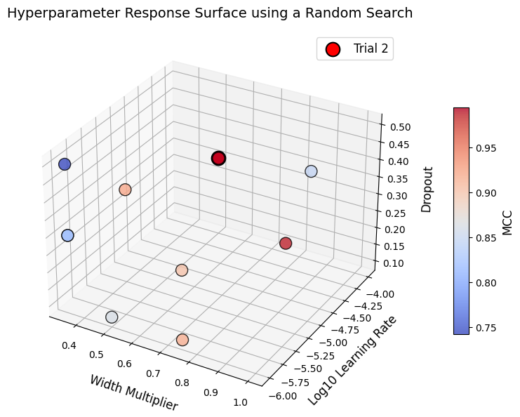Figure 6.5 shows the 4-dimensional hyperparameter response surface with the width multiplier, learning rate and dropout being represented by the xyz axes respectively and the MCC being colour coded while graded using a heatmap.

Figure 6.5: The hyperparameter response surface that depicts Table 6.3

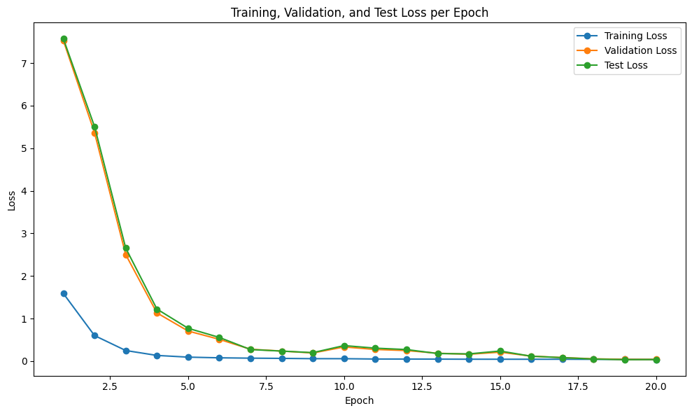Figure 6.6 shows the training, validation and test loss curves for each epoch for Trial 2 which was classified as being the ‘*best model*’, achieving the best validation performance measured by the MCC.

Figure 6.6: Training, validation and test loss curves per epoch relative to the optimal hyperparameters contained in Trial 2: $α$: 0.5, $η$:0.0001, $P$: 0.3 as measured by the MCC

The metrics that constitute the global metrics summary (Table 6.4) are Accuracy, Precision, Recall, F1-Score and the MCC. The calculations of these metrics were taken from Trial 2, that is, the trial with the highest global validation MCC.

|  |  |  |  |  |  |
| --- | --- | --- | --- | --- | --- |
| **Dataset** | **Accuracy** | **Precision** | **Recall** | **F1-Score** | **MCC** |
| Train | 0.999862 | 1.000000 | 0.999836 | 0.999918 | 0.999475 |
| Validation | 0.998546 | 0.998852 | 0.999426 | 0.999139 | 0.994475 |
| Test | 1.000000 | 1.000000 | 1.000000 | 1.000000 | 1.000000 |

Table 6.4: Global Metrics Summary taken from Trial 2 relative to the optimal hyperparameters $α$: 0.5, $η$: 0.0001, $P$: 0.3 as measured by the MCC

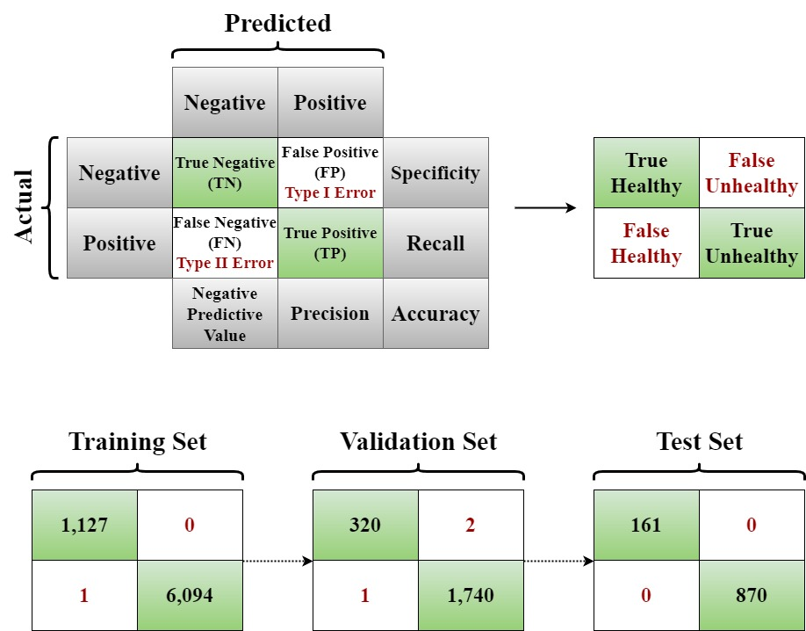Figure 6.7 is the confusion matrices that were generated from the results of Trial 2 and is associated with Table 6.4.

Figure 6.7: The global metrics summary calculations were generated by the results from Trial 2 that are illustrated in the confusion matrices from each dataset

# 7. Analysis. Stage 1

It must be reiterated that the BLM’s main objective was to establish the three primary hyperparameters (using a random search) that will be applied (from the outset) in the architecture of the FSLM. Therefore, the analysis of the results for BLM, are somewhat perfunctory, in so much as to ensure that there are no anomalies or adverse results that may cause concern.

## 7.1 Global Metrics

The Recall metric is one of the most important metrics when dealing with disease detection. In the context of plant disease, it is a measure of the number of correctly classified unhealthy plants or positive samples. Needless to say, the inability to detect an unhealthy plant (i.e. false negative), can lead to widespread damage to crops. This becomes more apparent when an agricultural region is particularly sensitive to crop yields.

Table 6.4 indicates the model’s ability to discriminate between healthy and unhealthy plants, is extremely accurate. Figure 6.7 shows that from the 2nd trial, the model errored on one image during the training phase and 3-images during the hyperparameter-tuning phase, while testing, produced perfect result.

Training Result: The MCC is near perfect, thus intimating a perfect correlation between the ground truth $\left(y_{i}\right)$ and prediction $\left(P_{i}\right)$. Irrespective of the large imbalance of data, which is often the case when dealing with disease detection, the model was still able to learn the distinguishing attributes between healthy and unhealthy. This has far exceeded the 50% expectations that was stated in ‘*Model Training & Evaluation Objectives’*[31]*.*

Validation Result: Indications show that the generalization is good, in other words, the model performs well on unseen data. The significance of this is that it has captured the essential features of the underlying abstract patterns that lie within the data rather than memorizing the inherent noise that exists in the training data.

Test Result: They are perfect across the board, which is somewhat worrying. Overfitting is not one of the issues, as the level of performance is similar across the three datasets. If there was a large disparity, then, overfitting concerns would arise. Furthermore, data leakage, is also not an issue, as the data was strictly separated with no cross-contamination. The three issues that could be a contributing factor to the perfect results are:

1. Insufficient data for the model to test.
2. Too easy for a deep learning model.
3. The data is of high quality, thereby rendering the model to decipher distinguishing features with precision.

## 7.2 Loss Curves

The loss curves that are depicted in Figure 6.6 follow a similar trajectory where the rapid convergence occurs within the first 6 epochs. The validation and test curves have minimal divergence throughout the trial. All three curves achieve very low levels of loss, which is indicative of low variance error. The model exhibits consistent performances from all three datasets. The results are predominantly underpinned by the three optimal hyperparameters, from Trial 2, thereby indicating an alignment with the various nuances that lie within the data.

Optimal hyperparameters:

* Width Multiplier $\left(α=0.5\right)$:   
  One of the most powerful attributes from MobileNetV2, is it’s ability to reduce over-parameterization by limiting the number of kernels which effectively helps the model’s convergence capabilities while maintaining high-levels of accuracy. This can be seen in Figure 6.6, where the convergence is rapid, while the Matthews Correlation Coefficient (MCC) (Table 6.4), is indicating a perfect correlation between the ground truth and prediction in the testing phase.
* 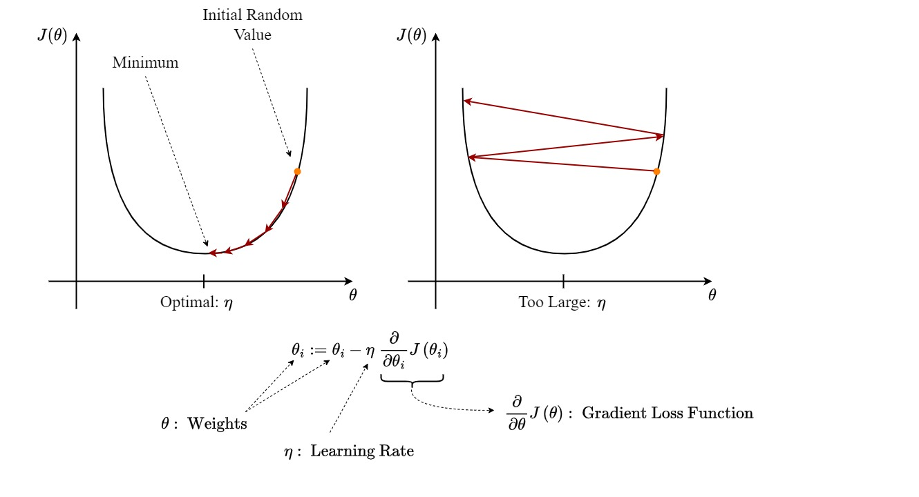Learning Rate $\left(η=0.0001\right)$:  
  The optimal learning rate enables a stable convergence. Small perturbations from the optimal rate can result in large swings when updating structural parameters as demonstrated in a hypothetical environment (Figure 7.1).

Figure 7.1: This is a hypothetical depiction of striking a balance by achieving the optimal learning rate which can prevent destabilizing convergence where the gradient descent updates the parameters $(θ)$. The rate of convergence is constrained by the learning rate: $η$

* Dropout $\left(P=0.3\right)$:   
  The dropout rate is somewhat moderate. It deactivates 30% of neurons during the training phase, thus reducing potential overfitting (differences between performances from the training and testing phases), and memorization. It is one of the key factors that has given rise to good generalization.

## 7.3 Summary

With the results being very impressive, irrespective of BLM’s reduced-width configuration, the classification model has clearly demonstrated that extracting the robust features from healthy versus unhealthy plant images could be assigned to high quality input signals. When presented with real-world images as opposed to studio quality images, would the same high-level predictions be made?

A significant point is that when dealing with disease detection classification problems, the minority class (positive = disease) would be the unhealthy plant. However, in the case of the PlantVillage dataset, the opposite is true, such that, the minority class is the healthy plants. Again, when presented with real-world scenarios, this misalignment needs to be taken into consideration as some modifications maybe required. To combat these potential issues, the model could employ additional techniques such as:

* Class Weighting:  
  The class weight is an innocuous component (Equation (7.1)) that adjusts the loss function by penalizing errors on the minority class. It ensures the model is unbiased and limits the dominance of the majority class due to its more frequent appearances. The healthy class is therefore assigned a higher weight, which in turn reduces the misclassification of that class due to the infrequent appearance, and so steering the model to improve the Recall metric associated with that class.

|  |  |
| --- | --- |
| $$ω_{i}=\frac{N}{K×n_{i}}$$ | (7.1) |

Where:

* + *N* is the total number of samples.
  + *K* is the total number of classes; in this case $K=2$.
  + $n_{i}$ is the number of samples in class $i$.

Therefore, to reflect this class weight within the total loss function, the expression would change to:

|  |  |
| --- | --- |
|  | (7.2) |

* Rigorous Data Augmentation:  
  Random cropping, rotation, flipping, lateral translations and colour jittering can all be incorporated into the data preprocessing phase.

# 8. Execution & Results. Stage 2 - FSLM

The model will be trained to learn a discriminative embedding space using a Siamese Network setup. The triplet loss function is the metric learning loss that will enforce a separation between the $d_{ap}$ and $d_{an}$ pairs. Acquiring the necessary learning patterns from the features[32], which are abstractly encoded within the data, backpropagation and gradient descent processes will update the structural parameters to facilitate the learning. In other words, the variances of one binary class must be distinguishable from the other. The margin $α_{trip}$ is the key component that determines how far apart dissimilar variables must be. Once these embeddings are learnt, the model will be ready for the next phase where it will undergo tuning of its hyperparameters using Bayesian optimization in an episodic setting; a Few-Shot task.

## 8.1 Siamese Network. Training the FSLM

The following is a brief overview of the coding implementation:

* Embedded hyperparameters:
  + During Stage 1, the BLM established three primary hyperparameters through the random search algorithm, which migrated to become an integral part of the architectural make-up of FSLM.
    - Width multiplier: $α=0.5$.
    - Learning rate: $η=0.0001$.
    - Dropout: $P=0.3$.
* Building the Siamese Network with Triplet Loss:
  + The model uses the transfer learning model MobileNetV2 as a feature extractor with it’s pretrained weights from the ImageNet dataset.
  + An embedding network is created that enables dedicated Dense layers to compress the extracted features to a 128-dimensional space. An $l_{2}$ normalization is applied to the 128-dimensional feature vector, ensuring the embeddings lie on a unit hypersphere, thereby allowing the Euclidean distances $\left(l_{2}\right)$ to be more impactful. The anchor, positive and negative inputs are implemented within the embedding network which computes the embeddings. These calculations are collected to then establish the triplet loss.
  + The embedding model is an additional model that is created for inference purposes.
* Custom Triplet Generator:
  + The generator produces batches of triplets, and for every triplet, an image is chosen from one class (nominated as the anchor), another image is then chosen from the same class (nominated as the positive), and the final image is chosen from the opposing class (nominated as the negative). Dummy labels subsequently are assigned to the binary classes, as the loss is calculated from the embeddings and not from the labels.
  + The generator continuously issues batches of triplets, which eliminates the necessity to load the entire dataset into memory. By customizing this generator, it allows more control and flexibility on how the triplets are sampled, while ‘*off-the-shelf*’ processes could be too stringent in their approach when encountering difficult extractions of triplets.
* Visualizations:
* Triplet Loss Curve:

The convergence during training will indicate if the model is effectively minimizing the triplet loss over all the epochs . If the network is learning (i.e. satisfying the triplet loss constraints) a decrease in loss over time should be observed. Due to the quantitative properties of the loss curve, it will complement the t-distributed Stochastic Neighbour Embedding (t-SNE[29]).

* Triplet Example:  
  Having a qualitative inspection of a triplet sample that is used during the training process will give some informative insights whether the network is learning. By contrast a quantitative check is given by displaying the Euclidean distances of these triplets where the following inequality is hoped to be observed: $d_{ap}+ α_{trip}< d_{an}$
* t-SNE of the Embedding[33]:  
  It is impossible to visualize higher dimensions than 4 (especially when one dimension is implicitly represented). t-SNE will reduce the 128-dimensional feature vector space to a 2-dimensional graph. Inferences can be made on whether the model has learned the discriminative embedding space from non-linear relationships by displaying the clustering patterns.
* Density Plot of Pairwise Distances [30][34]:  
  The plot is a distribution of Euclidean distances $\left(l_{2} norm\right)$ between the $d_{ap} vs d_{an}$ pairs. The ideal scenario would be that the density of $d_{ap}$ is concentrated at lower values when compared to the density of $d_{an}$. If this transpires, then the network is able to cluster similar images together while pushing dissimilar images apart.

## 8.2 Generated Results

The transfer learning model uses a Siamese Network setup that has three inputs; the triplets of anchor, positive and negative images by exploiting a shared feature extractor – MobileNetV2. The dedicated learnable Dense layers (dense, dense_1, dense_2) linearly project the 1280-dimensional feature vector to 128-dimensional space. This transformation is learned during backpropagation using the triplet loss. These embeddings are normalized using $l_{2}$ norms, ensuring the embeddings lie on a unit hypersphere, then they are concatenated $(128+128+128=384)$ to one 384-dimensional output per episode and thereafter, the triplet loss is calculated for that triplet sample.

|  |  |  |  |
| --- | --- | --- | --- |
| **Layer (type)** | **Output Shape** | **Param #** | **Connected to** |
| anchor_input  (InputLayer) | (None, 224, 224, 3) | 0 | - |
| positive_input  (InputLayer) | (None, 224, 224, 3) | 0 | - |
| negative_input  (InputLayer) | (None, 224, 224, 3) | 0 | - |
| mobilenetv2_0.5_224  (Functional) | (None, 1280) | 706,224 | anchor_input[0][0],  positive_input[0][0],  negative_input[0][0] |
| dropout (Dropout) | (None, 1280) | 0 | mobilenetv2_0.50_224[0][0] |
| dropout_1 (Dropout) | (None, 1280) | 0 | mobilenetv2_0.50_224[0][0] |
| dropout_2 (Dropout) | (None, 1280) | 0 | mobilenetv2_0.50_224[0][0] |
| dense (Dense) | (None, 128) | 163,968 | dropout[0][0] |
| dense_1 (Dense) | (None, 128) | 163,968 | dropout_1[0][0] |
| dense_2 (Dense) | (None, 128) | 163,968 | dropout_2[0][0] |
| lambda (Lambda) | (None, 128) | 0 | dense[0][0] |
| lambda_1 (Lambda) | (None, 128) | 0 | dense_1[0][0] |
| lambda_2 (Lambda) | (None, 128) | 0 | dense_2[0][0] |
| concatenate  (Concatenate) | (None, 384) | 0 | lambda[0][0],  lambda_1[0][0],  lambda_2[0][0] |

|  |  |
| --- | --- |
| Total params: | 1,198,128 (4.57 MB) |
| Trainable params: | 1,179,584 (4.50 MB) |
| Non-trainable params : | 18,544 (72.44 KB) |

Table 8.1: The tabulated description of the Siamese model results

In order to understand Table 8.1, a brief description of the various elements is given here:

* MobileNetV2 (mobilenetv2_0.5_224):
  + The naming convention indicates that the width multiplier ( $α)$ is 0.5, and there is no scaling down of the default resolution $(ρ=1)$, resulting in a full resolution of 224 x 224.
  + The parameters are 1,198,128 and is connected to all three inputs.
  + It processes each of the input images into a 1,280-dimensional feature vector.
  + The width multiplier $(α)$ was one of the hyperparameters that was tuned in Stage 1.
* Dropout Layer for Each Input or Branch:
  + It applies a dropout regularization to each of the 1,280-dimensional feature vectors.
  + With a prescribed amount of randomization applied to dropping some activations, the overfitting issues can be limited.
  + The dropout hyperparameter ($P$) was one of the parameters that was tuned in Stage 1.
* Dense Layers for Each Branch:
  + Each Dense layer is responsible for one of the input images. For example, ‘*dense*’ is responsible for the anchor input. Its responsibility is to compress the 1,280-dimensional feature vector space to 128-dimensional embedding space by using a transformation, such that there is a reduction by one order of magnitude:

|  |
| --- |
|  |

* + The dedicated Dense layers have 163,968 parameters each. The significance is that these parameters are trainable as they learn linear projections that are mapped from a high-dimensional feature to a lower discriminative embedding space, i.e. 128-dimensional embedding space.

|  |  |
| --- | --- |
| $$\left(imput dim. +1\right) ×output dim. =\left(1,280+1\right)×128=163,968$$ | (8.1) |

* Lambda Layers for $l_{2}$ Normalization:
  + Each Lambda layer is connected to the output of one of the Dense layers. For example, the output of ‘*dense_1*’ is the input of ‘*lambda_1*’.
  + An $l_{2}$ normalization is applied to each embedding in the embedding space so that its norm is 1. Therefore, the $l_{2}$ norm is taken from ‘*dense_1*’s output and inputted into the ‘*lambda_1*’s layer. As there are 128-dimensions, a unit hypersphere in essence is created and will be more impactful when the Euclidean distances are taken between these embeddings.
* Concatenation Layer:
  + Each normalized embedding is collected into a single 384-dimensional vector. This is done for each episodic event (i.e. each triplet sample).
  + The vector is then deconstructed back to the core embedding vectors in order for the triplet loss to be computed.
  + The triplet loss curve is generated from the training results, and illustrates the loss diminishing over the number of training epochs (Figure 8.1).
  + The triplet loss (Equation (8.2)) learns similar and dissimilar embedding vectors within the embedding space.

|  |  |
| --- | --- |
| $$Loss \left(X^{a}, X^{+}, X^{-}\right)=\max\left\{0, d^{+}+α_{trip} - d^{-}\right\}$$ | (8.2) |

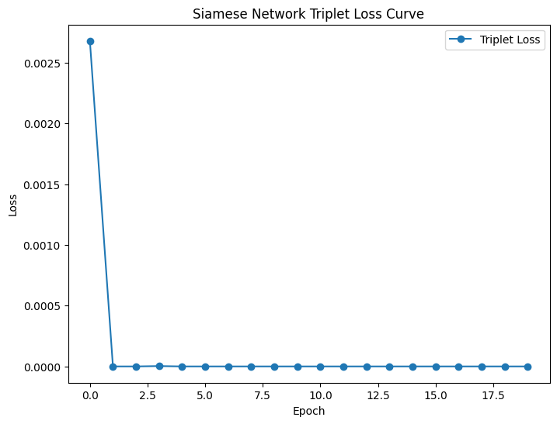An example of a triplet sample is generated for inspection purposes, where, informative insights can be obtained as to the computing processes that take place during the triplet loss calculation. The data for the three triplet samples are shown in Table 8.2. Ideally the results should be exhibiting the following results:

Figure 8.1: The triplet loss curve is a visualization of a quantitative loss learning metric of convergence

$$d_{ap}+ α_{trip}< d_{an}$$

|  |  |  |  |
| --- | --- | --- | --- |
| **Triplet Sample** | **Anchor-Positive Distance $\left(d_{ap}\right)$** | $$α_{trip}$$ | **Anchor-Negative Distance $\left(d_{an}\right)$** |
| 1 | 0.9438 | 0.2 | > 0.9906 |
| 2 | 0.8474 | 0.2 | < 1.0781 |
| 3 | 0.9787 | 0.2 | > 0.9346 |

Table 8.2: Three Euclidean distances for $d_{ap}$ and $d_{an}$ are computed for three sample triplets

The samples of the triplets and the graphically interpretation of Table 8.2 is shown in Figure 8.2. It is worth pointing out that this is only a snapshot of many samples that will be computed. It is unknown how far down the training process these samples were taken.

To complement the triplet loss curve, two further diagnostic visualization methods are employed to illustrate if the network has learnt the required distinguishing patterns with the restraint $α_{trip}=0.2$.

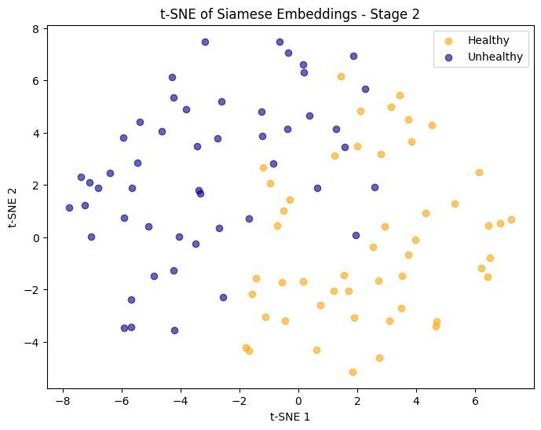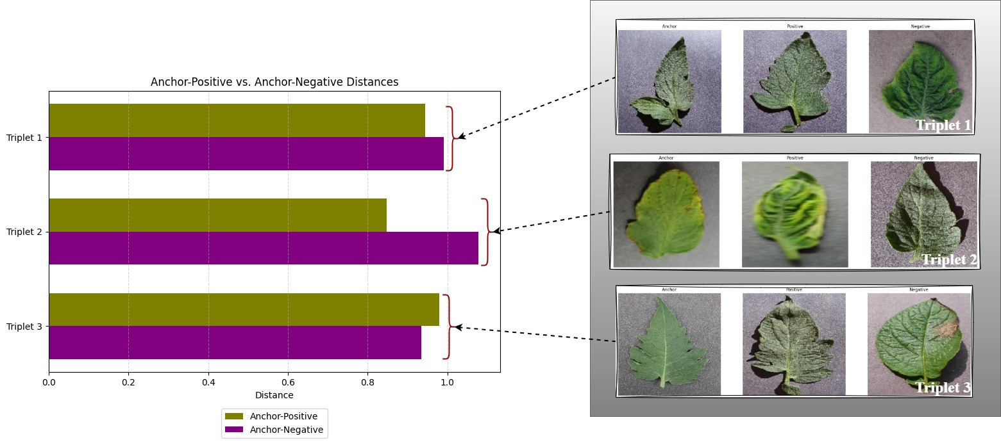Figure 8.3 shows a 2-dimensional clustering pattern that abstractly depicts a 128-dimensional feature vector space without losing any information.

Figure 8.3: t-SNE showing 2-dimensional feature vectors of healthy and unhealthy embedding spaces

Figure 8.2: Triplet 1 ~ Triplet 3’s Euclidean distances are calculated and displayed on the histogram with their respective triplet set shown on the right

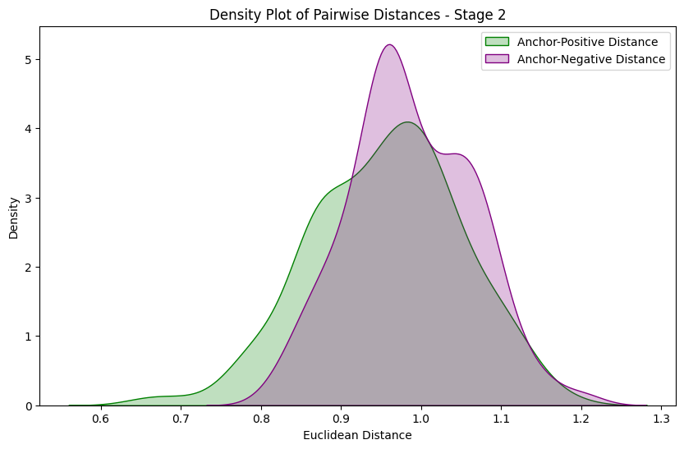The density plot of pairwise distances $\left(d_{ap} vs d_{an}\right)$ plots the distribution of Euclidean distances of these pairs. It does so by employing a Kernel Density Estimation (KDE) with a Gaussian kernel which allows a smooth estimate of the distribution. The embedding model (that was implemented during the Siamese model building process) is used to calculate the 128-dimensional representation of each of the anchor, positive and negative images. A batch of 200 triplet samples formed the set of distances, thereby giving a more insightful statistical sample over a large control group as shown in Figure 8.4.

Figure 8.4: Density plot of $d_{ap} vs d_{an}$ pairs taken from a set of 200 triplet samples

## 8.3 Few-Shot Learning. Hyperparameter-Tuning & Testing the FSLM

After the model has learnt the embedding space during the Siamese Network, (where the embedding branch is locked in with the newly trained structural parameters together with the hyperparameters), it shifts to acquire a more innate knowledge for FSL. The simulated conditions of learning are replicated to coincide with the stringent framework, where strict limitations are placed on the number of images that are made available. As with the Siamese Network process, the rationale behind key algorithms and techniques employed has been backed by research which has been discussed at great length within this report. This has led to the implementation of the chosen code with a brief overview given here:

* Episodic Data Generation:
  + Conventional deep learning regimes usually subject the models to large dataset exposure. In keeping with the FSL paradigm, hyperparameter-tuning is conducted in an episodic fashion embracing the 2-way 5-shot environment, where each episode is underpinned by the designated framework.
  + This method forces the model to adapt quickly to only a small sample of data.
* Hyperparameter-Tuning Model (FSLM) with Bayesian Optimization:
  + The backbone of the FSLM is the Siamese Network where the hyperparameters (width multiplier: $α=0.5$, learning rate: $η=0.0001$, and dropout: $P=0.3$), together with the weights and biases that were learnt are fixed and thus become the frozen embedding branch.
  + A Softmax activation is executed within a Dense layer and bolted on top of the frozen embeddings, where it will be tuned with the episodic support sets and evaluated on the associated query sets in order to ascertain the model’s capabilities to generalize.
  + Furthermore, the model can be encouraged to acquire a more robust generalizable mapping, through a custom Shannon entropy-based regularizer (taken from information theory) which is introduced in order to curtail over dominant features by penalization. The coefficient associated with Shannon regularizer is one of the hyperparameters that is tuned.
  + Bayesian optimizer is a low-dimensional search algorithm that is efficient at exploring/exploiting non-closed form search spaces. It does this by leveraging the past trial data and through the Expected Improvement (being the acquisition function of choice) suggests further investigations on promising configurations.
    - Hyperparameters:
$λ_{Shan }∈\{-10.0, -5.0, -1.0, 0.0, 0.01, 0.5\}$

$ξ∈\left\{\frac{3}{2},\frac{5}{2}\right\}$

$ξ_{EI}∈\{0.0, 0.1, 0.5, 0.75, 1.0\}$

* Evaluation of Model Performance:
  + In order to monitor the adaptability of the model to new tasks, the FSLM is subjected to numerous episodic support sets where it will learn and subsequently validated on the associated query sets.
  + Tabulated Global Metrics:
    - Accuracy, Precision, Recall, F1-Score, MCC metrics plus the confusion matrix are generated from the query data to evaluate the model’s performance which will demonstrate it’s potential ability to learn with limited data.
  + Loss & Accuracy:
    - For each trial, a plot is generated to visualize the dynamic fluctuations for the loss and accuracy trajectories for a given hyperparameter permutation.
    - Detection of overfitting/underfitting issues as well as the learning patterns, can be monitored on a trial-by-trial basis.
    - Each hyperparameter combination will result in varying rates of convergence with their respective performance levels. Analyzing these entities may lead to insights on whether a correlation exists between them.
  + Hyperparameter Response Surface:
    - A map of the various combinations of hyperparameters that were generated from the trials, together with how well the model performed is illustrated on the response surface.
    - The interactions of the hyperparameters are measured and by inspecting small perturbations can result in significant differences to the model’s performance.
    - By having a graphical interpretation[35] to the observed results, identifiable regions can be highlighted that can suggest whether the model may acquire an increase in performance.

## 8.4 Generated Results

While generating the episodic data in line with the FSL paradigm, a random sample of a support and query set was captured (Figure 8.5). It gives some level of indication on the difficulty that the model will be presented with in determining whether an image is healthy or not.

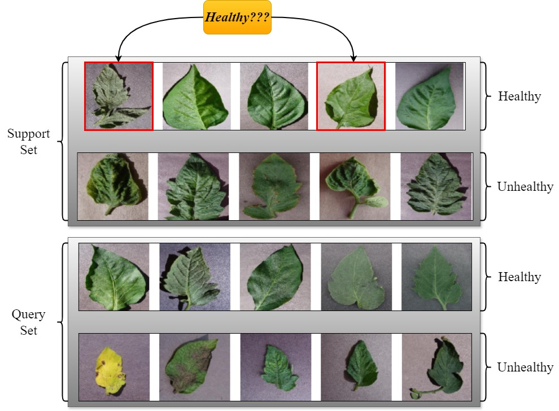The hyperparameter-tuning process initiated 10 trials with varying combinations of hyperparameters. Table 8.3 lists all the data that was recorded on: ‘*all_trial_history.csv*’ together with the ‘*Best Hyperparameters*’ values.

Figure 8.5: A random sample captured during the generation of episodic data for the support/query sets. The red highlighted plant leaves are said to be healthy, which demonstrates the challenges that are presented to the classification problem

|  |  |  |  |  |
| --- | --- | --- | --- | --- |
| **Trial ID** | **Hyperparameters** | | | **Best Validation Accuracy** |
| $$λ_{Shan}$$ | $$ξ$$ | $$ξ_{EI}$$ |
| 2 | 0.0 | 2.5 | 0.75 | 0.996874988 |
| 3 | -5.0 | 1.5 | 0.5 | 0.996874988 |
| 1 | -1.0 | 1.5 | 1.0 | 0.990625024 |
| 4 | 0.5 | 2.5 | 1.0 | 0.984375000 |
| 5 | -10.0 | 2.5 | 0.0 | 0.984375000 |
| 7 | -1.0 | 1.5 | 0.75 | 0.984375000 |
| 8 | 0.01 | 2.5 | 0.5 | 0.978124976 |
| 9 | -1.0 | 1.5 | 0.5 | 0.971875012 |
| 6 | 0.5 | 1.5 | 1.0 | 0.962499976 |
| 10 | -5.0 | 1.5 | 0.1 | 0.956250012 |

Table 8.3: Hyperparameter-tuning data is captured and reordered with the best hyperparameter combination at the top, namely Trial 2 resulting in the highest ‘Best Validation Accuracy’

In Figure 8.6, a graphical representation is given to depict the data from Table 8.3. The plot is a hyperparameter response surface showing the various combinations of hyperparameters, coupled with a heatmap, to indicate the best performing combination.

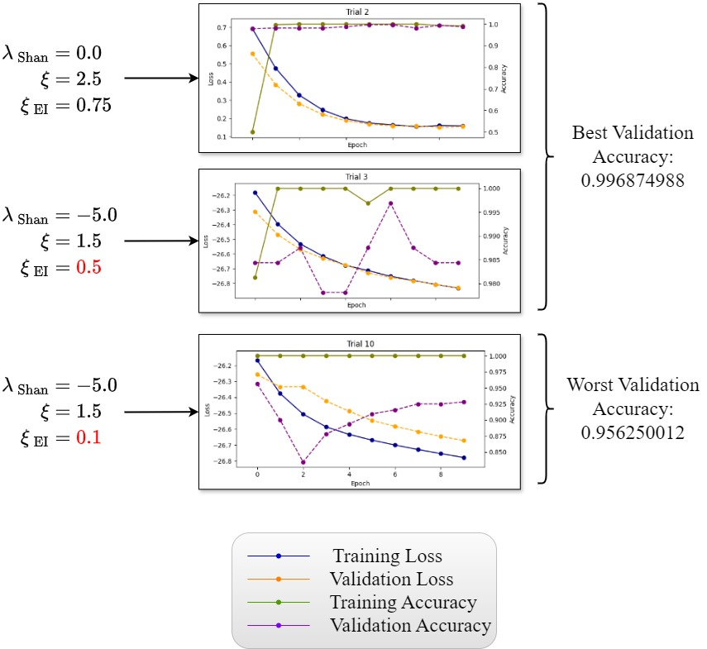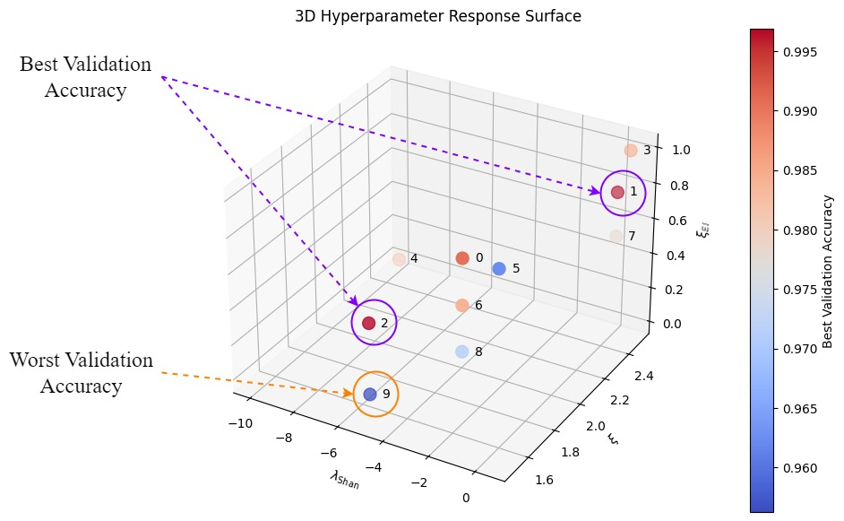The loss and accuracy results that pertain to Trials 2, 3 and 10 are shown in Figure 8.7[36]. Comparisons with the best and worst performing outcomes can be made.

Figure 8.6: The hyperparameter response surface. Here the trial numbering starts at 0 and not 1. Therefore, Trial 1 and 2 (which essentially are 2 and 3) result in the highest ‘Best Validation Accuracy’

Figure 8.7: The loss and accuracy per epochs are shown for Trials 2, 3, and 10. Small perturbations $\left(ξ_{EI}\right)$ in hyperparameters can lead to vastly different levels of performance

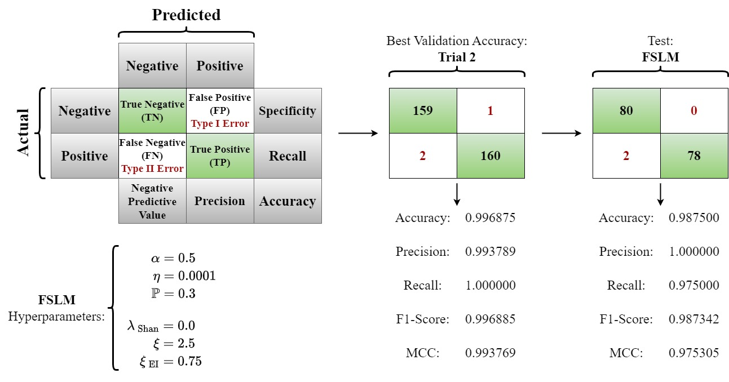The hyperparameters that were chosen in Trial 2: $λ_{Shan}=0.0$, $ξ=2.5$, $ξ_{EI}=0.75$ are implemented within the architecture of the FSLM and subjected to the episodic support/query test set. The results from the validation and subsequent test set with the optimal hyperparameters are depicted in Figure 8.8.

Figure 8.8: The FSLM validation and test results shown in their respective confusion matrices together with the computed global metrics

# 9. Analysis. Stage 2

This analysis is made-up of two phases. The first is the Siamese Network setup incorporating the triplet loss function using the training set, while the second is the Few-Shot Learning paradigm that is subjected to the validation and test sets, and uses the Bayesian optimization search algorithm during the tuning process.

## 9.1 Siamese Network with Triplet Loss

The model incorporated the three hyperparameters that were deemed as being the optimal combination from the previous stage:

* Width Multiplier: $α=0.5$ (MobileNetV2)
* Learning Rate: $η=0.0001$
* Dropout: $P=0.3$

### 9.1.1 Model Summary

|  |  |  |
| --- | --- | --- |
|  | **~ Parameters** | **Description** |
| Trainable: | 1.18 million | Parameters that are updated during the training: including MobileNetV2’s parameters and the Dense layers (3 Dense, Lambda and input layers). |
| Non-Trainable: | 18,544 | Frozen weights from pretrained layers on the ImageNet dataset. |
| Total: | 1.20 million | Trainable and non-trainable parameters combined. |
|  | **~ Footprint** | **Description** |
| Memory: | 4.57 MB | Very small for a deep CNN model due in-part to the width multiplier. |

Table 9.1: Brief description of the structural components of the Siamese Network model

### 9.1.2 Triplet Loss Curve

The triplet loss curve (Figure 8.1) starts at 0.0027 (which is already low) and then plummets to almost zero from the 2nd epoch. There it does not diverge and effectively flatlines to the 20th epoch. This is a good reflection on the model’s current embedding space as it satisfies the triplet loss condition, showing good discriminations between the features. This bodes well for the model as it is able to give an effective representation of the data from the outset, thus, requiring minor adjustments during the tuning process.

As with the BLM, with such a rapid convergence, this classification is not proving to be challenging and increasing the complexity of the problem will not be too difficult. Furthermore, the input images are studio quality with little to no noise, (‘*garbage in, garbage out*’). When subjected to real-world images taken in the field, will the model be so accurate in it’s predictions? In other words, will it be able to generalize on naïve data?

One may consider that there are possible overfitting issues, where the $d_{ap}$ and $d_{an}$ pairs are memorized. The immediate response to this is that there are none, and the evidence can be underlined by viewing the t-SNE and density of pairwise distances.

### 9.1.3 t-SNE of Siamese Embeddings

Figure 8.3 shows two manifolds (yellow points for healthy and blue for unhealthy). The t-SNE is a non-linear dimensionality reduction technique that has projected a 128-dimensional embedding space to a 2-dimensional representation. As the manifolds are distinct with minimal overlap around the central boundary region, this is indicative of a robust class separation. It supports the idea that the model has an embedding space which is well structured to distinguishing between the binary class, and that it has not shown any indications towards overfitting.

There are some inter-class variations which implicates that there are differences among the binary variables. This is to be expected as there are three plant categories contained in the healthy class and twelve plant categories in the unhealthy class, each having distinctive pathogens with varying degrees of deterioration. If a class weight was applied, better discrimination could be achieved.

### 9.1.4 Density Plot of Pairwise Distances

Figure 8.4 shows two density plots. The Anchor-Positive distribution is green and is centred around the Euclidean distance of 0.9, while the Anchor-Negative distribution is purple and is centred around the 1.0 ~ 1.1 region. Both distributions are showing distinctive means, however, their respective tails are overlapping. This could be attributed to the central boundary region having slight discriminating issues shown in the t-SNE diagram (Figure 8.3).

In a well structured Siamese Network, the strict inequality: $d_{ap}<d_{an}$ would indicate delineation between the classes which is clearly the case as the mean Euclidean distance of $d_{ap}=0.9$ is strictly less than $d_{an}≅1.0$.

In a real-world scenario, having such clear distinctions may prove to be ambitious. To encourage this separation of class, (especially in light of having a more complex environment, for example, more classes of plants and their respective pathogens), a distance threshold[37] could be set to enable the classification to operate with good generalization. A heuristic approach is to observe the Kernel Density Estimation plots (i.e. density plots of pairwise distances) and set the distance threshold through observation. In the case of Figure 8.4, setting the threshold $\left(δ\right)≅0.9 \sim 1.0$, would yield good separation.

### 9.1.5 Hyperparameters

The discussion on the three hyperparameters that resided in the Siamese Network setup was extensively covered in ‘*7.2 Loss Curves*’.

## 9.2 Few-Shot Learning with Bayesian Optimization

### 9.2.1 Setup of 2-Way 5-Shot Framework

The structure of the support and query sets are underlined by episodic events. Each support and query set contains 5 unique images from both the binary categories. The support set is hyperparameter-tuned with the Softmax classifier on the frozen Siamese Network embeddings. The model’s performance is evaluated on the associated query set, indicating its generalizable capabilities.

An example of a support and query is given in Figure 8.5 albeit a random selection. It does highlight the difficulty to decipher the nuances of some of the more challenging plant leaves as well as ascertaining whether they are healthy or not. As there is a distinct imbalance in the classes, by ensuring that each episode is balanced having the same number of categorical images, it eliminates any bias, thus allowing the accuracy metric to be the defining measure.

By having a small quantity of episodes with limited amounts of data, essentially invokes real-world environments. This enforces the model to adapt quickly by learning from the support images in order to classify with a high degree of accuracy the query images.

### 9.2.2 Hyperparameter-Tuning the FSLM

To recap on the architectural make-up of the FSLM, the following are key structural components:

* The low-dimensional embedding space where, to a large degree, the binary classes are appropriately separated, which was developed by the Siamese Network embeddings using:
  + MobileNetV2: Width multiplier $α=0.5$, learning rate $η=0.0004$, dropout $P=0.3$, Dense = 128, $l_{2}$ normalization.
* A Dense layer with a binary cross-entropy loss function with a Softmax activation placed on top of the now frozen embedding, is deployed.
* The parameters (weights and biases) are regulated by a Shannon regularizer which penalizes the entropy of the parameter distribution.

Hyperparameter optimization using a Bayesian optimization search algorithm:

* $λ_{Shan }$ weighted coefficient regulates the distribution of weights. Positive values penalizes excessive uniformity, thereby placing strict controls on overfitting, while negative values encourages diversification.  
  + $λ_{Shan }= 0.0$: No regularization is applied. The weights of the classifier is learned from the binary cross-entropy with no impact from the entropy component.
  + $λ_{Shan }∈\{0.01, 0.5\}$: The degree of positivity, rewards more concentrated weight distributions (low entropy) while penalizes uniform (flat) weight distributions.
  + $λ_{Shan }∈\{-10.0, -5.0, -1.0\}$: The degree of negativity, rewards more uniform weight distributions (high entropy), while discourages peaked (concentrated) distributions. Essentially, this inverts the effects of the regularizer.
* $ξ$ is a scaling/shape parameter. It can be considered as a smoothing/sensitivity parameter, where it can influence the degree of separation (decision boundary) and capturing (subtle differences) to the feature space that was previously developed by the frozen Siamese Network embeddings.   
  + $ξ=\frac{3}{2} →Low$: The responses result in less variability, thus becoming smoother/ less sensitive. This environment is ideal for distinctly separated classes.
  + $ξ=\frac{5}{2} →High$: The responses show a more aggressive variability, highlighting more subtle features encoded within the embedding space, which could encapsulate more inherent noise that may lead to overfitting issues.
* $ξ_{EI}$ is the expected improvement weighting parameter. The hyperparameter search space is multi-dimensional and highly complex. To obtain the optimal regions which will yield high validation accuracy, the navigational strategy of the search space is crucial.  
  + $ξ_{EI}=0.0$: No weight is assigned to the expected improvement, which lends the search algorithm to exploiting good regions rather than trying to explore other potential regions.
  + $ξ_{EI}∈\{0.1, 0.5, 0.75, 1.0\}$: The exploration strategy increases in-line with the increase in positive values. 0.5 and 0.75 is essentially a balance between the exploitation-exploration regimes. If the current choice of hyperparameters are not yielding desired high validation accuracy, then having a strong bias towards exploration (1.0), will develop new regions, however, the cost is larger variances in the performance.

### 9.2.3 Analysis Across Trials

The data accumulated from the tuning of the FSLM was captured in Table 8.3 and a hyperparameter response surface (Figure 8.6) was generated illustrating the results.

* The best trials were 2 and 3, having extremely high validation accuracy of approximately 0.9969. Interestingly, the result was achieved with vastly different configurations.  
  + Trial 2: The Shannon entropy component $\left(λ_{Shan}=0.0\right)$ had no impact, thereby relying solely on the ability of the binary cross-entropy to learn the classifier’s weights. The variability of capturing noise ($ξ=2.5$) was increased with tendency to lean to a more aggressive exploration strategy ($ξ_{EI}=0.75)$.
  + Trial 3: The Shannon regularizer is inverted ($λ_{Shan}=-5.0$), rewarding a more uniform weight distribution. However, it has a less sensitive attitude to variability ($ξ=1.5$) which tends to indicate the class discrimination is relatively easy together with a more balanced exploration/exploitation ($ξ_{EI}=0.50$)

These results suggests that an array of varying hyperparameters could reach good performance levels. This statement is underpinned when assessing Trials 4, 5 and 7 from Table 8.3, where each trial employs large variations in parameter combinations, and yet they all yield the same validation accuracy of approximately 0.9944. This exemplifies the complexity that is encountered in the non-closed form environment of the hyperparameter search space.

* The worst trial was 10, even though it still achieved very good levels of accuracy. Small perturbations within the hyperparameter search space can lead to noticeable variations in performances. Figure 8.7 shows exactly this. Trial 10 and 3 only differed in the expected improvement parameter ($ξ_{EI}$) by one degree of variation, with Trial 3 exhibiting a more balanced approach to exploration/exploitation of the search space, which implies that Trial 10 limited itself in more confined regions. This again underscores the sensitivity of the hyperparameter search space, which emphasizes the complexity of the problem of tuning and its importance to achieving the optimal combination.
* The following investigation alludes to the perturbations of one parameter being separated by one degree of variation, resulting in large validation accuracy levels being achieved.

|  |  |  |  |  |  |
| --- | --- | --- | --- | --- | --- |
| **Position** | **Trial ID** | **Hyperparameters** | | | **Validation Accuracy**  **~** |
| $$λ_{Shan}$$ | $$ξ$$ | $$ξ_{EI}$$ |
| 3 | 1 | -1.0 | 1.5 | **1.0** | 0.9906 |
| 6 | 7 | -1.0 | 1.5 | **0.75** | 0.9844 |
| 8 | 8 | -1.0 | 1.5 | **0.5** | 0.9719 |
| 4 | 4 | 0.5 | **2.5** | 1.0 | 0.9844 |
| 9 | 6 | 0.5 | **1.5** | 1.0 | 0.9625 |

Table 9.2: One degree of variation in the hyperparameter search space yields noticeable differences in accuracy

#### 9.2.3.1 Loss & Accuracy Plots

In order to make some connections with the numerous loss and accuracy plots per trial and the individual hyperparameters per trial, Figure 9.1 has been constructed to assist with Figure 8.7 and Figure AIII.1.

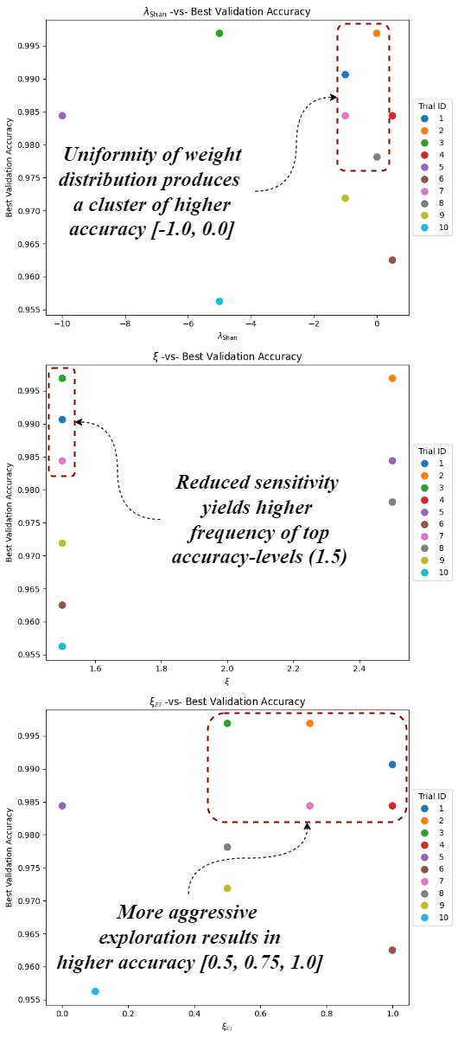

Figure 9.1: Each hyperparameter is isolated with respect to the best validation accuracy

Observations from Figure 9.1:

* + : Peak accuracy is achieved when no intervention from the Shannon regularizer occurs.
  + $λ_{Shan}=-1.0$: There is strong evidence that higher-levels of accuracy is correlated with higher entropy (uniform rather than concentrated weight distribution). This effective inversion of the Shannon regularizer can limit the classifier’s overconfidence.
 $ξ:$

 $ξ=1.5$ + : The frequency of occurrences that yields high accuracy results is considerable. The hyperparameter search seems to favour the less sensitive approach which could be indicative of the well structured embedding space that the Siamese Network developed during training.
 $ξ_{EI}:$

 $ξ_{EI}∈\{0.5, 0.75, 1.0\}$ + : The search algorithm implicated preferences towards a balance of exploration/exploitation to a more aggressive exploration tendency.

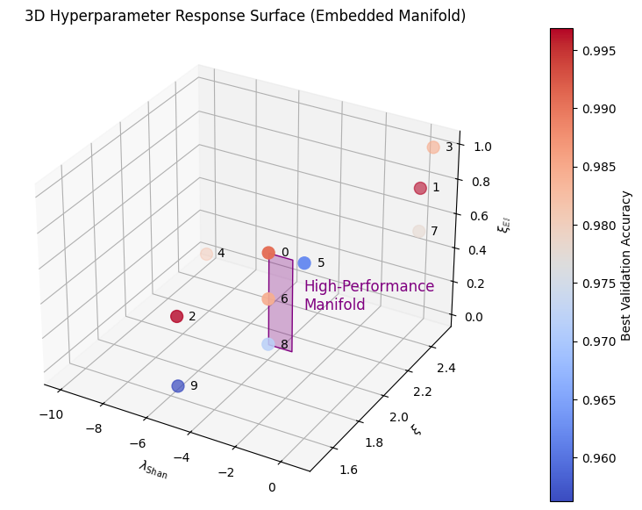By deconstructing the hyperparameter components and viewing them with respect to the best validation accuracy results; these findings can then be implemented on a previous illustrated diagram. The result is Figure 9.2 which uses the 2-dimensional manifold by embedding these findings within the hyperparameter response surface giving a relatively accurate region as to where we may want to conduct a more in-depth fine-grain search to find the ultimate combination[38]. Moreover, Trial 2 and 3 (labelled here as 1 and 2 respectively) lie some distance away from the high-performance manifold.

Figure 9.2: 2-dimensional manifold is embedded within the hyperparameter response surface, indicating where other likely combinations by be derived

Observations from Loss & Accuracy Curves:

* The plots typically have extremely quick validation accuracy convergence rates. There are some exceptions such as Trial 3 which has an erratic convergence in the validation accuracy[39].
* All trials have similar loss convergence rates with very little divergence between the training and validation loss curves.
* 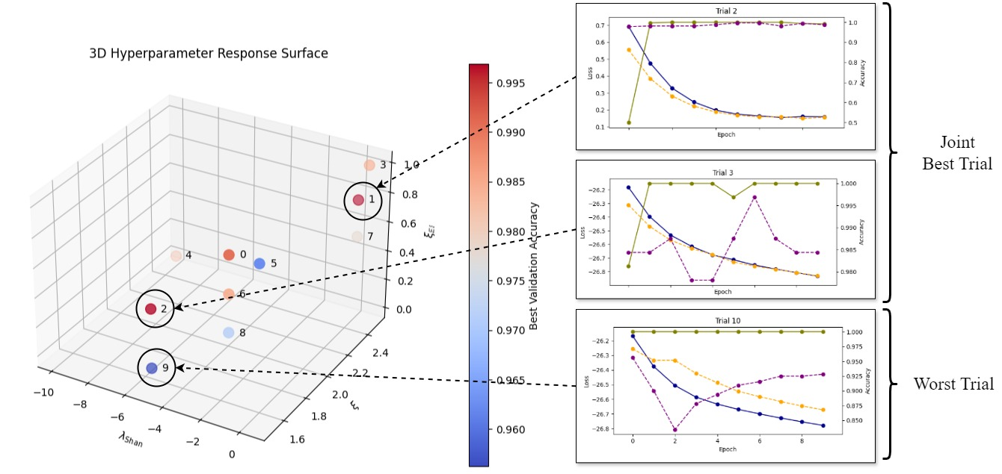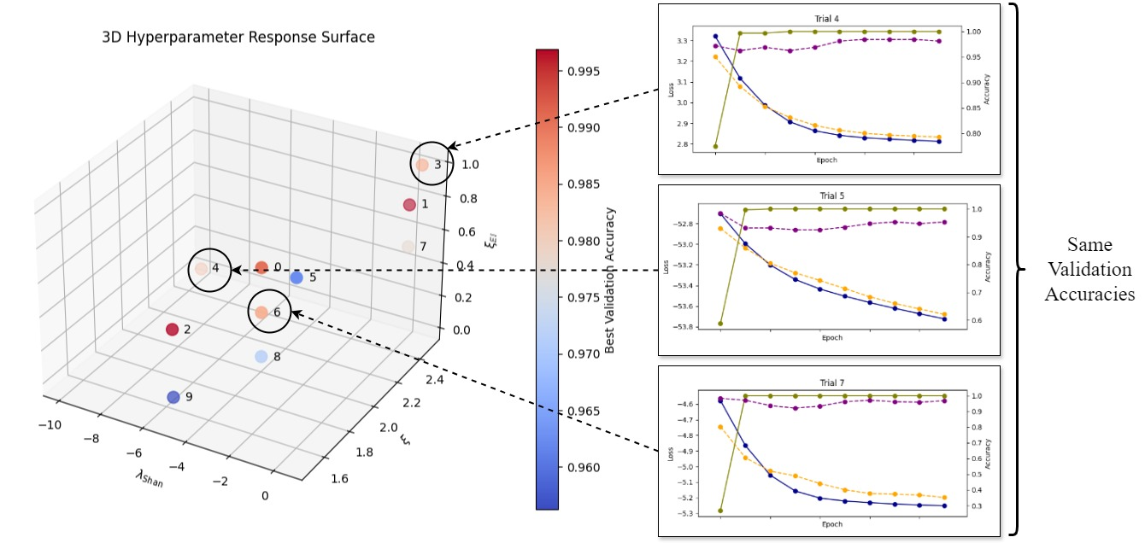As previously described, three trials had vastly different hyperparameter combinations that converged on the same high validation accuracy. In contrast there were two trials (Figure 8.7) that had small perturbations in one of the parameters in the order of one degree of variation, which resulted in the best and worst trials respectively. This can be seen in Figure 9.3 which exemplifies the sensitivity of these hyperparameters making any prediction on what is a good combination, very difficult to quantify, namely the ‘*High-Performance Manifold*’.

Figure 9.3:   
Top Diagram: Trials 4, 5 and 7(marked as 3, 4 and 6 respectively) resulted in ~ 0.9844 validation accuracy. Each one had vastly difference hyperparameter combinations.  
Bottom Diagram: Trials 2 and 3 (marked as 1 and 2) achieved the ‘Best Validation Accuracy’, whereas 10 (marked as 9) was the worst with both models exhibiting very similar combinations

### 9.2.4 Final Validation & Test Performance

The hyperparameters that were generated from Trial 2 are $λ_{Shan}=0.0$, $ξ=2.5$, $ξ_{EI}=0.75$ and were implemented into the FSLM where it was then subjected to the episodic support and query sets contained in the test dataset. Figure 8.8 shows the progression from validation to test, depicting the respective confusion matrices and global metrics. The test indicates an accuracy of 98.75% with a Recall of 98.77%. The model therefore, can distinguish between healthy and unhealthy classes, which is promising for real-world disease detection environments.

The model shows good robustness towards generalization -similar validation and test results. The results are closely aligned implying that memorization is not taking place on the images contained in the support set.

With such extreme variations in the hyperparameter search space, and with the results being consistently above 95% accuracy, this can be attributed to the structure of the frozen Siamese embeddings.

# 10. Concluding Remarks

Figure 10.1: Research shows that the temperature is rising in an upward trend

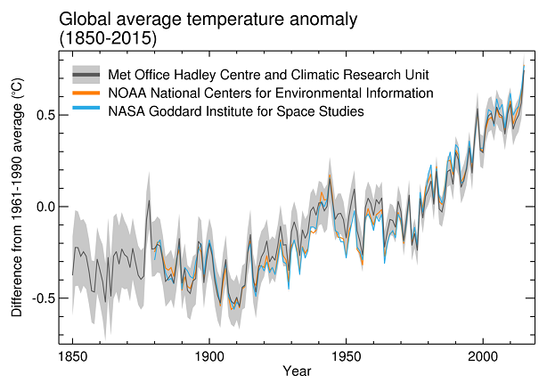Fact: the climate is changing with respect to rising temperatures (Figure 10.1[31]). If the current trajectory is maintained, these anomalies[40] could become the norm. The plants’ ability to resist agricultural pathogens will have diminishing returns and as a consequence, widespread deterioration rates could accelerate. In order to mitigate (or at best stem) these adverse trends, quick adaptable mobile devices need to be made available to farmers in remote regions that lack expert knowledge and where local communities are highly dependant on these food sources. These devises (IoT platforms) would be armed with plant disease detection applications that can diagnose the severity of the disease, and dispense the right advice to combat further progression of the disease or the survival of the remaining crop yield.

The aim was to initiate an investigation into the development of a deep neural network model that is lightweight enough to operate on IoT devices, while being efficient and performing at high-levels of accuracy with insufficient data. To achieve this, a number of ‘*state-of-the-art*’ concepts were introduced from computer vision and deep learning to the base model: MobileNetV2.

The model was further restricted in size and capacity by implementing a width multiplier of 0.5, which effectively produced a smaller model by reducing the number of kernels. Large image sets in the agricultural environment are not readily available, therefore, choosing a system that enforces a model to adapt quickly on limited data was paramount. Few-Shot Learning (FSL) was the ideal vehicle to steer this model, underpinned by Bayesian optimization – a non-closed form search engine that finds the optimal hyperparameters in an infinite space of possibilities .

There were many moving parts to this investigation that had complex processes. It was decided from the outset, that by simplifying the classification from a multi-class to a binary class problem, the study could be directed to concentrate on the construction of the model and it’s architectural aspects with the development of the training, hyperparameter-tuning and testing phases.

Two stages were executed, each having clearly defined and diverse objectives. The first stage was to establish if the BLM could perform adequately with a highly imbalanced dataset, while also generating the fundamental hyperparameters that would form the bedrock to the newly created model in the second stage. The second stage saw the creation of FSLM which inherited the hyperparameters. It was then subjected to three phases, training, hyperparameter-tuning and testing. The training phase called upon a Siamese Network setup with a triplet loss function to develop a well structured embedding space. The tuning phase used a Bayesian optimization algorithm to calibrate three pertinent hyperparameters, to find the best configuration to understand the nuances from the healthy and unhealthy plant images. Once the representative model was established, it was tested on a naïve dataset. The validation and test sets were realigned with episodic support/query sets that suited the 2-way 5-shot framework.

The results were very encouraging, as they were consistently above 95% predictive accuracy, with the Recall metric reaching in excess of 97%, implying that the model could discriminate between the binary classes with a high degree of precision. Across all three phases, the results were high, implicating the model’s ability to generalize well and showing no signs of overfitting.

With such excellent performances, the majority of the achievements could be attributed to the Siamese embedding space. A cautionary note; the problem may not have been challenging enough, but the positive take-away is that with so many moving parts that formulated the FSLM, all aspects operated above expectation. The initial investigation has provided sufficient evidence to move to a more ambitious classification problem while implementing these processes. In order to give the new advanced investigative model a more robust architectural structure (FSLM†[41]), some issues may need to be addressed, which was touched upon during the ‘*3. Literature Review*’. The following adjustments are purely recommendations in order to combat the potential loss of predictive accuracy when subjected to a multi-class classification problem. Furthermore, if successful, this model will need to be tested in the field with images that contain vast amounts of unwanted noise (FSLM††).

1. Swapping out the Softmax (linear) classifier for a Softmax (cosine similarity) classifier. For this to provide the necessary improvements, the following adjustments need to be adhered to:
   1. The output Siamese embeddings must be normalized ($l_{2}$) onto a unit 128-dimensional hypersphere, which is currently the case with the lambda layer.
   2. Instead of a Dense layer having a Softmax activation, the cosine similarity will need to be implemented in order to calculate the similarity between the query embeddings and each of the support embeddings.
   3. Introduction of a scaling factor that is integral with the process is a strong viable option to improve separation in the angular space. One of the most significant benefits are the separations becoming ‘*scale invariant*’. In other words, angles are computed rather than the vector magnitudes.
2. Disease detection environments tend to exhibit large imbalances among the classes, with unhealthy classes tending towards the minority class. To ensure a more robust separation, a class weighting system needs to be applied during the training process, (for example, priors for same-class and different-class pairs), thereby creating sturdy non-linear decision boundaries.
3. The triplet loss is concerned with the relative distances between embeddings and not their actual positions. By initially instigating a zero bias, the embeddings are effectively centralized, leading to increased interpretability in the embedding space. However, this will need to occur prior to the normalization ($l_{2}$) procedure, as normalization tends to nullify the impact of shifting the embeddings.

To implement FSLM†, the current PlantVillage dataset will need to be segregated into a stratified distribution using the following ratio 7:2:1. There are 15 categories with large frequency swings. For example, ‘*Tomato Yellow Leaf Curl Virus*’ contains 3,208 images, while in contrast ‘*Potato Healthy*’ only has 152. Due to such large imbalances, class weighting during training is a certainty. Using a 5-way 5-shot FSL framework, limits each episodic task to 5 classes, which allows the model to adequately learn from the support set and instils robust evaluations on the query set. It is also reported by [16], that a performance increase between 1.5% ~ 4% can be expected by using this environment. An example of a stratified split and the potential class weights are given in Table 10.1.

|  |  |  |  |  |  |  |
| --- | --- | --- | --- | --- | --- | --- |
|  | **Class Name** | **Total** | **Train**  **(70%)** | **Class**  **Weighting** | **Validation**  **(20%)** | **Test**  **(10%)** |
| 1. | Tomato Yellow Leaf Curl Virus | 3208 | 2246 | 0.61 | 642 | 320 |
| 2. | Tomato Bacterial Spot | 2127 | 1489 | 0.92 | 425 | 213 |
| 3. | Tomato Late Blight | 1909 | 1336 | 1.02 | 382 | 191 |
| 4. | Tomato Septoria Leaf Spot | 1771 | 1240 | 1.10 | 354 | 177 |
| 5. | Tomato Two Spotted Spider Mite | 1676 | 1173 | 1.17 | 335 | 168 |
| 6. | Tomato Healthy | 1591 | 1114 | 1.24 | 318 | 159 |
| 7. | Pepper Bell Healthy | 1478 | 1035 | 1.33 | 296 | 148 |
| 8. | Tomato Target Spot | 1404 | 983 | 1.40 | 281 | 140 |
| 9. | Potato Early Blight | 1000 | 700 | 1.97 | 200 | 100 |
| 10. | Potato Late Blight | 1000 | 700 | 1.97 | 200 | 100 |
| 11. | Tomato Early Blight | 1000 | 700 | 1.97 | 200 | 100 |
| 12. | Pepper Bell Bacterial Spot | 997 | 698 | 1.97 | 199 | 100 |
| 13. | Tomato Leaf Mold | 952 | 666 | 2.07 | 190 | 95 |
| 14. | Tomato Mosaic Virus | 373 | 261 | 5.27 | 75 | 37 |
| 15. | Potato Healthy | 152 | 106 | 12.98 | 30 | 16 |

Table 10.1: An example of a stratified distribution using a 7:2:1 ratio split

Some compelling considerations need to be addressed:

* Siamese Network:  
  The imbalance in data is more profound when compared with the binary classification which had a disparity of 5:1, where in this scenario, there are examples of up to 20:1. As previously mentioned, class weighting is vital with such huge differences.

|  |  |
| --- | --- |
| $$ω_{i}=\frac{N}{K×n_{i}}=\frac{20,639}{15 ×n_{i}}=1,375.93 ×n_{i}^{-1}$$ | (10.1) |

Where:

* + *N* is the total number of samples.
  + *K* is the total number of classes; in this case $K=2$.
  + $n_{i}$ is the number of samples in class $i$.

From inspecting Table 10.1, the weights increase considerably as the frequencies of images in each category decreases.

* FSL – 5-Way 5-Shot:  
  If the criteria is ‘no overlapping’ across all episodes within the hyperparameter-tuning and testing phases (i.e. each image can only be used once), this will place an enormous constraint on the number of episodes that can be deployed, which essentially limits the learning capacity of the system. The limiting case is ‘Potato Healthy’ which consists of 30 images in the validation set and only 16 in the test set. For clarity, every episode requires 10 images; 5 for the support set and 5 for the query set, thus imposing the following:

|  |  |
| --- | --- |
| $$Validation: \left\lfloor \frac{30}{10}\right\rfloor =3, Test: \left\lfloor \frac{16}{10}\right\rfloor =1$$ | (10.2) |

With this regime, not all classes can be represented in each episode. Thus a class selection will need to be randomized. The number of episodes will not be constrained by the minority class as in the case with the binary classification, however, the number of images contained in each category is meagre and impactful on the model’s learning capacity.

The moonshot is to orchestrate an ensemble of Siamese Networks to enable a multi-task approach. For example, to identify the degree of severity of the affected plants, with the solution readily available to eradicate or limit the spread of the pathogens and eventually collate an extensive database to share the newly updated knowledge-base that can lead to invaluable insights for alternative fields of research.

# References

[1] S. Chakraborty, A. V. Tiedemann, and P. S. Teng, ‘Climate change: potential impact on plant diseases’, *Environ. Pollut.*, vol. 108, no. 3, pp. 317–326, Jun. 2000, doi: 10.1016/S0269-7491(99)00210-9.

[2] K. P. Chaithanya and J. George Melekoodappattu, ‘An Exploration On Plant Disease Detection’, in *2022 Third International Conference on Intelligent Computing Instrumentation and Control Technologies (ICICICT)*, Kannur, India: IEEE, Aug. 2022, pp. 911–916. doi: 10.1109/ICICICT54557.2022.9917894.

[3] P. Deshwal, K. Sharma, and Mr. S. Moudgil, ‘Plant Leaf Disease Detection using Machine Learning’, *Int. J. Res. Appl. Sci. Eng. Technol.*, vol. 11, no. 5, pp. 5928–5932, May 2023, doi: 10.22214/ijraset.2023.52895.

[4] S. Thrun and L. Pratt, *Learning to Learn*, 1st ed. Springer New York, NY, 1997. [Online]. Available: https://doi.org/10.1007/978-1-4615-5529-2

[5] J. B. Tenenbaum, C. Kemp, T. L. Griffiths, and N. D. Goodman, ‘How to Grow a Mind: Statistics, Structure, and Abstraction’, *Science*, vol. 331, no. 6022, pp. 1279–1285, Mar. 2011, doi: 10.1126/science.1192788.

[6] E. Tairu Oluwafemi, ‘PlantVillage Dataset’. spMohanty’s GitHub Repository, kaggle. [Online]. Available: https://www.kaggle.com/datasets/emmarex/plantdisease/data

[7] K. P. Asha Rani and S. Gowrishankar, ‘Pathogen-Based Classification of Plant Diseases: A Deep Transfer Learning Approach for Intelligent Support Systems’, *IEEE Access*, vol. 11, pp. 64476–64493, 2023, doi: 10.1109/ACCESS.2023.3284680.

[8] V. S. Dhaka *et al.*, ‘A Survey of Deep Convolutional Neural Networks Applied for Prediction of Plant Leaf Diseases’, *Sensors*, vol. 21, no. 14, p. 4749, Jul. 2021, doi: 10.3390/s21144749.

[9] K. He, X. Zhang, S. Ren, and J. Sun, ‘Deep Residual Learning for Image Recognition’, Dec. 10, 2015, *arXiv*: arXiv:1512.03385. Accessed: Oct. 21, 2024. [Online]. Available: http://arxiv.org/abs/1512.03385

[10] A. G. Howard *et al.*, ‘MobileNets: Efficient Convolutional Neural Networks for Mobile Vision Applications’, Apr. 16, 2017, *arXiv*: arXiv:1704.04861. Accessed: Aug. 27, 2024. [Online]. Available: http://arxiv.org/abs/1704.04861

[11] ‘Rigid-Motion Scattering For Image Classification.pdf’.

[12] G. Gu, B. Ko, S. Go, S.-H. Lee, J. Lee, and M. Shin, ‘Towards Light-weight and Real-time Line Segment Detection’, Apr. 26, 2022, *arXiv*: arXiv:2106.00186. Accessed: Oct. 21, 2024. [Online]. Available: http://arxiv.org/abs/2106.00186

[13] M. Sandler, A. Howard, M. Zhu, A. Zhmoginov, and L.-C. Chen, ‘MobileNetV2: Inverted Residuals and Linear Bottlenecks’, Mar. 21, 2019, *arXiv*: arXiv:1801.04381. Accessed: Jul. 23, 2024. [Online]. Available: http://arxiv.org/abs/1801.04381

[14] D. Argüeso *et al.*, ‘Few-Shot Learning approach for plant disease classification using images taken in the field’, *Comput. Electron. Agric.*, vol. 175, p. 105542, Aug. 2020, doi: 10.1016/j.compag.2020.105542.

[15] J. Sun, W. Cao, X. Fu, S. Ochi, and T. Yamanaka, ‘Few‐shot learning for plant disease recognition: A review’, *Agron. J.*, vol. 116, no. 3, pp. 1204–1216, May 2024, doi: 10.1002/agj2.21285.

[16] G. S. Dhillon, P. Chaudhari, A. Ravichandran, and S. Soatto, ‘A Baseline for Few-Shot Image Classification’, Oct. 21, 2020, *arXiv*: arXiv:1909.02729. Accessed: Jul. 14, 2024. [Online]. Available: http://arxiv.org/abs/1909.02729

[17] W.-Y. Chen, Y.-C. F. Wang, Y.-C. Liu, Z. Kira, and J.-B. Huang, ‘A CLOSER LOOK AT FEW-SHOT CLASSIFICATION’, 2019.

[18] J. Snell, K. Swersky, and R. S. Zemel, ‘Prototypical Networks for Few-shot Learning’, Jun. 19, 2017, *arXiv*: arXiv:1703.05175. Accessed: Jul. 14, 2024. [Online]. Available: http://arxiv.org/abs/1703.05175

[19] B. Shahriari, K. Swersky, Z. Wang, R. P. Adams, and N. De Freitas, ‘Taking the Human Out of the Loop: A Review of Bayesian Optimization’, *Proc. IEEE*, vol. 104, no. 1, pp. 148–175, Jan. 2016, doi: 10.1109/JPROC.2015.2494218.

[20] J. Bergstra and Y. Bengio, ‘Random Search for Hyper-Parameter Optimization’.

[21] S. Wang, Stevens Institute of Technology. *Few-Shot Learning*. [YouTube lecture]. Available: https://www.youtube.com/watch?v=hE7eGew4eeg&list=PLgtf4d9zHHO8YjSSkkBT55XN8xsIvb-ku

[22] P. Lissa, D. Peretti, M. Schukat, E. Barrett, F. Seri, and M. Keane, ‘Machine Learning Methods Applied to Building Energy Production and Consumption Prediction’.

[23] S. Galli, *Hyperparameter Optimization for Machine Learning*. [Lecture series]. Available: https://www.trainindata.com/p/hyperparameter-optimization-for-machine-learning

[24] E. Brochu, V. M. Cora, and N. de Freitas, ‘A Tutorial on Bayesian Optimization of Expensive Cost Functions, with Application to Active User Modeling and Hierarchical Reinforcement Learning’, Dec. 12, 2010, *arXiv*: arXiv:1012.2599. Accessed: Jul. 11, 2024. [Online]. Available: http://arxiv.org/abs/1012.2599

[25] C. B. Do, ‘The Multivariate Gaussian Distribution’.

[26] ‘Cornell - Bayesian Optimization and Gaussian Processes.pdf’.

[27] S. P. Mohanty, D. P. Hughes, and M. Salathé, ‘Using Deep Learning for Image-Based Plant Disease Detection’, *Front. Plant Sci.*, vol. 7, p. 1419, Sep. 2016, doi: 10.3389/fpls.2016.01419.

[28] F. Schroff, D. Kalenichenko, and J. Philbin, ‘FaceNet: A Unified Embedding for Face Recognition and Clustering’, in *2015 IEEE Conference on Computer Vision and Pattern Recognition (CVPR)*, Jun. 2015, pp. 815–823. doi: 10.1109/CVPR.2015.7298682.

[29] L. van der Maaten and G. Hinton, ‘Visualizing Data using t-SNE’, *J. Mach. Learn. Res.*, vol. 9, no. 86, pp. 2579–2605, Nov. 2008, [Online]. Available: http://jmlr.org/papers/v9/vandermaaten08a.html

[30] B. W. Silverman, *Density Estimation for Statistics and Data Analysis*. Chapman & Hall, 1986.

[31] P. Dr Stott, ‘Global-average temperature records’.

[32] N. Lang, ‘tSNE Algorithm – explained simply and in detail!’, *Data Base Camp*, Mar. 2023, [Online]. Available: https://databasecamp.de/en/statistics/tsne-en

# Appendix I. Brief Overview of t-SNE

The t-distributed Stochastic Neighbour Embedding (t-SNE) is a non-linear dimensionality reduction method whose primary objective is to show a high-dimensional data in a 2 or 3-dimensional space while maintaining the local and global structural properties of the original data[42]. The authors [29] compare many alternative methods:

* Linear Techniques:
  + Principal Component Analysis (PCA)
  + Multi-Dimensional Scaling (MDS)
* Non-parametric Techniques:
  + Isomap
  + Locally Linear Embedding (LLE)
  + Sammon mapping

These techniques all perform admirably on artificial datasets, however, they fall short of local (variances within the clusters) and global (variances between different clusters) structural preservations. This claim is backed by empirical evidence as these techniques were subjected to the following five datasets:

* MNIST – handwritten digits
* Olivetti Face
* Coil-20 – object rotation images
* Word-features Dataset
* Netflix Movie Recommendations

t-SNE outperformed Sammon mapping, Isomap, LLE, Maximum Variance Unfolding (MVU) and Laplacian Eigenmaps, and in particular, MNIST was a near perfect separation.

The model does have certain limitations which are noteworthy:

* The computational cost $\left(O\left(n^{2}\right)\right)$ is heavy on resources especially for very large datasets.
* Highly sensitive to hyperparameters.
* Interpretation of small clusters can be somewhat distorted.

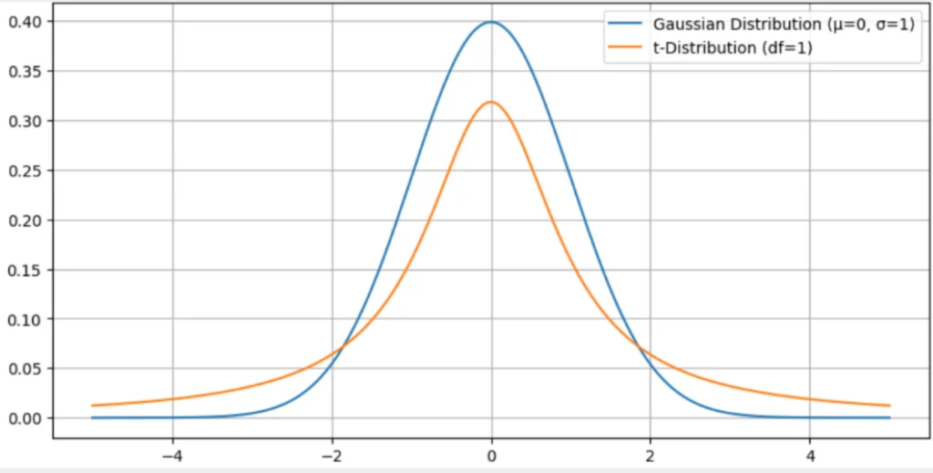The standard Stochastic Neighbour Embedding (SNE) has an over crowding issue as it employes a standard Gaussian distribution which results in visualizations that are distorted. The t-SNE, however, addresses this overcrowding by using the Student’s t-distribution. The Figure A.I.1[32] illustrates the differences between the two distributions, with the notable differences in the tails and the peaks.

Figure A.I.1: “Difference between t-distribution and Gaussian normal distribution”[31]

To recap, the t-SNE takes a high-dimensional dataset and reduces it to a low-dimensional graph, that retains a lot of the original information. It does this by transforming the pairwise Euclidean distances into conditional probabilities that explicitly represent similarities, i.e. $x_{i}$ is similar to

|  |  |
| --- | --- |
|  | (A.I.1) |

The conditional probabilities are symmetrized to form a joint probability.

|  |  |
| --- | --- |
|  | (A.I.2) |

Let $P=\left\{p_{ij}\right\}$

Now the points reside in a low-dimensional space (e.g. 2 or 3-dimensions), and the algorithm defines a similar probability but instead of using the normalized Gaussian distribution conditioned on $j$, given $i$ (Equation (A.I.1)), it invokes the normalized Student’s t-distribution with one degree of freedom (Equation (A.I.3)).

|  |  |
| --- | --- |
|  | (A.I.3) |

Let $Q=\left\{q_{ij}\right\}$

The cost function is the Kullback-Leiber (KL) divergence which measures the divergence between the high-dimensional distribution (Equation (A.I.2)) and the low-dimensional distribution (Equation (A.I.3)).

|  |  |
| --- | --- |
|  | (A.I.4) |

The t-SNE uses the process of gradient descent to minimize the cost function which subsequently provides a 2 or 3-dimensional representation that preserves the local structure of the original data.

# Appendix II. Brief Overview of Density Plots

The author [30] describes extensively the density estimation approaches, investigating theory in conjunction with empirical case studies such as:

* Directional data (turtles’ swimming directions).
* Engineering surface analysis.
* Sudden infant death syndrome.

It further describes how the Kernel Density Estimation (KDE) is a more adaptable method than the likes of histograms as it incorporates a smoothing function (kernel) for a probability density estimation. This subsequently leads to more interpretable results when compared to the widely used histogram which is highly dependent on the bin width intensity.

Alternative methods are stipulated such as nearest neighbour methods, orthogonal series and penalized likelihood estimators.

The noteworthy limitations associated with KDE’s are:

* The smoothing parameters (bandwidth selection) is extremely sensitive and careful selection needs to be addressed.
* For high-dimensional data, the computational cost on resources escalates.
* The ubiquitous bias-variance trade-off is prevalent and issues may arise.

The density plot of pairwise distances $\left(d_{ap},d_{an}\right)$ has the following properties:

* Applies the $l_{2}$ norm (Euclidean distance) to calculate distances between embeddings.
  + For each triplet sample:

|  |  |  |
| --- | --- | --- |
| $$d_{ap}=\sqrt{\sum_{i=1}^{n=128}{{\left(a_{i}-p_{i}\right)}^{2}}}$$ | $$d_{an}=\sqrt{\sum_{i=1}^{n=128}{{\left(a_{i}-n_{i}\right)}^{2}}}$$ | (A.II.1) |

Where $\left.\begin{aligned}a_{i} \\ p_{i} \\ n_{i}\end{aligned}\right\} embedding vector for i^{th}\left\{\begin{aligned}anchor image \\ positive image \\ negative image\end{aligned}\right., and n=128.$

* Utilizes the KDE while encoding a Gaussian kernel, thereby generating a distance smoothing distribution [30]. The less favourable alternative as previously discussed is to use a histogram which tends to be noisy. The KDE $(K\left(∙\right))$ resides within the probability density function $\left(\hat{f}(x)\right)$ of distances that incorporates a smoothing parameter $(h)$:

|  |  |
| --- | --- |
| $$\hat{f}\left(x\right)=\frac{1}{Nh}\sum_{i=1}^{N}{K\left(\frac{x-x_{i}}{h}\right)}$$ | (A.II.2) |

For a set of $N$ samples ${\left\{x_{i}\right\}}_{i=1}^{N}$, where a Gaussian kernel is usually chosen:

|  |  |
| --- | --- |
| $$K\left(u\right)=\frac{1}{\sqrt{2π}}e^{-\frac{u^{2}}{2}}$$ | (A.II.3) |

Depending on the level of smoothness applied, the KDE will give the degree of approximation to the distribution of distances.

In reality, this is a diagnostic method to ascertain if the embedding space has been learnt by the Siamese Network.

To summarize, in the context of metric learning with a Siamese Network setup using a triplet loss function, the density plot can visually provide indications on how the network has performed in relation to the structural organization of the embedding space and so complements the triplet loss curve which essentially is a quantitative metric of convergence. The density plot is supported by seminal research [30] and has been used in metric learning research [28].

# A graph of different colored linesAppendix III. Loss & Accuracy Plot for All Trials

Figure AIII.1: The results of the 10 trials that were conducted with the training and validation loss/accuracy plots per each epoch

# Appendix IV. Decision Rule & Threshold Formulation

The current classification problem is binary in nature. The input data is of studio quality and with both these contributing factors the idealistic environment is not realistic. To pre-empt a more complex environment, for example, real-world scenarios, a more robust method will need to be explored.

The methods described here are complementary to the metric learning loss function. The triplet loss is implemented during the Siamese Network training phase, which develops the embedding space where similar images are close together and dissimilar images are pushed further apart (encouraged by a linear margin component). Once the embedding space has been established and learned, thresholding algorithms can be bolted on during the inference phases to determine if two images are similar or not based on their Euclidean distance, thereby adding another level of robustness to the classification process. There are several methods that if leveraged, could be employed as a strategy for utilizing the embedding distances for classification.

Let the density function for:

* Same class distances: $f_{ap}(x)$
* Different class distances: $f_{an}(x)$

Where *x* is the dummy variable for the Euclidean distance $→x(a,b)={\left\|a-b\right\|}_{2}=\sqrt{\sum_{i=1}^{n}{{\left(a_{i}-b_{i}\right)}^{2}}}$

Let’s assume, for simplicity sake, that an adequate decision rule can be engineered with the following inequality:

* $x\left(a,b\right)< δ→$ same class classification.
* $x\left(a,b\right)≥δ→$ different class classification.

How to determine $δ$? Here lies the challenge. By choosing the optimal method for the Advanced Few-Shot Learning Model (FSLM†), the misclassification rate could be minimized, which inadvertently could lead to improvements to the model’s generalization capabilities. Two methods are discussed here.

1. Equal Error Rate (EER):  
   Error rates are ubiquitous in data science, and here is no exception. Error rate values are a critical entity and equilibrating the cumulative probabilities is essentially what defines the EER. Let the following expressions be true:
   1. False Acceptance Rate (FAR) is defined as the probability (cumulative density) over a specified region, that a different-class pair is falsely accepted as being the same-class pair: $FAR=\int_{0}^{δ}{f_{an}\left(x\right)dx}$
   2. False Rejection Rate (FRR) is defined as the probability (cumulative density) over another specified region, that a same-class pair is incorrectly rejected: $FRR=\int_{δ}^{∞}{f_{ap}(x)}dx$

Where $f_{an}\left(x\right), f_{ap}\left(x\right)$ are the probability density functions for anchor-negative distances and anchor-positive distances respectively.

|  |  |
| --- | --- |
| $$EER: \underset{P_{an}}{\underbrace{\int_{0}^{δ}{f_{an}\left(x\right)dx}}}=\underset{P_{ap}}{\underbrace{\int_{δ}^{∞}{f_{ap}(x)}dx}}$$ | (AIV.1) |

A noteworthy remark: Equation (AIV.1) assumes that there is good class balance. If this is not the case, as seen so often in disease detection scenarios, where there is a distinct imbalance on the side of the diseased class, then the EER will need to be adjusted by incorporating weighted class priors:

|  |  |
| --- | --- |
| $$EER: FAR ×π_{an}=FRR×π_{ap}$$ | (AIV.2) |

Where $π_{an}$ is the weighted class prior for different-class and $π_{ap}$ is the weighted class prior for the same-class. Therefore, by manipulating the threshold $(δ)$, which essentially defines EER, the equality expression can hold true.

1. Minimizing Overall Misclassification Error:  
   This method is in essence an extension of the EER incorporating the weight prior classes. Let the overall misclassification error be denoted as $E(δ)$, which is defined as:

|  |  |
| --- | --- |
| $$E\left(δ\right)=π_{ap} ∙ FRR\left(δ\right)+π_{an}∙ FAR(δ)$$ | (AIV.3) |

|  |  |
| --- | --- |
|  | (AIV.4) |

The objective is to establish the optimal threshold ${(δ}^{*})$, by minimizing the overall misclassification error which is a special case of the EER.

1. The illustration has been altered from the original paper to suit this presentation.
2. Normally with such severe imbalanced data, augmentation would be advisable. However, as this stage is purely exploratory for hyperparameter optimization, the decision not to generate new transformed images is taken.
3. The formulations for the various metrics are documented in Equation (5.2).
4. GR & QT have as of yet not been unified.
5. Shallow Networks consist of one hidden layer between the input and output signal.
6. MobileNetV2 is not part of the authors study.
7. Residual structures are the difference between the predicted output and the input signal.
8. Notice that the spatial dimensions $D_{F}^{2}$ has no bearing on the outcome of the ratio *R*.
9. The illustration is an adaptation taken from [13].
10. Top-1 Accuracy $=\frac{Number of correct top predictions}{Total number of predictions} →$ It is a measure of the model’s highest probabilistic prediction against the ground truth.
11. An adaptation taken from [13].
12. The cosine similarity is a distance metric which helps to reduce the standard variation within each class. These weights or scalars can be interpreted as prototypical representations for each class [18]. In other words each *w* represents the mean of each class.
13. The expected loss is not the same as the average loss in the context of Bayesian optimization. Expected loss or expected improvement assesses the model’s uncertainty/variance and thus is said to be forward-looking as it tries to obtain a global minimum, while average loss deals only with the observed data, and therefore is considered to be backward-looking.
14. Figure 4.1 is an illustration that has been previously presented in section ‘*2. Aim & Objectives*’.
15. The data preprocessing element has been omitted from the diagram in order to concentrate on both Stage 1 and Stage 2.
16. A more in-depth discussion can be found in section ‘*3.1 Transfer Learning*’.
17. A support set will consist of a number of classes (*k*) and within each class, a number of annotated objects (*n*). This is known as *k*-way *n*-shot. The rule-of-thumb suggests that prediction accuracy is dependent on (*k, n*). Improving predictive accuracy will require reducing the complexity (*k*) and increasing the available information in order to make statistical inferences (*n*).
18. Not to be confused with the width multiplier hyperparameter from MobileNetV2. The separation hyperparameter is distinguished by having a subscript ‘trip’.
19. The triplet loss gradient is the computed gradient $\left(\frac{∂L}{∂θ}\right)$ when using backpropagation in the context of training a Siamese Network with a triplet loss.
20. An adaptation taken from [21]
21. High-dimensional data that can reside in a smaller subspace of the feature space, is one of the cornerstones of improving efficiency and generalization in a FSL paradigm.
22. An adaptation taken from [22].
23. By limiting the classification problem, it may inadvertently become too easy for a CNN model to undertake. This will be monitored by assessing the results.
24. The data contained in the support and query sets are annotated.
25. The data contained in the support sets are annotated, while in the query sets they are unannotated.
26. If the loss function, $Loss \left(X^{a}, X^{+}, X^{-}\right)$, is positive, the margin $(α_{trip})$ requirement is violated. A loss occurs and gradients are computed to adjust the embeddings. If the loss function is negative or zero, the expression would be set to zero and no propagation would occur since the margin criterion was met.
27. When $λ_{Shan}=0$, the Shannon regularizer is excluded from the loss function.
28. When $ξ_{EI}=0$, no bias is introduced. The larger $ξ_{EI}$ is, the more the system is guided towards exploration (section 4.3.3.1).
29. Both algorithms execute their models on different data that have been sampled from the PlantVillage dataset.
30. Not all the hyperparameter permutations were explored, therefore, lets assume that the generated values that constitute being the ‘*best model*’ are considered to be optimal.
31. This section can be found in section *‘2. Aim & Objectives’*.
32. Minimizing the Euclidean distance between similar images, while maximizing the Euclidean distance between dissimilar pairs.
33. An overview of the workings together with a brief review of [29], is described in ‘*Appendix I. Brief Overview of t-SNE*’.
34. An overview of the workings and a brief review of [30] is given in ‘*Appendix II. Brief Overview of Density Plots*’.
35. Normally when the number of hyperparameters exceed three, the possibility to visualize the hyperparameter response surface becomes impossible.
36. The full illustrated results are shown in ‘*Appendix III. 10 Trial – Loss & Accuracy Plot’*
37. A high-level overview is given in ‘*Appendix IV. Decision Rule & Formulation*’ for a more formulaic-based approach.
38. The diagram is angled to show the 3-dimensional construction, and so distorts the manifold (the region lies along $ξ=1.5$, which is not clear on the diagram).
39. 30% of the trials have very erratic validation accuracy convergence rates, while the remaining 70% mimic very similar trajectories.
40. In geologic time, 160 years worth of data can be considered as an anomaly.
41. An advanced model that could possibly be developed in a future research.
42. It is heavily used within the analytical environments of data science and machine learning communities due to its ability to separate class attributes into self-contained clusters.